20160922
# This task was written into SD#985745.

From: Belogrud Sergey Vladimirovich
Sent: Friday, September 16, 2016 7:12 PM
To: Melnikov Andrey Aleksandrovich (0)
Subject: RE: Уточнение по SD#985745

Передоговорились по телефону.
Итого.
1. Для ОС создаётся raid1 (зеркало) из двух дисков. Всё место под раздел /.
2. На остальных дисках одного и другого raid-контроллера создаются raid0 (stripe).
Это означает увеличение доступного объёма данных, но отсутствие защиты от сбоев диска. То есть при поломке диска все данные будут потеряны безвозвратно.
Раздел с поломанным диском станет недоступен. И, возможно, прикладное ПО перестанет функционировать.
Подразумевается, что срочных действий при поломках, например, дисков, на этом сервере не потребуется (ночью, в выходные и т.п.).
Это важно понимать – это будет везде зафиксировано, чтобы исключить какие-либо претензии в будущем.

3. Название сервера меняем на ds-clickhouse01t.

Сергей Белогруд
Старший системный администратор
Тел.: +7 495 648-10-00, доб. 2173

# If we have raid10.
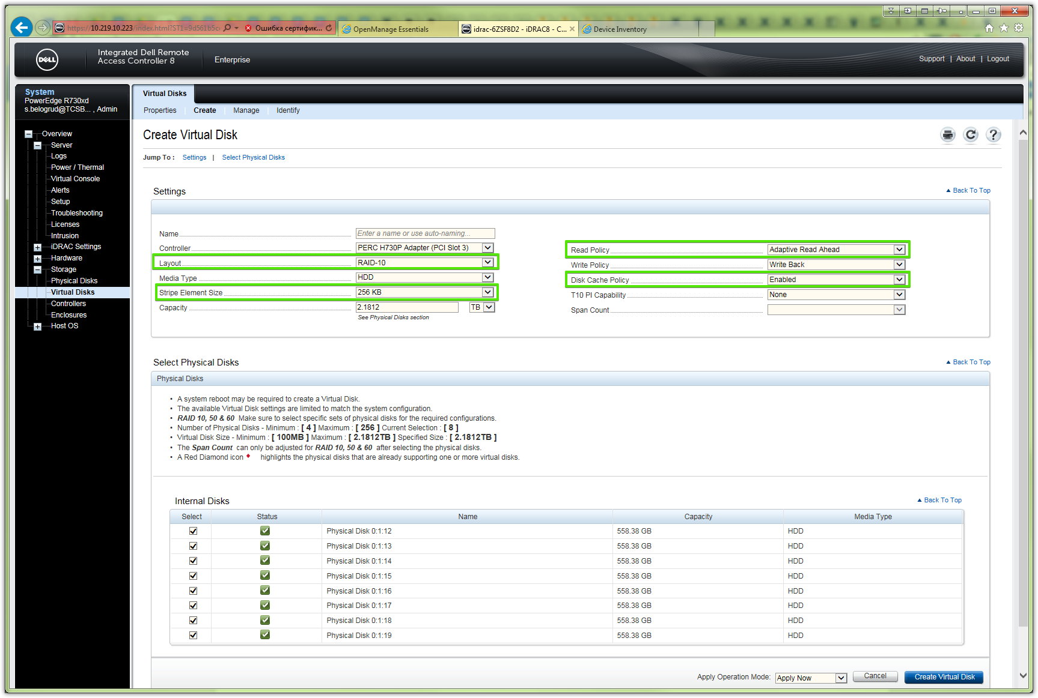

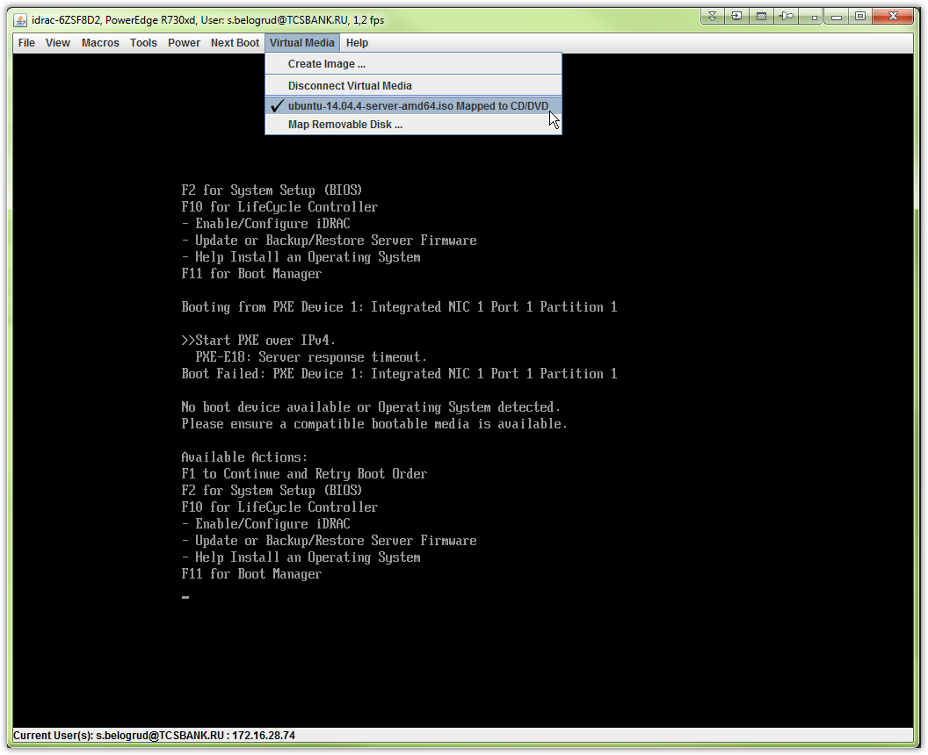

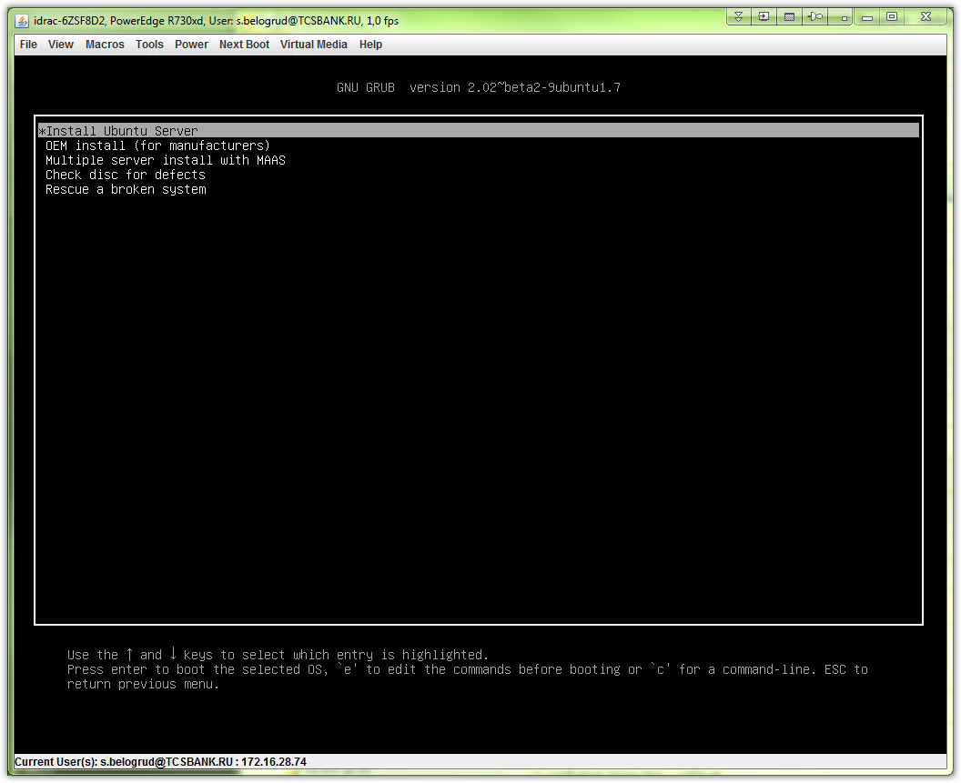

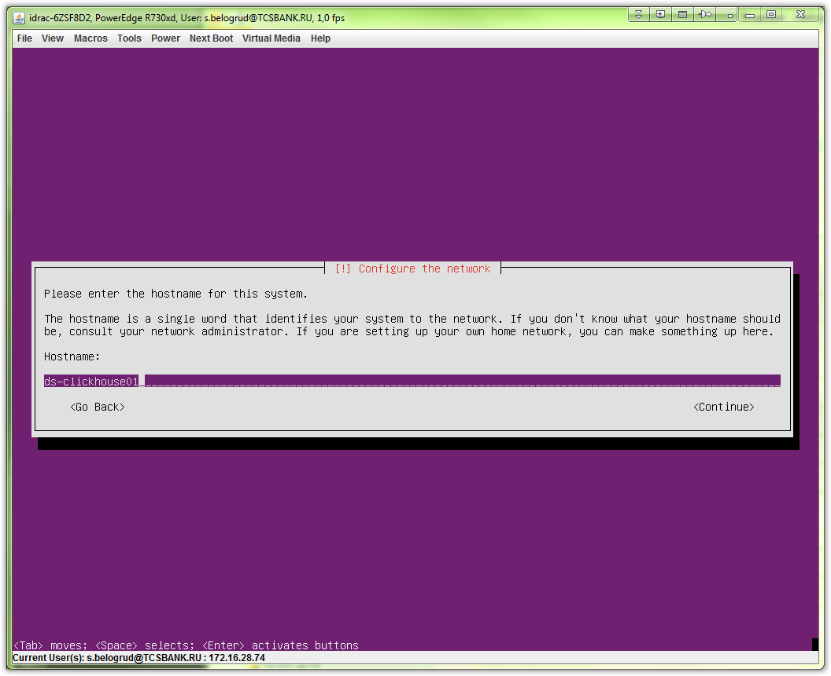
# I have used automatic disk partitioning.
# During installation process.
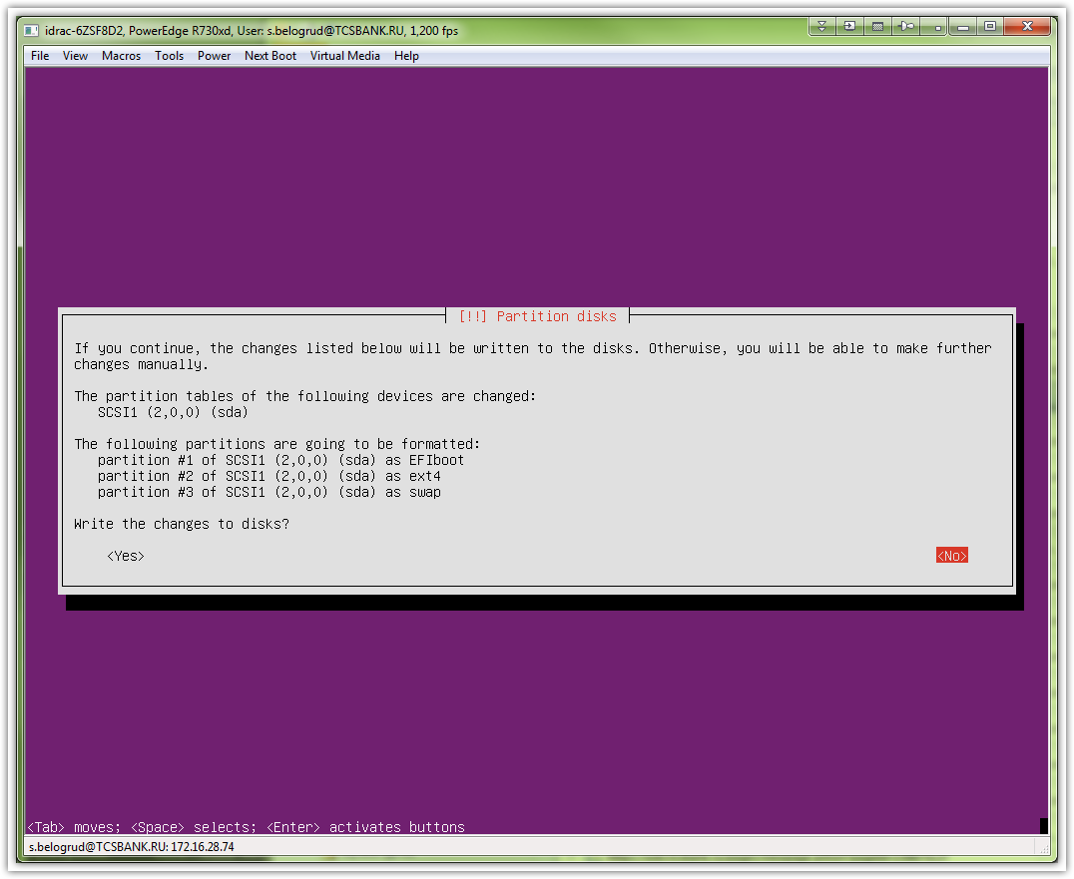

# After server was installed.
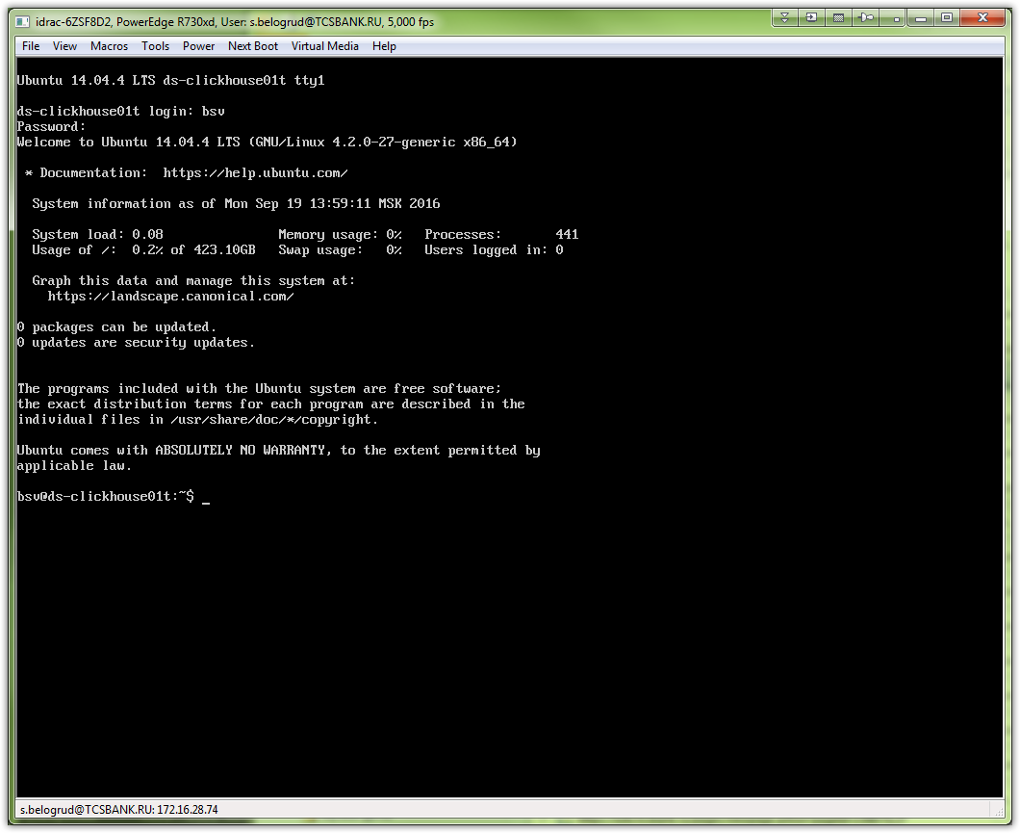

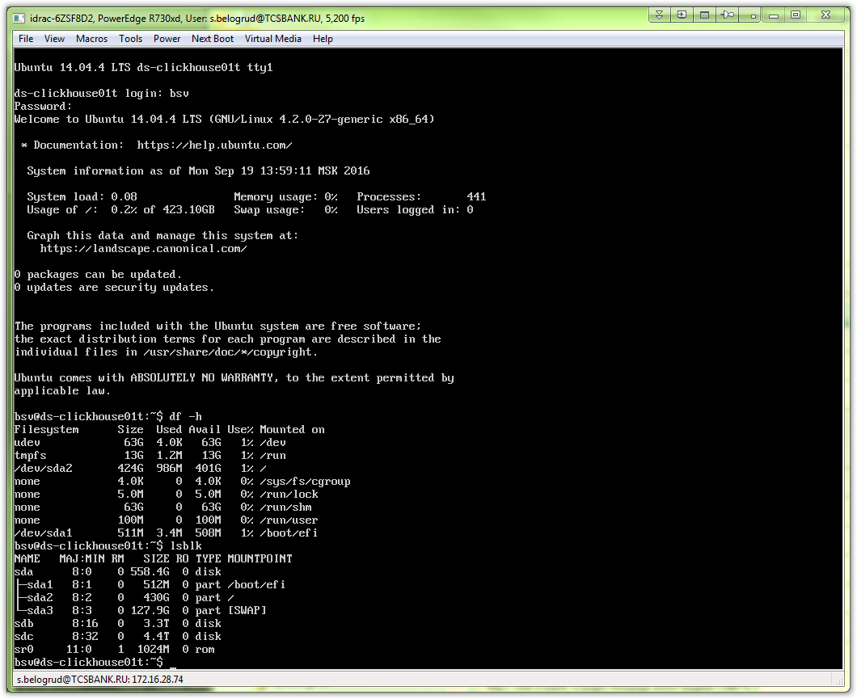

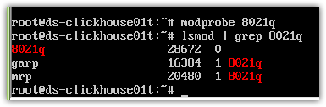

modprobe bonding
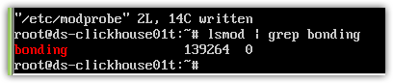
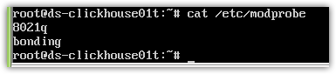
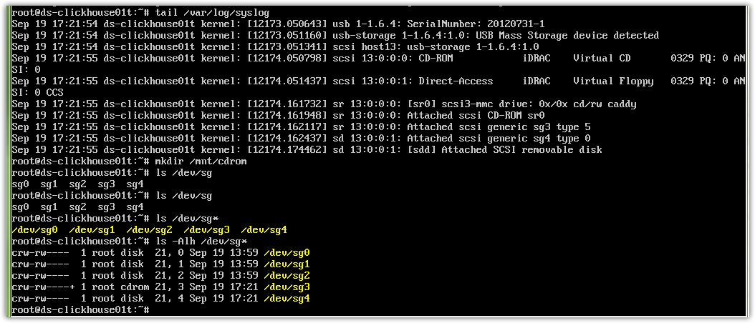
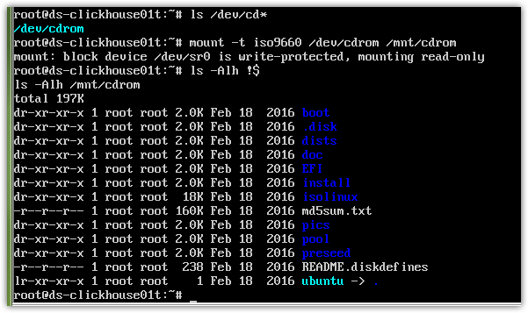
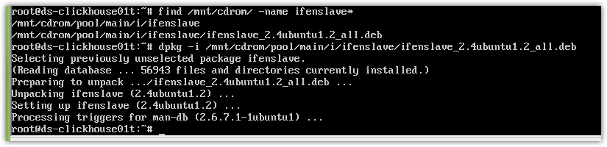
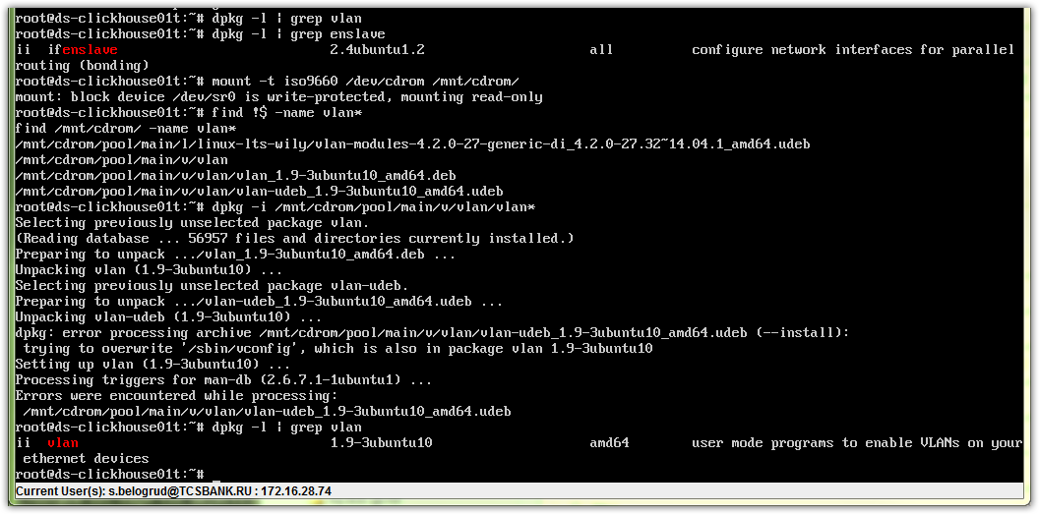

# Configuration steps to enable network on ubuntu server.
# There is tagged (vlan) network above bonding interfaces.

mount -t iso9660 /dev/cdrom /mnt/cdrom
find /mnt/cdrom -name vlan*
dpkg -i /mnt/cdrom/pool/main/v/vlan/vlan_1.9-3ubuntu10_amd64.deb
find /mnt/cdrom -name ifenslave*
dpkg -i /mnt/cdrom/pool/main/i/ifenslave/ifenslave_2.4ubuntu1.2_all.deb

root@ds-clickhouse01t:~# cat /etc/modprobe
8021q
bonding
root@ds-clickhouse01t:~#

root@ds-clickhouse01t:~# cat /etc/network/interfaces
# This file describes the network interfaces available on your system
# and how to activate them. For more information, see interfaces(5).

# The loopback network interface
auto lo
iface lo inet loopback

auto em1
iface em1 inet manual
bond-master bond0
bond-primary em1

auto em2
iface em2 inet manual
bond-master bond0

auto bond0
iface bond0 inet manual
bond-mode 1
bond-miimon 100
bond-slaves em1 em2

auto bond0.1864
iface bond0.1864 inet static
address 10.218.64.50
netmask 255.255.255.0
gateway 10.218.64.254
vlan-raw-device bond0
post-up route add default gw 10.218.64.254

root@ds-clickhouse01t:~#

# There are several command to start network working.
ifup em1
ifup em2
ifup bond0
ifup bond0.1864

ping -c 10.218.64.254

# Setting up domain name for host.
#
root@ds-clickhouse01t:~# cat /etc/hosts
127.0.0.1 localhost
127.0.1.1 ds-clickhouse01t

# The following lines are desirable for IPv6 capable hosts
::1 localhost ip6-localhost ip6-loopback
ff02::1 ip6-allnodes
ff02::2 ip6-allrouters
root@ds-clickhouse01t:~#
root@ds-clickhouse01t:~# cat /etc/hosts
127.0.0.1 localhost
127.0.1.1 ds-clickhouse01.tcsbank.ru ds-clickhouse01t

# The following lines are desirable for IPv6 capable hosts
::1 localhost ip6-localhost ip6-loopback
ff02::1 ip6-allnodes
ff02::2 ip6-allrouters
root@ds-clickhouse01t:~#

root@ds-clickhouse01t:~# hostname
ds-clickhouse01t
root@ds-clickhouse01t:~#
root@ds-clickhouse01t:~# hostname -d
tcsbank.ru
root@ds-clickhouse01t:~#
root@ds-clickhouse01t:~# hostname -f
ds-clickhouse01.tcsbank.ru
root@ds-clickhouse01t:~#

# If I write info directly to /etc/resolv.conf - it will be overwritten.
# I need to change other file.
root@ds-clickhouse01t:~# vim /etc/resolvconf/resolv.conf.d/base
nameserver 10.216.40.4
nameserver 10.216.42.5
search tcsbank.ru

root@ds-clickhouse01t:~# resolvconf -u
root@ds-clickhouse01t:~# cat /etc/resolv.conf
# Dynamic resolv.conf(5) file for glibc resolver(3) generated by resolvconf(8)
# DO NOT EDIT THIS FILE BY HAND -- YOUR CHANGES WILL BE OVERWRITTEN
nameserver 10.216.40.4
nameserver 10.216.42.5
search tcsbank.ru
root@ds-clickhouse01t:~#

#
# Continue configuring ubuntu server.
#
root@m1-gp-tst-sdw17:~# groupadd wheel

root@m1-gp-tst-sdw18:~# visudo
...
%wheel ALL=(ALL:ALL) ALL
...

# Here puppet could be installed from local repository.
#
root@ds-clickhouse01t:~# wget http://repo-linux/puppetlabs/apt/puppetlabs-release-trusty.deb
--2016-09-19 20:18:08-- http://repo-linux/puppetlabs/apt/puppetlabs-release-trusty.deb
Resolving repo-linux (repo-linux)... 10.216.42.6
Connecting to repo-linux (repo-linux)|10.216.42.6|:80... connected.
HTTP request sent, awaiting response... 200 OK
Length: 16944 (17K) [application/octet-stream]
Saving to: ‘puppetlabs-release-trusty.deb’

100%[===========================================================================================================================================================>] 16,944 --.-K/s in 0.009s

2016-09-19 20:18:08 (1.85 MB/s) - ‘puppetlabs-release-trusty.deb’ saved [16944/16944]

root@ds-clickhouse01t:~#

root@ds-clickhouse01t:~# dpkg -i puppetlabs-release-trusty.deb
Selecting previously unselected package puppetlabs-release.
(Reading database ... 56972 files and directories currently installed.)
Preparing to unpack puppetlabs-release-trusty.deb ...
Unpacking puppetlabs-release (1.1-1) ...
Setting up puppetlabs-release (1.1-1) ...
root@ds-clickhouse01t:~#

root@ds-clickhouse01t:~# cat /etc/apt/sources.list.d/puppetlabs.list
# Puppetlabs products
deb http://apt.puppetlabs.com trusty main
deb-src http://apt.puppetlabs.com trusty main

# Puppetlabs dependencies
deb http://apt.puppetlabs.com trusty dependencies
deb-src http://apt.puppetlabs.com trusty dependencies

# Puppetlabs devel (uncomment to activate)
# deb http://apt.puppetlabs.com trusty devel
# deb-src http://apt.puppetlabs.com trusty devel
root@ds-clickhouse01t:~# sed -i -e 's/apt.puppetlabs.com/repo-linux\/puppetlabs\/apt\//g' /etc/apt/sources.list.d/puppetlabs.list

root@ds-clickhouse01t:~# cat /etc/apt/sources.list.d/puppetlabs.list
# Puppetlabs products
deb http://repo-linux/puppetlabs/apt/ trusty main
deb-src http://repo-linux/puppetlabs/apt/ trusty main

# Puppetlabs dependencies
deb http://repo-linux/puppetlabs/apt/ trusty dependencies
deb-src http://repo-linux/puppetlabs/apt/ trusty dependencies

# Puppetlabs devel (uncomment to activate)
# deb http://repo-linux/puppetlabs/apt/ trusty devel
# deb-src http://repo-linux/puppetlabs/apt/ trusty devel
root@ds-clickhouse01t:~#

root@ds-clickhouse01t:~# sed -i -e 's/us.archive.ubuntu.com/repo-linux.tcsbank.ru/g' /etc/apt/sources.list
root@ds-clickhouse01t:~# sed -i -e 's/security.ubuntu.com/repo-linux.tcsbank.ru/g' /etc/apt/sources.list

root@ds-clickhouse01t:~# aptitude update
Ign http://repo-linux trusty InRelease
Ign http://repo-linux.tcsbank.ru trusty InRelease
Hit http://repo-linux trusty Release.gpg
Get: 1 http://repo-linux.tcsbank.ru trusty-updates InRelease [65.9 kB]
Hit http://repo-linux trusty Release
Get: 2 http://repo-linux.tcsbank.ru trusty-backports InRelease [65.9 kB]
Hit http://repo-linux trusty/main Sources
Get: 3 http://repo-linux.tcsbank.ru trusty-security InRelease [65.9 kB]
Hit http://repo-linux trusty/dependencies Sources
Hit http://repo-linux trusty/main amd64 Packages
…
Get: 69 http://repo-linux.tcsbank.ru trusty/universe Translation-en [4,089 kB]
Ign http://repo-linux.tcsbank.ru trusty/main Translation-en_US
Ign http://repo-linux.tcsbank.ru trusty/multiverse Translation-en_US
Ign http://repo-linux.tcsbank.ru trusty/restricted Translation-en_US
Ign http://repo-linux.tcsbank.ru trusty/universe Translation-en_US
Fetched 33.4 MB in 6s (4,776 kB/s)

Current status: 91 updates [+91], 74619 new [+74566].
root@ds-clickhouse01t:~#

root@ds-clickhouse01t:~# aptitude install puppet
The following NEW packages will be installed:
augeas-lenses{a} debconf-utils{a} facter{a} hiera{a} libaugeas-ruby{a} libaugeas0{a} libruby1.9.1{a} libyaml-0-2{a} puppet puppet-common{a} ruby{a} ruby-augeas{a} ruby-json{a} ruby-shadow{a}
ruby1.9.1{a} virt-what{a}
0 packages upgraded, 16 newly installed, 0 to remove and 91 not upgraded.
Need to get 4,608 kB of archives. After unpacking 23.9 MB will be used.
Do you want to continue? [Y/n/?] Y
Get: 1 http://repo-linux.tcsbank.ru/ubuntu/ trusty-updates/main libyaml-0-2 amd64 0.1.4-3ubuntu3.1 [48.1 kB]
...
Setting up puppet-common (3.8.7-1puppetlabs1) ...
Setting up puppet (3.8.7-1puppetlabs1) ...
* Starting puppet agent

puppet not configured to start, please edit /etc/default/puppet to enable
...done.
Processing triggers for libc-bin (2.19-0ubuntu6.7) ...
Processing triggers for ureadahead (0.100.0-16) ...

root@ds-clickhouse01t:~#

root@ds-clickhouse01t:~# puppet agent -t
Warning: Setting templatedir is deprecated. See http://links.puppetlabs.com/env-settings-deprecations
(at /usr/lib/ruby/vendor_ruby/puppet/settings.rb:1139:in `issue_deprecation_warning')
Info: Creating a new SSL key for ds-clickhouse01t.tcsbank.ru
Info: Caching certificate for ca
Info: csr_attributes file loading from /etc/puppet/csr_attributes.yaml
Info: Creating a new SSL certificate request for ds-clickhouse01t.tcsbank.ru
Info: Certificate Request fingerprint (SHA256): A2:49:13:BE:31:33:50:A3:EF:54:B1:7A:31:BB:03:B8:E8:B8:17:FF:96:4F:9A:26:85:67:B9:75:C1:7B:A0:34
Info: Caching certificate for ca
Exiting; no certificate found and waitforcert is disabled
root@ds-clickhouse01t:~#

[root@puppet ~]# puppet cert list | grep clickhouse
"ds-clickhouse01t.tcsbank.ru" (SHA256) A2:49:13:BE:31:33:50:A3:EF:54:B1:7A:31:BB:03:B8:E8:B8:17:FF:96:4F:9A:26:85:67:B9:75:C1:7B:A0:34
[root@puppet ~]# puppet cert sign ds-clickhouse01t.tcsbank.ru
Notice: Signed certificate request for ds-clickhouse01t.tcsbank.ru
Notice: Removing file Puppet::SSL::CertificateRequest ds-clickhouse01t.tcsbank.ru at '/var/lib/puppet/ssl/ca/requests/ds-clickhouse01t.tcsbank.ru.pem'
[root@puppet ~]#

root@m1-gp-tst-sdw17:~# userdel -r bsv
userdel: bsv mail spool (/var/mail/bsv) not found
root@m1-gp-tst-sdw17:~# id bsv
id: bsv: no such user
root@m1-gp-tst-sdw17:~#

root@ds-clickhouse01t:~# puppet agent -t
Info: Retrieving pluginfacts
Info: Retrieving plugin
Info: Loading facts
Info: Caching catalog for ds-clickhouse01t.tcsbank.ru
Info: Applying configuration version '1474297584'
Notice: /Stage[main]/Puppet::Service/Service[puppet]/ensure: ensure changed 'stopped' to 'running'
Info: /Stage[main]/Puppet::Service/Service[puppet]: Unscheduling refresh on Service[puppet]
Notice: Finished catalog run in 0.21 seconds
root@ds-clickhouse01t:~#

root@ds-clickhouse01t:~# service puppet status
* agent is not running
root@ds-clickhouse01t:~# service puppet start
* Starting puppet agent

puppet not configured to start, please edit /etc/default/puppet to enable
...done.
root@ds-clickhouse01t:~#

root@ds-clickhouse01t:~# vim /etc/default/puppet
# Defaults for puppet - sourced by /etc/init.d/puppet

# Enable puppet agent service?
# Setting this to "yes" allows the puppet agent service to run.
# Setting this to "no" keeps the puppet agent service from running.
START=yes

# Startup options
DAEMON_OPTS=""

# Prepairing disk partitions.

root@ds-clickhouse01t:~# lsblk
NAME MAJ:MIN RM SIZE RO TYPE MOUNTPOINT
sda 8:0 0 558.4G 0 disk
├─sda1 8:1 0 512M 0 part /boot/efi
├─sda2 8:2 0 430G 0 part /
└─sda3 8:3 0 127.9G 0 part [SWAP]
sdb 8:16 0 3.3T 0 disk
sdc 8:32 0 4.4T 0 disk
root@ds-clickhouse01t:~# parted -a optimal /dev/sdb mklabel GPT print mkpart primary xfs 0% 100% print
Model: DELL PERC H730P Mini (scsi)
Disk /dev/sdb: 3597GB
Sector size (logical/physical): 512B/512B
Partition Table: gpt

Number Start End Size File system Name Flags

Model: DELL PERC H730P Mini (scsi)
Disk /dev/sdb: 3597GB
Sector size (logical/physical): 512B/512B
Partition Table: gpt

Number Start End Size File system Name Flags
1 1049kB 3597GB 3597GB primary

Information: You may need to update /etc/fstab.

root@ds-clickhouse01t:~#
root@ds-clickhouse01t:~# parted -a optimal /dev/sdc mklabel GPT print mkpart primary xfs 0% 100% print
Model: DELL PERC H730P Adp (scsi)
Disk /dev/sdc: 4796GB
Sector size (logical/physical): 512B/512B
Partition Table: gpt

Number Start End Size File system Name Flags

Model: DELL PERC H730P Adp (scsi)
Disk /dev/sdc: 4796GB
Sector size (logical/physical): 512B/512B
Partition Table: gpt

Number Start End Size File system Name Flags
1 1049kB 4796GB 4796GB primary

Information: You may need to update /etc/fstab.

root@ds-clickhouse01t:~#

root@ds-clickhouse01t:~# lsblk
NAME MAJ:MIN RM SIZE RO TYPE MOUNTPOINT
sda 8:0 0 558.4G 0 disk
├─sda1 8:1 0 512M 0 part /boot/efi
├─sda2 8:2 0 430G 0 part /
└─sda3 8:3 0 127.9G 0 part [SWAP]
sdb 8:16 0 3.3T 0 disk
└─sdb1 8:17 0 3.3T 0 part
sdc 8:32 0 4.4T 0 disk
└─sdc1 8:33 0 4.4T 0 part
root@ds-clickhouse01t:~#

root@ds-clickhouse01t:~# apt-get install xfsprogs
Reading package lists... Done
Building dependency tree
Reading state information... Done
Suggested packages:
xfsdump acl attr quota
The following NEW packages will be installed:
xfsprogs
0 upgraded, 1 newly installed, 0 to remove and 91 not upgraded.
Need to get 508 kB of archives.
After this operation, 2,691 kB of additional disk space will be used.
Get:1 http://repo-linux.tcsbank.ru/ubuntu/ trusty/main xfsprogs amd64 3.1.9ubuntu2 [508 kB]
Fetched 508 kB in 0s (7,505 kB/s)
Selecting previously unselected package xfsprogs.
(Reading database ... 60254 files and directories currently installed.)
Preparing to unpack .../xfsprogs_3.1.9ubuntu2_amd64.deb ...
Unpacking xfsprogs (3.1.9ubuntu2) ...
Processing triggers for man-db (2.6.7.1-1ubuntu1) ...
Setting up xfsprogs (3.1.9ubuntu2) ...
Processing triggers for libc-bin (2.19-0ubuntu6.7) ...
root@ds-clickhouse01t:~#

root@ds-clickhouse01t:~# mkfs.xfs /dev/sdb1
meta-data=/dev/sdb1 isize=256 agcount=4, agsize=219561856 blks
= sectsz=512 attr=2, projid32bit=0
data = bsize=4096 blocks=878247424, imaxpct=5
= sunit=0 swidth=0 blks
naming =version 2 bsize=4096 ascii-ci=0
log =internal log bsize=4096 blocks=428831, version=2
= sectsz=512 sunit=0 blks, lazy-count=1
realtime =none extsz=4096 blocks=0, rtextents=0
root@ds-clickhouse01t:~# mkfs.xfs /dev/sdc1
meta-data=/dev/sdc1 isize=256 agcount=5, agsize=268435455 blks
= sectsz=512 attr=2, projid32bit=0
data = bsize=4096 blocks=1170996736, imaxpct=5
= sunit=0 swidth=0 blks
naming =version 2 bsize=4096 ascii-ci=0
log =internal log bsize=4096 blocks=521728, version=2
= sectsz=512 sunit=0 blks, lazy-count=1
realtime =none extsz=4096 blocks=0, rtextents=0
root@ds-clickhouse01t:~#

root@ds-clickhouse01t:~# blkid
/dev/sda1: UUID="3A86-277D" TYPE="vfat"
/dev/sda2: UUID="150f27c1-a779-41b1-86ef-7dbd36b0df31" TYPE="ext4"
/dev/sda3: UUID="d2517359-0c29-456c-ab82-78df2e366e6f" TYPE="swap"
/dev/sdb1: UUID="0729f249-a17f-4e67-bfe7-4f1ed5c56d50" TYPE="xfs"
/dev/sdc1: UUID="f4cc81c2-cefb-446c-b4a0-6d12005d7572" TYPE="xfs"
root@ds-clickhouse01t:~#

root@ds-clickhouse01t:~# mkdir /data1
root@ds-clickhouse01t:~# mkdir /data2

root@ds-clickhouse01t:~# vim /etc/fstab
...
UUID=0729f249-a17f-4e67-bfe7-4f1ed5c56d50 /data1 xfs defaults 0 2
UUID=f4cc81c2-cefb-446c-b4a0-6d12005d7572 /data2 xfs defaults 0 2

root@ds-clickhouse01t:~# mount /data1 ; mount /data2

root@ds-clickhouse01t:~# df -h
Filesystem Size Used Avail Use% Mounted on
udev 63G 12K 63G 1% /dev
tmpfs 13G 1.1M 13G 1% /run
/dev/sda2 424G 1.3G 401G 1% /
none 4.0K 0 4.0K 0% /sys/fs/cgroup
none 5.0M 0 5.0M 0% /run/lock
none 63G 0 63G 0% /run/shm
none 100M 0 100M 0% /run/user
/dev/sda1 511M 3.4M 508M 1% /boot/efi
/dev/sdb1 3.3T 33M 3.3T 1% /data1
/dev/sdc1 4.4T 33M 4.4T 1% /data2
root@ds-clickhouse01t:~#

................................................................................

#
# This is one server with Debian OS installed. Monitoring this server was produced by Leonov Aleksey.
# It's more closer to ubuntu, that ever we have.
#
[root@vm-vol-nag4-tst objects]# pynag list filename where object_type=host and host_name=zabbix
filename
--------------------------------------------------------------------------------
/usr/local/nagios/etc/objects/servers/dc-m1/linux/m1-zabbix02.cfg
----------1 objects matches search condition------------------------------------
[root@vm-vol-nag4-tst objects]#

................................................................................

# Below are attempts to configure nagios to monitor this server.

root@ds-clickhouse01t:~# apt-get install nagios-nrpe-server
Reading package lists... Done
Building dependency tree
Reading state information... Done
nagios-nrpe-server is already the newest version.
0 upgraded, 0 newly installed, 0 to remove and 88 not upgraded.
root@ds-clickhouse01t:~#

root@ds-clickhouse01t:~# service nagios-nrpe-server start
* Starting nagios-nrpe nagios-nrpe
...done.
root@ds-clickhouse01t:~#

root@ds-clickhouse01t:~# update-rc.d nagios-nrpe-server defaults
System start/stop links for /etc/init.d/nagios-nrpe-server already exist.
root@ds-clickhouse01t:~# update-rc.d nagios-nrpe-server enable
update-rc.d: warning: start runlevel arguments (none) do not match nagios-nrpe-server Default-Start values (2 3 4 5)
update-rc.d: warning: stop runlevel arguments (none) do not match nagios-nrpe-server Default-Stop values (0 1 6)
Enabling system startup links for /etc/init.d/nagios-nrpe-server ...
Removing any system startup links for /etc/init.d/nagios-nrpe-server ...
/etc/rc0.d/K20nagios-nrpe-server
/etc/rc1.d/K20nagios-nrpe-server
/etc/rc2.d/S20nagios-nrpe-server
/etc/rc3.d/S20nagios-nrpe-server
/etc/rc4.d/S20nagios-nrpe-server
/etc/rc5.d/S20nagios-nrpe-server
/etc/rc6.d/K20nagios-nrpe-server
Adding system startup for /etc/init.d/nagios-nrpe-server ...
/etc/rc0.d/K20nagios-nrpe-server -> ../init.d/nagios-nrpe-server
/etc/rc1.d/K20nagios-nrpe-server -> ../init.d/nagios-nrpe-server
/etc/rc6.d/K20nagios-nrpe-server -> ../init.d/nagios-nrpe-server
/etc/rc2.d/S20nagios-nrpe-server -> ../init.d/nagios-nrpe-server
/etc/rc3.d/S20nagios-nrpe-server -> ../init.d/nagios-nrpe-server
/etc/rc4.d/S20nagios-nrpe-server -> ../init.d/nagios-nrpe-server
/etc/rc5.d/S20nagios-nrpe-server -> ../init.d/nagios-nrpe-server
root@ds-clickhouse01t:~#

root@ds-clickhouse01t:~# service nagios-nrpe-server status
* nagios-nrpe is not running
root@ds-clickhouse01t:~#

root@ds-clickhouse01t:~# ls -Alh /etc/nrpe.d/
total 32K
-rw-r--r-- 1 root root 262 Sep 19 19:29 access.cfg
-rw-r--r-- 1 root root 262 Sep 19 19:27 allowed.cfg
-rw-r--r-- 1 root root 570 Sep 19 19:27 check_disks.cfg
-rw-r--r-- 1 root root 80 Sep 19 19:27 check_load.cfg
-rw-r--r-- 1 root root 96 Sep 19 19:27 check_memory.cfg
-rw-r--r-- 1 root root 192 Sep 19 19:27 check_ntp.cfg
-rw-r--r-- 1 root root 86 Sep 19 19:27 check_passwords.cfg
-rw-r--r-- 1 root root 161 Sep 19 19:27 check_procs.cfg
root@ds-clickhouse01t:~#

root@ds-clickhouse01t:~# cat /etc/nrpe.d/check_disks.cfg
command[check_boot_fs]=/usr/lib64/nagios/plugins/check_disk -W 20% -K 10% -w 20% -c 10% -p /boot
command[check_root_fs]=/usr/lib64/nagios/plugins/check_disk -W 20% -K 10% -w 20% -c 10% -p /
command[check_opt_fs]=/usr/lib64/nagios/plugins/check_disk -W 20% -K 10% -w 20% -c 10% -p /opt
command[check_tmp_fs]=/usr/lib64/nagios/plugins/check_disk -W 20% -K 10% -w 20% -c 10% -p /tmp
command[check_usr_fs]=/usr/lib64/nagios/plugins/check_disk -W 20% -K 10% -w 20% -c 10% -p /usr
command[check_var_fs]=/usr/lib64/nagios/plugins/check_disk -W 20% -K 10% -w 20% -c 10% -p /var
root@ds-clickhouse01t:~# /usr/lib64/nagios/plugins/check_disk -W 20% -K 10% -w 20% -c 10% -p /
-bash: /usr/lib64/nagios/plugins/check_disk: No such file or directory
root@ds-clickhouse01t:~#

root@ds-clickhouse01t:~# ls /usr/lib/nagios/plugins/
check_apt check_dhcp check_file_age check_icmp check_jabber check_mrtg check_nntps check_oracle check_real check_snmp check_time urlize
check_breeze check_dig check_flexlm check_ide_smart check_ldap check_mrtgtraf check_nt check_overcr check_rpc check_spop check_udp utils.pm
check_by_ssh check_disk check_ftp check_ifoperstatus check_ldaps check_mysql check_ntp check_pgsql check_rta_multi check_ssh check_ups utils.sh
check_clamd check_disk_smb check_host check_ifstatus check_load check_mysql_query check_ntp_peer check_ping check_sensors check_ssmtp check_users
check_cluster check_dns check_hpjd check_imap check_log check_nagios check_ntp_time check_pop check_simap check_swap check_wave
check_dbi check_dummy check_http check_ircd check_mailq check_nntp check_nwstat check_procs check_smtp check_tcp negate
root@ds-clickhouse01t:~#

root@ds-clickhouse01t:~# sed -i 's/lib64/lib/g' /etc/nrpe.d/*.cfg

root@ds-clickhouse01t:~# cat /etc/nrpe.d/check_disks.cfg
command[check_boot_fs]=/usr/lib/nagios/plugins/check_disk -W 20% -K 10% -w 20% -c 10% -p /boot
command[check_root_fs]=/usr/lib/nagios/plugins/check_disk -W 20% -K 10% -w 20% -c 10% -p /
command[check_opt_fs]=/usr/lib/nagios/plugins/check_disk -W 20% -K 10% -w 20% -c 10% -p /opt
command[check_tmp_fs]=/usr/lib/nagios/plugins/check_disk -W 20% -K 10% -w 20% -c 10% -p /tmp
command[check_usr_fs]=/usr/lib/nagios/plugins/check_disk -W 20% -K 10% -w 20% -c 10% -p /usr
command[check_var_fs]=/usr/lib/nagios/plugins/check_disk -W 20% -K 10% -w 20% -c 10% -p /var
root@ds-clickhouse01t:~#

#
# This feature become available after applyed "nrpe" and "nrpe-access" in puppet.
#
root@ds-clickhouse01t:~# vim /etc/nagios/nrpe.cfg
...
#allowed_hosts=127.0.0.1,nag2,monitoring1,monitoring2,monitoring3,monitoring4,monitoring5,monitoring6
allowed_hosts=127.0.0.1,172.16.1.11,172.16.1.115,172.16.1.117,nag2,monitoring1,monitoring2,monitoring3,monitoring4,monitoring5,monitoring6,mon1.tcsbank.ru,mon2.tcsbank.ru,mon3.tcsbank.ru,mon4.tcsbank.ru,mon5.tcsbank.ru,mon6.tcsbank.ru,mon7.tcsbank.ru
...

................................................................................

[root@vm-vol-nag4-tst objects]# vim -o /usr/local/nagios/etc/objects/servers/dc-m1/linux/m1-zabbix02.cfg servers/dc-ds/linux/ds-clickhouse01t.cfg

[root@vm-vol-nag4-tst objects]# grep -ire "a.melnikov" contacts/*
contacts/a.melnikov.cfg: contact_name a.melnikov_email
contacts/a.melnikov.cfg: email a.melnikov@tinkoff.ru
contacts/a.melnikov.cfg: contact_name a.melnikov_sms
contacts/a.melnikov.cfg: email a.melnikov@tinkoff.ru
[root@vm-vol-nag4-tst objects]#

................................................................................

root@ds-clickhouse01t:~# less /var/log/syslog
...
Sep 20 14:27:32 ds-clickhouse01 nrpe[30148]: Invalid IPv6 address in ACL: mon6.tcsbank.ru
Sep 20 14:27:32 ds-clickhouse01 nrpe[30148]: Invalid IPv6 address in ACL: mon7.tcsbank.ru
Sep 20 14:27:32 ds-clickhouse01 nrpe[30149]: Starting up daemon
Sep 20 14:27:32 ds-clickhouse01 nrpe[30149]: Warning: Could not get group entry for 'nrpe'
Sep 20 14:27:32 ds-clickhouse01 nrpe[30149]: Warning: Could not set effective GID=-1
Sep 20 14:27:32 ds-clickhouse01 nrpe[30149]: Warning: Could not get passwd entry for 'nrpe'
Sep 20 14:27:32 ds-clickhouse01 nrpe[30149]: Warning: Possibly root user failed dropping privileges with initgroups()
Sep 20 14:27:32 ds-clickhouse01 nrpe[30149]: Error: NRPE daemon cannot be run as user/group root!
...

root@ds-clickhouse01t:~# apt-get install nagios-nrpe-server nagios-plugins
Reading package lists... Done
Building dependency tree
Reading state information... Done
nagios-nrpe-server is already the newest version.
nagios-plugins is already the newest version.
0 upgraded, 0 newly installed, 0 to remove and 88 not upgraded.
root@ds-clickhouse01t:~#

root@ds-clickhouse01t:~# vim /etc/nagios/nrpe.cfg
...
# NRPE USER
# This determines the effective user that the NRPE daemon should run as.
# You can either supply a username or a UID.
#
# NOTE: This option is ignored if NRPE is running under either inetd or xinetd

nrpe_user=nrpe

# NRPE GROUP
# This determines the effective group that the NRPE daemon should run as.
# You can either supply a group name or a GID.
#
# NOTE: This option is ignored if NRPE is running under either inetd or xinetd

nrpe_group=nrpe
...

root@ds-clickhouse01t:~# id nrpe
id: nrpe: no such user
root@ds-clickhouse01t:~#

root@ds-clickhouse01t:~# dpkg-query -L nagios-nrpe-server
/.
/etc
/etc/nagios
/etc/nagios/nrpe.cfg
/etc/nagios/nrpe_local.cfg
...

root@ds-clickhouse01t:~# mv /etc/nagios/nrpe.cfg{,.from.puppet}

root@ds-clickhouse01t:~# dpkg -S nrpe.cfg
nagios-nrpe-server: /etc/nagios/nrpe.cfg
root@ds-clickhouse01t:~#

root@ds-clickhouse01t:~# apt-get -o Dpkg::Options::="--force-confmiss" install --reinstall nagios-nrpe-server
Reading package lists... Done
Building dependency tree
Reading state information... Done
0 upgraded, 0 newly installed, 1 reinstalled, 0 to remove and 88 not upgraded.
Need to get 0 B/32.8 kB of archives.
After this operation, 0 B of additional disk space will be used.
(Reading database ... 61512 files and directories currently installed.)
Preparing to unpack .../nagios-nrpe-server_2.15-0ubuntu1_amd64.deb ...
* Stopping nagios-nrpe nagios-nrpe
start-stop-daemon: warning: failed to kill 30149: No such process
...done.
Unpacking nagios-nrpe-server (2.15-0ubuntu1) over (2.15-0ubuntu1) ...
Processing triggers for ureadahead (0.100.0-16) ...
Processing triggers for man-db (2.6.7.1-1ubuntu1) ...
Setting up nagios-nrpe-server (2.15-0ubuntu1) ...

Configuration file `/etc/nagios/nrpe.cfg', does not exist on system.
Installing new config file as you requested.
* Starting nagios-nrpe nagios-nrpe
...done.
root@ds-clickhouse01t:~#

root@ds-clickhouse01t:~# cp /etc/nagios/nrpe.cfg{,.orig}

root@ds-clickhouse01t:~# diff -Nuar <(egrep -v -e "^#|^$" /etc/nagios/nrpe.cfg) <(egrep -v -e "^#|^$" /etc/nagios/nrpe.cfg.from.puppet)
--- /dev/fd/63 2016-09-20 15:00:22.990867263 +0300
+++ /dev/fd/62 2016-09-20 15:00:22.990867263 +0300
@@ -1,19 +1,11 @@
log_facility=daemon
pid_file=/var/run/nagios/nrpe.pid
server_port=5666
-nrpe_user=nagios
-nrpe_group=nagios
-allowed_hosts=127.0.0.1
-
-dont_blame_nrpe=0
-allow_bash_command_substitution=0
+nrpe_user=nrpe
+nrpe_group=nrpe
+allowed_hosts=127.0.0.1,172.16.1.11,172.16.1.115,172.16.1.117,nag2,monitoring1,monitoring2,monitoring3,monitoring4,monitoring5,monitoring6,mon1.tcsbank.ru,mon2.tcsbank.ru,mon3.tcsbank.ru,mon4.tcsbank.ru,mon5.tcsbank.ru,mon6.tcsbank.ru,mon7.tcsbank.ru
+dont_blame_nrpe=1
debug=0
-command_timeout=60
+command_timeout=300
connection_timeout=300
-command[check_users]=/usr/lib/nagios/plugins/check_users -w 5 -c 10
-command[check_load]=/usr/lib/nagios/plugins/check_load -w 15,10,5 -c 30,25,20
-command[check_hda1]=/usr/lib/nagios/plugins/check_disk -w 20% -c 10% -p /dev/hda1
-command[check_zombie_procs]=/usr/lib/nagios/plugins/check_procs -w 5 -c 10 -s Z
-command[check_total_procs]=/usr/lib/nagios/plugins/check_procs -w 150 -c 200
-include=/etc/nagios/nrpe_local.cfg
-include_dir=/etc/nagios/nrpe.d/
+include_dir=/etc/nrpe.d/
root@ds-clickhouse01t:~#

root@ds-clickhouse01t:~# vim -o /etc/nagios/nrpe.{cfg,cfg.from.puppet}

root@ds-clickhouse01t:~# egrep "^nrpe_|^command_timeout|^include" /etc/nagios/nrpe.cfg
nrpe_user=nagios
nrpe_group=nagios
command_timeout=300
include_dir=/etc/nrpe.d/
include=/etc/nagios/nrpe_local.cfg
include_dir=/etc/nagios/nrpe.d/
root@ds-clickhouse01t:~#

root@ds-clickhouse01t:~# diff -Nuar <(egrep -v -e "^#|^$" /etc/nagios/nrpe.cfg.orig) <(egrep -v -e "^#|^$" /etc/nagios/nrpe.cfg)
--- /dev/fd/63 2016-09-20 15:09:23.318268055 +0300
+++ /dev/fd/62 2016-09-20 15:09:23.318268055 +0300
@@ -3,17 +3,12 @@
server_port=5666
nrpe_user=nagios
nrpe_group=nagios
-allowed_hosts=127.0.0.1
+allowed_hosts=127.0.0.1,172.16.1.11,172.16.1.115,172.16.1.117,nag2,monitoring1,monitoring2,monitoring3,monitoring4,monitoring5,monitoring6,mon1.tcsbank.ru,mon2.tcsbank.ru,mon3.tcsbank.ru,mon4.tcsbank.ru,mon5.tcsbank.ru,mon6.tcsbank.ru,mon7.tcsbank.ru

-dont_blame_nrpe=0
-allow_bash_command_substitution=0
+dont_blame_nrpe=1
debug=0
-command_timeout=60
+command_timeout=300
connection_timeout=300
-command[check_users]=/usr/lib/nagios/plugins/check_users -w 5 -c 10
-command[check_load]=/usr/lib/nagios/plugins/check_load -w 15,10,5 -c 30,25,20
-command[check_hda1]=/usr/lib/nagios/plugins/check_disk -w 20% -c 10% -p /dev/hda1
-command[check_zombie_procs]=/usr/lib/nagios/plugins/check_procs -w 5 -c 10 -s Z
-command[check_total_procs]=/usr/lib/nagios/plugins/check_procs -w 150 -c 200
+include_dir=/etc/nrpe.d/
include=/etc/nagios/nrpe_local.cfg
include_dir=/etc/nagios/nrpe.d/
root@ds-clickhouse01t:~#

root@ds-clickhouse01t:~# service nagios-nrpe-server status
* nagios-nrpe is not running
root@ds-clickhouse01t:~# service nagios-nrpe-server start
* Starting nagios-nrpe nagios-nrpe
...done.
root@ds-clickhouse01t:~# service nagios-nrpe-server status
* nagios-nrpe is running
root@ds-clickhouse01t:~# ps axu | grep nrp[e]
nagios 31089 0.0 0.0 23464 2488 ? Ss 15:11 0:00 /usr/sbin/nrpe -c /etc/nagios/nrpe.cfg -d
root@ds-clickhouse01t:~#

root@ds-clickhouse01t:~# netstat -nlpt | grep nrpe
tcp 0 0 0.0.0.0:5666 0.0.0.0:* LISTEN 31089/nrpe
tcp6 0 0 :::5666 :::* LISTEN 31089/nrpe
root@ds-clickhouse01t:~#

................................................................................
................................................................................

[root@vm-vol-nag4-tst objects]# vim -o /home/bsv/work/templates/hw-lin-template.cfg servers/dc-ds/linux/ds-clickhouse01t.cfg

root@ds-clickhouse01t:~# /usr/lib/nagios/plugins/check_load -w 15,10,5 -c 30,25,20
OK - load average: 0.00, 0.01, 0.05|load1=0.000;15.000;30.000;0; load5=0.010;10.000;25.000;0; load15=0.050;5.000;20.000;0;
root@ds-clickhouse01t:~# grep check_memory_load_linux /etc/nrpe.d/*
/etc/nrpe.d/check_memory.cfg:command[check_memory_load_linux]=/usr/lib/nagios/plugins/check_mem_linux.pl -f -C -w 20 -c 10
root@ds-clickhouse01t:~# /usr/lib/nagios/plugins/check_mem_linux.pl -f -C -w 20 -c 10
-bash: /usr/lib/nagios/plugins/check_mem_linux.pl: No such file or directory
root@ds-clickhouse01t:~#

[root@puppet ~]# scp /etc/puppet/modules/nagios/files/check_mem_linux.pl bsv@ds-clickhouse01t:/tmp/
bsv@ds-clickhouse01t's password:
check_mem_linux.pl 100% 8030 7.8KB/s 00:00
[root@puppet ~]#

root@ds-clickhouse01t:~# cp /tmp/check_mem_linux.pl /usr/lib/nagios/plugins/

................................................................................

# Here is configuring access to dell repository.

root@ds-clickhouse01t:~/work/20160920-1642# echo 'deb http://linux.dell.com/repo-linux-redirect-via-proxy/repo/community/ubuntu trusty openmanage' | sudo tee -a /etc/apt/sources.list.d/linux.dell.com.sources.list
deb http://linux.dell.com/repo-linux-redirect-via-proxy/repo/community/ubuntu trusty openmanage
root@ds-clickhouse01t:~/work/20160920-1642#

root@ds-clickhouse01t:~/work/20160920-1642# ls -Alh ~/.gnupg/
total 12K
-rw------- 1 root root 9.2K Sep 20 16:51 gpg.conf
-rw------- 1 root root 0 Sep 20 16:51 pubring.gpg
-rw------- 1 root root 0 Sep 20 16:51 secring.gpg
root@ds-clickhouse01t:~/work/20160920-1642#

root@ds-clickhouse01t:~/work/20160920-1642# gpg --keyserver-options http-proxy=http://repo-linux.tcsbank.ru:80 --keyserver hkp://pool.sks-keyservers.net:80 --recv-key 1285491434D8786F
gpg: requesting key 34D8786F from hkp server pool.sks-keyservers.net
gpgkeys: key 1285491434D8786F not found on keyserver
gpg: no valid OpenPGP data found.
gpg: Total number processed: 0
root@ds-clickhouse01t:~/work/20160920-1642# gpg -a --export 1285491434D8786F | sudo apt-key add -
gpg: WARNING: nothing exported
gpg: no valid OpenPGP data found.
root@ds-clickhouse01t:~/work/20160920-1642#

Ign http://repo-linux.tcsbank.ru trusty/multiverse Translation-en_US
Ign http://repo-linux.tcsbank.ru trusty/restricted Translation-en_US
Ign http://repo-linux.tcsbank.ru trusty/universe Translation-en_US
Reading package lists... Done
W: Failed to fetch http://linux.dell.com/repo-linux-redirect-via-proxy/repo/community/ubuntu/dists/trusty/InRelease

W: Failed to fetch http://linux.dell.com/repo-linux-redirect-via-proxy/repo/community/ubuntu/dists/trusty/Release.gpg Unable to connect to linux.dell.com:http:

W: Some index files failed to download. They have been ignored, or old ones used instead.
root@ds-clickhouse01t:~/work/20160920-1642#

root@ds-clickhouse01t:~/work/20160920-1642# vim /etc/apt/sources.list.d/linux.dell.com.sources.list

................................................................................

root@ds-clickhouse01t:~# curl -x http://repo-linux:80 http://linux.dell.com/repo-linux-redirect-via-proxy/repo/community/ubuntu/dists/trusty/ | w3m -dump -T text/html
% Total % Received % Xferd Average Speed Time Time Time Current
Dload Upload Total Spent Left Speed
100 2461 100 2461 0 0 4296 0 --:--:-- --:--:-- --:--:-- 4302
Index of /repo/community/ubuntu/dists/trusty

[ICO] Name Last modified Size Description
в”Ѓв”Ѓв”Ѓв”Ѓв”Ѓв”Ѓв”Ѓв”Ѓв”Ѓв”Ѓв”Ѓв”Ѓв”Ѓв”Ѓв”Ѓв”Ѓв”Ѓв”Ѓв”Ѓв”Ѓв”Ѓв”Ѓв”Ѓв”Ѓв”Ѓв”Ѓв”Ѓв”Ѓв”Ѓв”Ѓв”Ѓв”Ѓв”Ѓв”Ѓв”Ѓв”Ѓв”Ѓв”Ѓв”Ѓв”Ѓв”Ѓв”Ѓв”Ѓв”Ѓв”Ѓв”Ѓв”Ѓв”Ѓв”Ѓв”Ѓв”Ѓв”Ѓв”Ѓв”Ѓв”Ѓв”Ѓв”Ѓв”Ѓв”Ѓ
[DIR] Parent Directory -
[ ] Contents-amd64 16-Jun-2016 11:57 2.5M
[ ] Contents-amd64.bz2 16-Jun-2016 11:57 149K
[ ] Contents-amd64.gz 16-Jun-2016 11:57 277K
[ ] Contents-i386 16-Jun-2016 11:57 3.8K
[ ] Contents-i386.bz2 16-Jun-2016 11:57 628
[ ] Contents-i386.gz 16-Jun-2016 11:57 539
[ ] Release 16-Jun-2016 11:57 29K
[ ] Release.gpg 16-Jun-2016 12:00 836
[DIR] openmanage/ 16-Jun-2016 11:56 -
в”Ѓв”Ѓв”Ѓв”Ѓв”Ѓв”Ѓв”Ѓв”Ѓв”Ѓв”Ѓв”Ѓв”Ѓв”Ѓв”Ѓв”Ѓв”Ѓв”Ѓв”Ѓв”Ѓв”Ѓв”Ѓв”Ѓв”Ѓв”Ѓв”Ѓв”Ѓв”Ѓв”Ѓв”Ѓв”Ѓв”Ѓв”Ѓв”Ѓв”Ѓв”Ѓв”Ѓв”Ѓв”Ѓв”Ѓв”Ѓв”Ѓв”Ѓв”Ѓв”Ѓв”Ѓв”Ѓв”Ѓв”Ѓв”Ѓв”Ѓв”Ѓв”Ѓв”Ѓв”Ѓв”Ѓв”Ѓв”Ѓв”Ѓв”Ѓ

root@ds-clickhouse01t:~#

................................................................................
................................................................................

# Install and configure nagios check hardware on this server.
# Below I’m tried to configure access to repository via proxy.

root@ds-clickhouse01t:~/work/20160920-1642# vim /etc/apt/apt.conf
Acquire::http::Proxy "http://repo-linux.tcsbank.ru:80";

root@ds-clickhouse01t:~/work/20160920-1642# apt-get update
...
Hit http://repo-linux.tcsbank.ru trusty/restricted Translation-en
Hit http://repo-linux.tcsbank.ru trusty/universe Translation-en
Ign http://linux.dell.com trusty InRelease
Ign http://repo-linux.tcsbank.ru trusty/main Translation-en_US
Ign http://repo-linux.tcsbank.ru trusty/multiverse Translation-en_US
Ign http://repo-linux.tcsbank.ru trusty/restricted Translation-en_US
Ign http://repo-linux.tcsbank.ru trusty/universe Translation-en_US
Get:1 http://linux.dell.com trusty Release.gpg [836 B]
Get:2 http://linux.dell.com trusty Release [29.3 kB]
Ign http://linux.dell.com trusty Release
Get:3 http://linux.dell.com trusty/openmanage amd64 Packages [25.3 kB]
Get:4 http://linux.dell.com trusty/openmanage i386 Packages [1,747 B]
Ign http://linux.dell.com trusty/openmanage Translation-en_US
Ign http://linux.dell.com trusty/openmanage Translation-en
Fetched 57.1 kB in 6s (9,021 B/s)
Reading package lists... Done
W: GPG error: http://linux.dell.com trusty Release: The following signatures couldn't be verified because the public key is not available: NO_PUBKEY 1285491434D8786F
root@ds-clickhouse01t:~/work/20160920-1642#

# In this url is described how to install Dell OpenMange on ubuntu server.
# http://linux.dell.com/repo/community/ubuntu/
#

Dell OpenManage Ubuntu & Debian Repositories
This is the Dell OpenManage repository for Ubuntu Server LTS and select Debian releases. It is NOT officially supported by Dell and is provided as an unofficial build for customers not able to use our officially supported builds of OMSA for RHEL and SLES. On Dell servers supporting it, we recommend using the remote management functionality provided by iDRAC over WS-MAN, IPMI and remote racadm.
Ubuntu Server 10.04 LTS and Debian Squeeze & Wheezy are no longer tested for these builds (for old OMSA versions for those releases, visit here). Below, you will find instructions on how to install and setup OpenManage command-line and web interfaces.

Availability Matrix
OS Release | OMSA | iSM | DTK
Ubuntu 10.04 (lucid) | v7.0, v7.1 | n/a | n/a
Ubuntu 12.04 (precise) | v7.2, v7.3, v7.4 | v1.0, v2.0, v2.1, v2.2 | v4.4
Ubuntu 14.04 (trusty) | v7.4, v8.3 | v1.0, v2.0, v2.1, v2.2, v2.3 | v4.4, v5.3
Debian 7 (wheezy) | v7.3, v7.4 | v1.0, v2.0, v2.1, v2.2 | v4.4, v5.3
Debian 8 (jessie) | v8.3 | v2.1, v2.2, v2.3 | v5.3

Installation
- Create the file '/etc/apt/sources.list.d/linux.dell.com.sources.list'. Cut and paste the command below (if typing by hand, note carefully the spacing).
- $ sudo echo 'deb http://linux.dell.com/repo/community/ubuntu {release-name} openmanage' | sudo tee -a /etc/apt/sources.list.d/linux.dell.com.sources.list
- If you would like to restrict your system to a specific OpenManage release, such as the 8.3 release, you can specify it like this:
- $ sudo echo 'deb http://linux.dell.com/repo/community/ubuntu {release-name} openmanage/830' | sudo tee -a /etc/apt/sources.list.d/linux.dell.com.sources.list
- To verify OMSA packages, add the repository key to apt.
- $ sudo gpg --keyserver pool.sks-keyservers.net --recv-key 1285491434D8786F
- $ gpg -a --export 1285491434D8786F | sudo apt-key add -
- If you are behind a firewall that only allows outbound traffic over port 80, you may need to use this instead. In the first line below, you possibly need to add "--keyserver-options http-proxy=http://<user>:<password>@<proxy>:<port>".
- $ sudo gpg --keyserver hkp://pool.sks-keyservers.net:80 --recv-key 1285491434D8786F
- $ gpg -a --export 1285491434D8786F | sudo apt-key add -
- Make apt aware of the new software repository by issuing the following command:
- $ sudo apt-get update
- Install one of the following selection of meta-packages to install the OMSA functionality you require:
- srvadmin-all | - — Install all OMSA components
- srvadmin-base * | - — Install only base OMSA, no web server
- srvadmin-idrac * | - — Install components to manage iDRAC
- srvadmin-idrac7 * | - — Install components to manage iDRAC7
- srvadmin-idracadm8 | - — Install components to manage iDRAC8
- srvadmin-webserver * | - — Install Web Interface
- srvadmin-storageservices * | - — Install RAID Management
- dtk-scripts | - — Install DTK
- dcism | - — Install iDRAC Service Module
- * not available with OMSA v8.3

- For example, to install all of OMSA:
- $ sudo apt-get install srvadmin-all

Upgrade
To upgrade to OMSA v8.3, it is *highly* recommended that you first remove the old installation first.

Removal
- Uninstall all packages:
- $ sudo apt-get --auto-remove remove srvadmin-all
- Uninstall all packages including config files:
- $ sudo apt-get --auto-remove purge srvadmin-all

CLI
The dataeng service, which is required to run any CLI commands in OMSA, starts automatically at reboot. If you want to manually start the service, issue the command below.
- sudo service dataeng start
- Now, you can use the omreport, omconfig, and omhelp commands.
- For example, you can issue omreport system summary to get details about your system.
- You can use omconfig to configure component properties.
- omhelp provides help information for commands.
See the OpenManage CLI User's Guide for comprehensive documentation. It can be found at the documentation link below for your version of OMSA.

Web Interface
To use web interface, users with appropriate permissions need to be added.
- Add users with appropriate permissions to /opt/dell/srvadmin/etc/omarolemap file. See detailed information in the User's Guide available from the documentation link below for your version of OMSA. For example:
- john_doe * Administrator
- Start the web server.
- $ sudo service dsm_om_connsvc start
- Go to https://<ip_address>:1311/ in your browser to access OMSA.
- If you want to start the dsm_om_connsvc service at boot, issue the following command:
- $ sudo update-rc.d dsm_om_connsvc defaults

Documentation
OpenManage System Administrator (OMSA):
- OpenManage 8.3 Documentation
- OpenManage 8.2 Documentation
- OpenManage 7.4 Documentation
Deployment Toolkit (DTK):
- DTK 5.3 Documentation
- DTK 4.4 Documentation
- DTK 4.3 Documentation
iDRAC Service Module (iSM):
- iSM 2.3 Documentation
- iSM 2.2 Documentation
- iSM 2.1 Documentation
- iSM 2.0 Documentation

Getting Help and Giving Feedback
For questions and feedback, please use linux-poweredge mailing list.

Open Source
The source for open source packages in this repository is provided at http://linux.dell.com/repo/community/ubuntu/source/.
Copyright 2016 Dell, Inc.

#
# I’ve seen too much packages and reject idea to install all this soft.
#
root@ds-clickhouse01t:~/work/20160920-1642# apt-get install srvadmin-all
Reading package lists... Done
Building dependency tree
Reading state information... Done
The following extra packages will be installed:
acl argtable2 at-spi2-core ca-certificates-java cim-schema colord cpp
cpp-4.8 dbus-x11 dconf-gsettings-backend dconf-service desktop-file-utils
fontconfig fontconfig-config fonts-dejavu-core fonts-dejavu-extra
gcc-4.8-base gconf-service gconf-service-backend gconf2 gconf2-common gdisk
gvfs gvfs-common gvfs-daemons gvfs-libs hicolor-icon-theme java-common
libasound2 libasound2-data libasyncns0 libatasmart4 libatk-bridge2.0-0
libatk-wrapper-java libatk-wrapper-java-jni libatk1.0-0 libatk1.0-data
libatspi2.0-0 libavahi-glib1 libbonobo2-0 libbonobo2-common
libcairo-gobject2 libcairo2 libcanberra0 libcimcclient0 libcloog-isl4
libcmpicppimpl0 libcolord1 libcolorhug1 libdatrie1 libdconf1 libdrm-intel1
libdrm-nouveau2 libdrm-radeon1 libexif12 libflac8 libfontconfig1 libfontenc1
libgconf-2-4 libgconf2-4 libgd3 libgdk-pixbuf2.0-0 libgdk-pixbuf2.0-common
libgif4 libgl1-mesa-dri libgl1-mesa-glx libglapi-mesa libgnome2-0
libgnome2-bin libgnome2-common libgnomevfs2-0 libgnomevfs2-common
libgphoto2-6 libgphoto2-l10n libgphoto2-port10 libgraphite2-3 libgtk-3-0
libgtk-3-bin libgtk-3-common libgtk2.0-0 libgtk2.0-bin libgtk2.0-common
libgudev-1.0-0 libgusb2 libharfbuzz0b libice6 libicu52 libidl-common libidl0
libieee1284-3 libisl10 libjasper1 libjbig0 libjpeg-turbo8 libjpeg8
liblcms2-2 libllvm3.4 libltdl7 libmpc3 libmpfr4 libnspr4 libnss3
libnss3-nssdb libogg0 libopenipmi0 liborbit-2-0 liborbit2 libpango-1.0-0
libpangocairo-1.0-0 libpangoft2-1.0-0 libpciaccess0 libpixman-1-0 libpulse0
libsane libsane-common libsctp1 libsecret-1-0 libsecret-common libsfcutil0
libslp1 libsm6 libsmbios2 libsndfile1 libstdc++6 libsysfs2 libthai-data
libthai0 libtiff5 libtxc-dxtn-s2tc0 libudisks2-0 libv4l-0 libv4lconvert0
libvorbis0a libvorbisenc2 libvorbisfile3 libvpx1 libwayland-client0
libwayland-cursor0 libwsman-client2 libwsman-curl-client-transport1
libwsman-server1 libwsman1 libx11-xcb1 libxaw7 libxcb-dri2-0 libxcb-dri3-0
libxcb-glx0 libxcb-present0 libxcb-render0 libxcb-shape0 libxcb-shm0
libxcb-sync1 libxcomposite1 libxcursor1 libxdamage1 libxfixes3 libxft2
libxi6 libxinerama1 libxkbcommon0 libxmu6 libxpm4 libxrandr2 libxrender1
libxshmfence1 libxslt1.1 libxt6 libxtst6 libxv1 libxxf86dga1 libxxf86vm1
lksctp-tools openipmi openjdk-7-jre openjdk-7-jre-headless openwsman
policykit-1-gnome python-libsmbios sfcb smbios-utils sound-theme-freedesktop
srvadmin-base srvadmin-deng srvadmin-deng-snmp srvadmin-hapi
srvadmin-idrac-ivmcli srvadmin-idrac-snmp srvadmin-idrac-vmcli
srvadmin-idracadm7 srvadmin-idracadm8 srvadmin-isvc srvadmin-isvc-snmp
srvadmin-itunnelprovider srvadmin-jre srvadmin-nvme srvadmin-omacore
srvadmin-omacs srvadmin-omcommon srvadmin-omilcore srvadmin-ominst
srvadmin-oslog srvadmin-rac-components srvadmin-racdrsc srvadmin-smcommon
srvadmin-smweb srvadmin-storage srvadmin-storage-cli srvadmin-storage-snmp
srvadmin-storelib srvadmin-storelib-sysfs srvadmin-tomcat srvadmin-webserver
srvadmin-xmlsup syscfg tzdata tzdata-java udisks2 x11-common x11-utils
Suggested packages:
cpp-doc gcc-4.8-locales gconf-defaults-service gvfs-backends
gvfs-backends-goa default-jre equivs libasound2-plugins alsa-utils
libbonobo2-bin libcanberra-gtk0 libcanberra-pulse libgd-tools libglide3
desktop-base libgnomevfs2-bin libgnomevfs2-extra gamin fam gnome-mime-data
gphoto2 gtkam librsvg2-common libjasper-runtime liblcms2-utils ttf-baekmuk
ttf-arphic-gbsn00lp ttf-arphic-bsmi00lp ttf-arphic-gkai00mp
ttf-arphic-bkai00mp pulseaudio avahi-daemon hplip hpoj libsane-extras
sane-utils slpd openslp-doc libsmbios-doc icedtea-7-plugin
icedtea-7-jre-jamvm libnss-mdns sun-java6-fonts fonts-ipafont-gothic
fonts-ipafont-mincho ttf-wqy-microhei ttf-wqy-zenhei ttf-indic-fonts-core
ttf-telugu-fonts ttf-oriya-fonts ttf-kannada-fonts ttf-bengali-fonts
sblim-cmpi-base reiserfsprogs exfat-utils btrfs-tools mdadm cryptsetup-bin
mesa-utils
The following NEW packages will be installed:
acl argtable2 at-spi2-core ca-certificates-java cim-schema colord cpp
cpp-4.8 dbus-x11 dconf-gsettings-backend dconf-service desktop-file-utils
fontconfig fontconfig-config fonts-dejavu-core fonts-dejavu-extra
gconf-service gconf-service-backend gconf2 gconf2-common gdisk gvfs
gvfs-common gvfs-daemons gvfs-libs hicolor-icon-theme java-common libasound2
libasound2-data libasyncns0 libatasmart4 libatk-bridge2.0-0
libatk-wrapper-java libatk-wrapper-java-jni libatk1.0-0 libatk1.0-data
libatspi2.0-0 libavahi-glib1 libbonobo2-0 libbonobo2-common
libcairo-gobject2 libcairo2 libcanberra0 libcimcclient0 libcloog-isl4
libcmpicppimpl0 libcolord1 libcolorhug1 libdatrie1 libdconf1 libdrm-intel1
libdrm-nouveau2 libdrm-radeon1 libexif12 libflac8 libfontconfig1 libfontenc1
libgconf-2-4 libgconf2-4 libgd3 libgdk-pixbuf2.0-0 libgdk-pixbuf2.0-common
libgif4 libgl1-mesa-dri libgl1-mesa-glx libglapi-mesa libgnome2-0
libgnome2-bin libgnome2-common libgnomevfs2-0 libgnomevfs2-common
libgphoto2-6 libgphoto2-l10n libgphoto2-port10 libgraphite2-3 libgtk-3-0
libgtk-3-bin libgtk-3-common libgtk2.0-0 libgtk2.0-bin libgtk2.0-common
libgudev-1.0-0 libgusb2 libharfbuzz0b libice6 libicu52 libidl-common libidl0
libieee1284-3 libisl10 libjasper1 libjbig0 libjpeg-turbo8 libjpeg8
liblcms2-2 libllvm3.4 libltdl7 libmpc3 libmpfr4 libnspr4 libnss3
libnss3-nssdb libogg0 libopenipmi0 liborbit-2-0 liborbit2 libpango-1.0-0
libpangocairo-1.0-0 libpangoft2-1.0-0 libpciaccess0 libpixman-1-0 libpulse0
libsane libsane-common libsctp1 libsecret-1-0 libsecret-common libsfcutil0
libslp1 libsm6 libsmbios2 libsndfile1 libsysfs2 libthai-data libthai0
libtiff5 libtxc-dxtn-s2tc0 libudisks2-0 libv4l-0 libv4lconvert0 libvorbis0a
libvorbisenc2 libvorbisfile3 libvpx1 libwayland-client0 libwayland-cursor0
libwsman-client2 libwsman-curl-client-transport1 libwsman-server1 libwsman1
libx11-xcb1 libxaw7 libxcb-dri2-0 libxcb-dri3-0 libxcb-glx0 libxcb-present0
libxcb-render0 libxcb-shape0 libxcb-shm0 libxcb-sync1 libxcomposite1
libxcursor1 libxdamage1 libxfixes3 libxft2 libxi6 libxinerama1 libxkbcommon0
libxmu6 libxpm4 libxrandr2 libxrender1 libxshmfence1 libxslt1.1 libxt6
libxtst6 libxv1 libxxf86dga1 libxxf86vm1 lksctp-tools openipmi openjdk-7-jre
openjdk-7-jre-headless openwsman policykit-1-gnome python-libsmbios sfcb
smbios-utils sound-theme-freedesktop srvadmin-all srvadmin-base
srvadmin-deng srvadmin-deng-snmp srvadmin-hapi srvadmin-idrac-ivmcli
srvadmin-idrac-snmp srvadmin-idrac-vmcli srvadmin-idracadm7
srvadmin-idracadm8 srvadmin-isvc srvadmin-isvc-snmp srvadmin-itunnelprovider
srvadmin-jre srvadmin-nvme srvadmin-omacore srvadmin-omacs srvadmin-omcommon
srvadmin-omilcore srvadmin-ominst srvadmin-oslog srvadmin-rac-components
srvadmin-racdrsc srvadmin-smcommon srvadmin-smweb srvadmin-storage
srvadmin-storage-cli srvadmin-storage-snmp srvadmin-storelib
srvadmin-storelib-sysfs srvadmin-tomcat srvadmin-webserver srvadmin-xmlsup
syscfg tzdata-java udisks2 x11-common x11-utils
The following packages will be upgraded:
gcc-4.8-base libstdc++6 tzdata
3 upgraded, 217 newly installed, 0 to remove and 85 not upgraded.
Need to get 217 MB of archives.
After this operation, 834 MB of additional disk space will be used.
Do you want to continue? [Y/n]

# I tried to install only several of know packages, that we use on other our servers (not ubuntu).
#

root@ds-clickhouse01t:~/work/20160920-1642# apt-get install srvadmin-idrac7
Reading package lists... Done
Building dependency tree
Reading state information... Done
The following extra packages will be installed:
libargtable2-0 libopenipmi0 libsmbios2 openipmi python-libsmbios
smbios-utils srvadmin-deng srvadmin-hapi srvadmin-idrac-vmcli
srvadmin-idracadm7 srvadmin-isvc srvadmin-omacs srvadmin-omilcore
srvadmin-rac-components srvadmin-racadm4 srvadmin-racdrsc
Suggested packages:
libsmbios-doc
The following NEW packages will be installed:
libargtable2-0 libopenipmi0 libsmbios2 openipmi python-libsmbios
smbios-utils srvadmin-deng srvadmin-hapi srvadmin-idrac-vmcli
srvadmin-idrac7 srvadmin-idracadm7 srvadmin-isvc srvadmin-omacs
srvadmin-omilcore srvadmin-rac-components srvadmin-racadm4 srvadmin-racdrsc
0 upgraded, 17 newly installed, 0 to remove and 88 not upgraded.
Need to get 4,468 kB of archives.
After this operation, 25.3 MB of additional disk space will be used.
Do you want to continue? [Y/n]

Do you want to continue? [Y/n] Y
WARNING: The following packages cannot be authenticated!
srvadmin-omilcore srvadmin-deng srvadmin-hapi srvadmin-idrac-vmcli
srvadmin-racadm4 srvadmin-rac-components srvadmin-racdrsc srvadmin-idracadm7
srvadmin-isvc srvadmin-omacs srvadmin-idrac7
Install these packages without verification? [y/N] y
Get:1 http://repo-linux.tcsbank.ru/ubuntu/ trusty/universe libargtable2-0 amd64 12-1ubuntu1 [13.8 kB]
Get:2 http://repo-linux.tcsbank.ru/ubuntu/ trusty-updates/main libopenipmi0 amd64 2.0.18-0ubuntu7.2 [423 kB]
Get:3 http://repo-linux.tcsbank.ru/ubuntu/ trusty/universe libsmbios2 amd64 2.2.28-2 [272 kB]
Get:4 http://repo-linux.tcsbank.ru/ubuntu/ trusty-updates/main openipmi amd64 2.0.18-0ubuntu7.2 [125 kB]
Get:5 http://repo-linux.tcsbank.ru/ubuntu/ trusty/universe python-libsmbios all 2.2.28-2 [34.7 kB]
Get:6 http://repo-linux.tcsbank.ru/ubuntu/ trusty/universe smbios-utils amd64 2.2.28-2 [149 kB]
Get:7 http://linux.dell.com/repo-linux-redirect-via-proxy/repo/community/ubuntu/ trusty/openmanage srvadmin-omilcore all 8.3.0 [18.8 kB]
Get:8 http://linux.dell.com/repo-linux-redirect-via-proxy/repo/community/ubuntu/ trusty/openmanage srvadmin-deng amd64 8.3.0-1 [687 kB]
Get:9 http://linux.dell.com/repo-linux-redirect-via-proxy/repo/community/ubuntu/ trusty/openmanage srvadmin-hapi amd64 8.3.0-1 [300 kB]
Get:10 http://linux.dell.com/repo-linux-redirect-via-proxy/repo/community/ubuntu/ trusty/openmanage srvadmin-idrac-vmcli amd64 8.2.0-1 [84.7 kB]
Get:11 http://linux.dell.com/repo-linux-redirect-via-proxy/repo/community/ubuntu/ trusty/openmanage srvadmin-racadm4 amd64 7.4.0-1 [183 kB]
Get:12 http://linux.dell.com/repo-linux-redirect-via-proxy/repo/community/ubuntu/ trusty/openmanage srvadmin-rac-components amd64 8.2.0-1 [15.3 kB]
Get:13 http://linux.dell.com/repo-linux-redirect-via-proxy/repo/community/ubuntu/ trusty/openmanage srvadmin-racdrsc amd64 8.2.0-1 [10.7 kB]
Get:14 http://linux.dell.com/repo-linux-redirect-via-proxy/repo/community/ubuntu/ trusty/openmanage srvadmin-idracadm7 amd64 8.2.0-1 [561 kB]
Get:15 http://linux.dell.com/repo-linux-redirect-via-proxy/repo/community/ubuntu/ trusty/openmanage srvadmin-isvc amd64 8.3.0-1 [1,209 kB]
Get:16 http://linux.dell.com/repo-linux-redirect-via-proxy/repo/community/ubuntu/ trusty/openmanage srvadmin-omacs amd64 8.3.0-2 [381 kB]
Get:17 http://linux.dell.com/repo-linux-redirect-via-proxy/repo/community/ubuntu/ trusty/openmanage srvadmin-idrac7 amd64 7.4.0-1 [1,594 B]
Fetched 4,468 kB in 16s (270 kB/s)
Selecting previously unselected package libargtable2-0.
(Reading database ... 61512 files and directories currently installed.)
Preparing to unpack .../libargtable2-0_12-1ubuntu1_amd64.deb ...
Unpacking libargtable2-0 (12-1ubuntu1) ...
Selecting previously unselected package libopenipmi0.
Preparing to unpack .../libopenipmi0_2.0.18-0ubuntu7.2_amd64.deb ...
Unpacking libopenipmi0 (2.0.18-0ubuntu7.2) ...
Selecting previously unselected package libsmbios2.
Preparing to unpack .../libsmbios2_2.2.28-2_amd64.deb ...
Unpacking libsmbios2 (2.2.28-2) ...
Selecting previously unselected package openipmi.
Preparing to unpack .../openipmi_2.0.18-0ubuntu7.2_amd64.deb ...
Unpacking openipmi (2.0.18-0ubuntu7.2) ...
Selecting previously unselected package python-libsmbios.
Preparing to unpack .../python-libsmbios_2.2.28-2_all.deb ...
Unpacking python-libsmbios (2.2.28-2) ...
Selecting previously unselected package smbios-utils.
Preparing to unpack .../smbios-utils_2.2.28-2_amd64.deb ...
Unpacking smbios-utils (2.2.28-2) ...
Selecting previously unselected package srvadmin-omilcore.
Preparing to unpack .../srvadmin-omilcore_8.3.0_all.deb ...
Unpacking srvadmin-omilcore (8.3.0) ...
Selecting previously unselected package srvadmin-deng.
Preparing to unpack .../srvadmin-deng_8.3.0-1_amd64.deb ...
Unpacking srvadmin-deng (8.3.0-1) ...
Selecting previously unselected package srvadmin-hapi.
Preparing to unpack .../srvadmin-hapi_8.3.0-1_amd64.deb ...
Unpacking srvadmin-hapi (8.3.0-1) ...
Selecting previously unselected package srvadmin-idrac-vmcli.
Preparing to unpack .../srvadmin-idrac-vmcli_8.2.0-1_amd64.deb ...
Unpacking srvadmin-idrac-vmcli (8.2.0-1) ...
Selecting previously unselected package srvadmin-racadm4.
Preparing to unpack .../srvadmin-racadm4_7.4.0-1_amd64.deb ...
Unpacking srvadmin-racadm4 (7.4.0-1) ...
Selecting previously unselected package srvadmin-rac-components.
Preparing to unpack .../srvadmin-rac-components_8.2.0-1_amd64.deb ...
Unpacking srvadmin-rac-components (8.2.0-1) ...
Selecting previously unselected package srvadmin-racdrsc.
Preparing to unpack .../srvadmin-racdrsc_8.2.0-1_amd64.deb ...
Unpacking srvadmin-racdrsc (8.2.0-1) ...
Selecting previously unselected package srvadmin-idracadm7.
Preparing to unpack .../srvadmin-idracadm7_8.2.0-1_amd64.deb ...
Unpacking srvadmin-idracadm7 (8.2.0-1) ...
Selecting previously unselected package srvadmin-isvc.
Preparing to unpack .../srvadmin-isvc_8.3.0-1_amd64.deb ...
Unpacking srvadmin-isvc (8.3.0-1) ...
Selecting previously unselected package srvadmin-omacs.
Preparing to unpack .../srvadmin-omacs_8.3.0-2_amd64.deb ...
Unpacking srvadmin-omacs (8.3.0-2) ...
Selecting previously unselected package srvadmin-idrac7.
Preparing to unpack .../srvadmin-idrac7_7.4.0-1_amd64.deb ...
Unpacking srvadmin-idrac7 (7.4.0-1) ...
Processing triggers for ureadahead (0.100.0-16) ...
Processing triggers for man-db (2.6.7.1-1ubuntu1) ...
Setting up libargtable2-0 (12-1ubuntu1) ...
Setting up libopenipmi0 (2.0.18-0ubuntu7.2) ...
Setting up libsmbios2 (2.2.28-2) ...
Setting up openipmi (2.0.18-0ubuntu7.2) ...
Setting up python-libsmbios (2.2.28-2) ...
Setting up smbios-utils (2.2.28-2) ...
Setting up srvadmin-omilcore (8.3.0) ...
**********************************************************
After the install process completes, you may need
to log out and then log in again to reset the PATH
variable to access the Dell OpenManage CLI utilities
**********************************************************
Setting up srvadmin-deng (8.3.0-1) ...
26 files processed
7 files processed
OS SNMP support not installed
update-rc.d: warning: default start runlevel arguments (2 3 4 5) do not match dataeng Default-Start values (3 5)
update-rc.d: warning: default stop runlevel arguments (0 1 6) do not match dataeng Default-Stop values (1 2)
Adding system startup for /etc/init.d/dataeng ...
/etc/rc0.d/K20dataeng -> ../init.d/dataeng
/etc/rc1.d/K20dataeng -> ../init.d/dataeng
/etc/rc6.d/K20dataeng -> ../init.d/dataeng
/etc/rc2.d/S20dataeng -> ../init.d/dataeng
/etc/rc3.d/S20dataeng -> ../init.d/dataeng
/etc/rc4.d/S20dataeng -> ../init.d/dataeng
/etc/rc5.d/S20dataeng -> ../init.d/dataeng
Setting up srvadmin-idrac-vmcli (8.2.0-1) ...
Setting up srvadmin-racadm4 (7.4.0-1) ...
update-alternatives: using /opt/dell/srvadmin/sbin/racadm-wrapper-rac4 to provide /opt/dell/srvadmin/sbin/racadm (racadm) in auto mode
Setting up srvadmin-rac-components (8.2.0-1) ...
Setting up srvadmin-racdrsc (8.2.0-1) ...
Setting up srvadmin-idracadm7 (8.2.0-1) ...
update-alternatives: using /opt/dell/srvadmin/sbin/racadm-wrapper-idrac7 to provide /opt/dell/srvadmin/sbin/racadm (racadm) in auto mode
Setting up srvadmin-omacs (8.3.0-2) ...
Processing triggers for ureadahead (0.100.0-16) ...
Setting up srvadmin-hapi (8.3.0-1) ...
Setting up srvadmin-isvc (8.3.0-1) ...
56 files processed
6 files processed
23 files processed
Setting up srvadmin-idrac7 (7.4.0-1) ...
Processing triggers for libc-bin (2.19-0ubuntu6.7) ...
root@ds-clickhouse01t:~/work/20160920-1642#

root@ds-clickhouse01t:~/work/20160920-1642# apt-get install srvadmin-deng-snmp srvadmin-idrac-snmp srvadmin-isvc-snmp srvadmin-server-snmp srvadmin-storage-snmp srvadmin-storageservices-snmp
Reading package lists... Done
Building dependency tree
Reading state information... Done
The following extra packages will be installed:
libsysfs2 libxslt1.1 srvadmin-base srvadmin-nvme srvadmin-omacore
...
Setting up srvadmin-storelib-sysfs (8.3.0) ...
update-alternatives: using /lib/x86_64-linux-gnu/libsysfs.so.2 to provide /opt/lsi/3rdpartylibs/x86_64/libsysfs.so (srvadmin-storelib-sysfs) in auto mode
update-alternatives: warning: not replacing /opt/lsi/3rdpartylibs/x86_64/libsysfs.so with a link
Setting up srvadmin-storelib (8.3.0) ...
Setting up srvadmin-smcommon (8.3.0) ...
Setting up srvadmin-nvme (8.3.0) ...
Setting up srvadmin-xmlsup (8.3.0-1) ...
Setting up srvadmin-storage (8.3.0) ...
Setting up srvadmin-ominst (8.3.0-1) ...
Setting up srvadmin-omacore (8.3.0-1) ...
Setting up srvadmin-base (8.3.0) ...
Setting up srvadmin-deng-snmp (8.3.0-1) ...
Setting up srvadmin-idrac-snmp (8.2.0-1) ...
Setting up srvadmin-isvc-snmp (8.3.0-1) ...
Setting up srvadmin-server-snmp (8.3.0) ...
Setting up srvadmin-storage-snmp (8.3.0) ...
Setting up srvadmin-storageservices-snmp (7.4.0) ...
Processing triggers for libc-bin (2.19-0ubuntu6.7) ...
root@ds-clickhouse01t:~/work/20160920-1642#

root@ds-clickhouse01t:~/work/20160920-1642# racadm getniccfg | head
racadm: command not found
root@ds-clickhouse01t:~/work/20160920-1642# apt-get install srvadmin-idrac
Reading package lists... Done
Building dependency tree
Reading state information... Done
The following extra packages will be installed:
srvadmin-idrac-ivmcli srvadmin-idracadm
The following NEW packages will be installed:
srvadmin-idrac srvadmin-idrac-ivmcli srvadmin-idracadm
0 upgraded, 3 newly installed, 0 to remove and 88 not upgraded.
Need to get 724 kB of archives.
After this operation, 2,317 kB of additional disk space will be used.
Do you want to continue? [Y/n] Y
WARNING: The following packages cannot be authenticated!
srvadmin-idracadm srvadmin-idrac-ivmcli srvadmin-idrac
Install these packages without verification? [y/N] y
Get:1 http://linux.dell.com/repo-linux-redirect-via-proxy/repo/community/ubuntu/ trusty/openmanage srvadmin-idracadm amd64 7.4.0-1 [631 kB]
Get:2 http://linux.dell.com/repo-linux-redirect-via-proxy/repo/community/ubuntu/ trusty/openmanage srvadmin-idrac-ivmcli amd64 8.2.0-1 [91.7 kB]
Get:3 http://linux.dell.com/repo-linux-redirect-via-proxy/repo/community/ubuntu/ trusty/openmanage srvadmin-idrac amd64 7.4.0-1 [1,766 B]
Fetched 724 kB in 3s (200 kB/s)
Selecting previously unselected package srvadmin-idracadm.
(Reading database ... 63614 files and directories currently installed.)
Preparing to unpack .../srvadmin-idracadm_7.4.0-1_amd64.deb ...
Unpacking srvadmin-idracadm (7.4.0-1) ...
Selecting previously unselected package srvadmin-idrac-ivmcli.
Preparing to unpack .../srvadmin-idrac-ivmcli_8.2.0-1_amd64.deb ...
Unpacking srvadmin-idrac-ivmcli (8.2.0-1) ...
Selecting previously unselected package srvadmin-idrac.
Preparing to unpack .../srvadmin-idrac_7.4.0-1_amd64.deb ...
Unpacking srvadmin-idrac (7.4.0-1) ...
Setting up srvadmin-idracadm (7.4.0-1) ...
Setting up srvadmin-idrac-ivmcli (8.2.0-1) ...
Setting up srvadmin-idrac (7.4.0-1) ...
root@ds-clickhouse01t:~/work/20160920-1642#

root@ds-clickhouse01t:~/work/20160920-1642# apt-get install dcism
Reading package lists... Done
Building dependency tree
Reading state information... Done
The following NEW packages will be installed:
dcism
0 upgraded, 1 newly installed, 0 to remove and 88 not upgraded.
Need to get 159 kB of archives.
After this operation, 733 kB of additional disk space will be used.
WARNING: The following packages cannot be authenticated!
dcism
Install these packages without verification? [y/N] y
Get:1 http://linux.dell.com/repo-linux-redirect-via-proxy/repo/community/ubuntu/ trusty/openmanage dcism amd64 2.0.0-1 [159 kB]
Fetched 159 kB in 1s (98.8 kB/s)
Selecting previously unselected package dcism.
(Reading database ... 63634 files and directories currently installed.)
Preparing to unpack .../dcism_2.0.0-1_amd64.deb ...
Unpacking dcism (2.0.0-1) ...
Processing triggers for ureadahead (0.100.0-16) ...
Setting up dcism (2.0.0-1) ...
Adding system startup for /etc/init.d/dcismeng ...
/etc/rc0.d/K20dcismeng -> ../init.d/dcismeng
/etc/rc1.d/K20dcismeng -> ../init.d/dcismeng
/etc/rc6.d/K20dcismeng -> ../init.d/dcismeng
/etc/rc2.d/S20dcismeng -> ../init.d/dcismeng
/etc/rc3.d/S20dcismeng -> ../init.d/dcismeng
/etc/rc4.d/S20dcismeng -> ../init.d/dcismeng
/etc/rc5.d/S20dcismeng -> ../init.d/dcismeng
Processing triggers for ureadahead (0.100.0-16) ...
Processing triggers for libc-bin (2.19-0ubuntu6.7) ...
root@ds-clickhouse01t:~/work/20160920-1642#

root@ds-clickhouse01t:~/work/20160920-1642# apt-get install snmp snmpd
Reading package lists... Done
Building dependency tree
Reading state information... Done
snmp is already the newest version.
snmp set to manually installed.
The following NEW packages will be installed:
snmpd
0 upgraded, 1 newly installed, 0 to remove and 88 not upgraded.
Need to get 73.3 kB of archives.
After this operation, 232 kB of additional disk space will be used.
Do you want to continue? [Y/n] Y
Get:1 http://repo-linux.tcsbank.ru/ubuntu/ trusty-updates/main snmpd amd64 5.7.2~dfsg-8.1ubuntu3.2 [73.3 kB]
Fetched 73.3 kB in 0s (1,431 kB/s)
Preconfiguring packages ...
Selecting previously unselected package snmpd.
(Reading database ... 63703 files and directories currently installed.)
Preparing to unpack .../snmpd_5.7.2~dfsg-8.1ubuntu3.2_amd64.deb ...
Unpacking snmpd (5.7.2~dfsg-8.1ubuntu3.2) ...
Processing triggers for ureadahead (0.100.0-16) ...
Processing triggers for man-db (2.6.7.1-1ubuntu1) ...
Setting up snmpd (5.7.2~dfsg-8.1ubuntu3.2) ...
update-rc.d: warning: stop runlevel arguments (1) do not match snmpd Default-Stop values (0 1 6)
* Starting network management services:
Processing triggers for ureadahead (0.100.0-16) ...
root@ds-clickhouse01t:~/work/20160920-1642#

root@ds-clickhouse01t:~/work/20160920-1642# update-rc.d snmpd enable
update-rc.d: warning: start runlevel arguments (none) do not match snmpd Default-Start values (2 3 4 5)
update-rc.d: warning: stop runlevel arguments (none) do not match snmpd Default-Stop values (0 1 6)
Enabling system startup links for /etc/init.d/snmpd ...
Removing any system startup links for /etc/init.d/snmpd ...
/etc/rc1.d/K20snmpd
/etc/rc2.d/S20snmpd
/etc/rc3.d/S20snmpd
/etc/rc4.d/S20snmpd
/etc/rc5.d/S20snmpd
Adding system startup for /etc/init.d/snmpd ...
/etc/rc1.d/K20snmpd -> ../init.d/snmpd
/etc/rc2.d/S20snmpd -> ../init.d/snmpd
/etc/rc3.d/S20snmpd -> ../init.d/snmpd
/etc/rc4.d/S20snmpd -> ../init.d/snmpd
/etc/rc5.d/S20snmpd -> ../init.d/snmpd
root@ds-clickhouse01t:~/work/20160920-1642#

#
# In puppet added class "snmpconfig".
#
root@ds-clickhouse01t:~/work/20160920-1642# cp /etc/snmp/snmpd.conf{,.orig}
root@ds-clickhouse01t:~/work/20160920-1642# puppet agent -t
Info: Retrieving pluginfacts
Info: Retrieving plugin
Info: Loading facts
Info: Caching catalog for ds-clickhouse01t.tcsbank.ru
Info: Applying configuration version '1474445235'
Notice: /Stage[main]/Snmpconfig/File[/etc/snmp]/group: group changed 'root' to 'wheel'
Notice: /Stage[main]/Snmpconfig/File[/etc/snmp]/mode: mode changed '0755' to '0750'
Notice: /Stage[main]/Snmpconfig/File[/etc/snmp/includer.sh]/ensure: defined content as '{md5}683805e594ad37ab5b2af36bff8a6f38'
Notice: /Stage[main]/Snmpconfig/File[/etc/snmp/config.d]/ensure: created
Notice: /Stage[main]/Snmpconfig/File[/etc/snmp/config.d/rocomm.conf]/ensure: defined content as '{md5}c3635e965a111b34e41c1769374e5130'
Info: /Stage[main]/Snmpconfig/File[/etc/snmp/config.d/rocomm.conf]: Scheduling refresh of Exec[/etc/init.d/snmpd reload]
Notice: /Stage[main]/Snmpconfig/Exec[/etc/init.d/snmpd reload]: Triggered 'refresh' from 1 events
Notice: /Stage[main]/Snmpconfig/Exec[run_includer]/returns: executed successfully
Notice: Finished catalog run in 1.45 seconds
root@ds-clickhouse01t:~/work/20160920-1642#

root@ds-clickhouse01t:~/work/20160920-1642# diff -Nuar /etc/snmp/snmpd.conf{,.orig}
--- /etc/snmp/snmpd.conf 2016-09-21 12:06:22.466769718 +0300
+++ /etc/snmp/snmpd.conf.orig 2016-09-21 12:06:11.126784581 +0300
@@ -191,4 +191,3 @@
# Listen for network connections (from localhost)
# rather than the default named socket /var/agentx/master
#agentXSocket tcp:localhost:705
-includeDir /etc/snmp/config.d
root@ds-clickhouse01t:~/work/20160920-1642#

root@ds-clickhouse01t:~/work/20160920-1642# ls -Alh /etc/snmp/config.d/
total 4.0K
-rw-r--r-- 1 root root 125 Sep 21 12:06 rocomm.conf
root@ds-clickhouse01t:~/work/20160920-1642#

root@ds-clickhouse01t:~/work/20160920-1642# cat /etc/snmp/config.d/rocomm.conf
rocommunity tcspub 172.16.1.6
rocommunity tcspub 172.16.1.115
rocommunity tcspub 172.16.1.117
rocommunity tcspub 172.16.1.11
root@ds-clickhouse01t:~/work/20160920-1642#

#
# It's very important thing!
# It allow to run all necessary services to monitoring work.
#
root@ds-clickhouse01t:~# reboot

#
# After reboot aftocompetition of this command starts working (tab button).
# And it's show appropriate information!
#
root@ds-clickhouse01t:~# racadm getniccfg | head

IPv4 settings:
NIC Enabled = 1
IPv4 Enabled = 1
DHCP Enabled = 0
IP Address = 10.219.10.223
Subnet Mask = 255.255.255.0
Gateway = 10.219.10.254

IPv6 settings:
root@ds-clickhouse01t:~#

#
# But in nagios snmp check for dell hardware didn't start work...
#
root@ds-clickhouse01t:~# snmpwalk -v 2c -c tcspub 10.218.64.50 1. | head
1.: Unknown Object Identifier ()
root@ds-clickhouse01t:~#

................................................................................

root@ds-clickhouse01t:~# less /var/log/syslog
...
Sep 21 12:37:20 ds-clickhouse01 snmpd[2250]: message repeated 93 times: [ error on subcontainer 'ia_addr' insert (-1)]
Sep 21 12:37:32 ds-clickhouse01 snmpd[2250]: Received TERM or STOP signal... shutting down...
Sep 21 12:37:35 ds-clickhouse01 snmpd[3570]: error on subcontainer 'ia_addr' insert (-1)
Sep 21 12:37:35 ds-clickhouse01 snmpd[3570]: error on subcontainer 'ia_addr' insert (-1)
Sep 21 12:37:35 ds-clickhouse01 snmpd[3570]: Cannot statfs /var/lib/ureadahead/debugfs/tracing#012: No such file or directory
Sep 21 12:37:35 ds-clickhouse01 snmpd[3570]: /etc/snmp/snmpd.conf: line 144: Warning: Unknown token: defaultMonitors.
Sep 21 12:37:35 ds-clickhouse01 snmpd[3570]: /etc/snmp/snmpd.conf: line 146: Warning: Unknown token: linkUpDownNotifications.
Sep 21 12:37:35 ds-clickhouse01 snmpd[3570]: Turning on AgentX master support.
Sep 21 12:37:35 ds-clickhouse01 snmpd[3572]: NET-SNMP version 5.7.2
Sep 21 12:38:05 ds-clickhouse01 snmpd[3572]: error on subcontainer 'ia_addr' insert (-1)
root@ds-clickhouse01t:~#

................................................................................
................................................................................

root@ds-clickhouse01t:~# egrep -v -e "^#| *#|^$" /etc/snmp/snmpd.conf
agentAddress udp:127.0.0.1:161
view all included .1
view systemonly included .1.3.6.1.2.1.1
view systemonly included .1.3.6.1.2.1.25.1
rocommunity public default -V systemonly
rouser authOnlyUser
sysLocation Sitting on the Dock of the Bay
sysContact Me <me@example.org>
sysServices 72
proc mountd
proc ntalkd 4
proc sendmail 10 1
disk / 10000
disk /var 5%
includeAllDisks 10%
load 12 10 5
trapsink localhost public
iquerySecName internalUser
rouser internalUser
defaultMonitors yes
linkUpDownNotifications yes
extend test1 /bin/echo Hello, world!
extend-sh test2 echo Hello, world! ; echo Hi there ; exit 35
master agentx
includeDir /etc/snmp/config.d
root@ds-clickhouse01t:~#

root@ds-clickhouse01t:~# cp /etc/snmp/snmpd.conf{,.20160922-1158}

#
# This config was taken from ds-gp-prd-sdw1.
#
root@ds-clickhouse01t:~# cat > /etc/snmp/snmpd.conf
group notConfigGroup v1 notConfigUser
group notConfigGroup v2c notConfigUser
rocommunity tcspub nag2.tcsbank.ru
rocommunity tcspub sim.tcsbank.ru
rocommunity tcspub cacti.tcsbank.ru
rocommunity tcspub mon1.tcsbank.ru
rocommunity tcspub mon2.tcsbank.ru
rocommunity tcspub mon3.tcsbank.ru
rocommunity tcspub mon4.tcsbank.ru
rocommunity tcspub mon5.tcsbank.ru
rocommunity tcspub mon6.tcsbank.ru
rocommunity tcspub 172.16.1.115
rocommunity tcspub 172.16.1.117
rocommunity tcspub 10.217.50.167
view all included .1
view systemview included .1.3.6.1.2.1.1
view systemview included .1.3.6.1.2.1.25.1.1
access notConfigGroup "" any noauth exact all none none
syslocation Unknown (edit /etc/snmp/snmpd.conf)
syscontact Root <root@localhost> (configure /etc/snmp/snmp.local.conf)
dontLogTCPWrappersConnects yes
smuxpeer .1.3.6.1.4.1.674.10892.1
com2sec notConfigUser default tcspub
Trapsink 10.216.43.159 tcspub
rocommunity tcspub 10.216.43.159
includeDir /etc/snmp/config.d
root@ds-clickhouse01t:~#

root@ds-clickhouse01t:~# snmpwalk -v 2c -c tcspub 127.0.0.1 1 | head
Timeout: No Response from 127.0.0.1
root@ds-clickhouse01t:~# service snmpd stop
* Stopping network management services:
root@ds-clickhouse01t:~# service snmpd status
* snmpd is not running
root@ds-clickhouse01t:~# service snmpd start
* Starting network management services:
root@ds-clickhouse01t:~# service snmpd status
* snmpd is running
root@ds-clickhouse01t:~# snmpwalk -v 2c -c tcspub 127.0.0.1 1 | head
iso.3.6.1.2.1.1.1.0 = STRING: "Linux ds-clickhouse01t 4.2.0-27-generic #32~14.04.1-Ubuntu SMP Fri Jan 22 15:32:26 UTC 2016 x86_64"
iso.3.6.1.2.1.1.2.0 = OID: iso.3.6.1.4.1.8072.3.2.10
iso.3.6.1.2.1.1.3.0 = Timeticks: (3838) 0:00:38.38
iso.3.6.1.2.1.1.4.0 = STRING: "Root <root@localhost> (configure /etc/snmp/snmp.local.conf)"
iso.3.6.1.2.1.1.5.0 = STRING: "ds-clickhouse01t"
iso.3.6.1.2.1.1.6.0 = STRING: "Unknown (edit /etc/snmp/snmpd.conf)"
iso.3.6.1.2.1.1.8.0 = Timeticks: (0) 0:00:00.00
iso.3.6.1.2.1.1.9.1.2.1 = OID: iso.3.6.1.6.3.11.3.1.1
iso.3.6.1.2.1.1.9.1.2.2 = OID: iso.3.6.1.6.3.15.2.1.1
iso.3.6.1.2.1.1.9.1.2.3 = OID: iso.3.6.1.6.3.10.3.1.1
root@ds-clickhouse01t:~#

root@ds-clickhouse01t:~# netstat -nlpu | grep snmp
udp 0 0 0.0.0.0:58357 0.0.0.0:* 26879/snmpd
udp 0 0 0.0.0.0:161 0.0.0.0:* 26879/snmpd
root@ds-clickhouse01t:~#

#
# Still not working...
#
[root@vm-vol-nag4-tst objects]# /usr/lib64/nagios/plugins/check_openmanage -H 10.218.64.50 -C tcspub -P 2c -p
ERROR: (SNMP) OpenManage is not installed or is not working correctly
[root@vm-vol-nag4-tst objects]#

[root@vm-vol-nag4-tst objects]# snmpwalk -v 2c -c tcspub 10.218.64.50 1 | head
No log handling enabled - turning on stderr logging
Did not find 'mib-2' in module SNMPv2-SMI-v1 (/root/.snmp/mibs/host-resources-mib.mib)
Unlinked OID in HOST-RESOURCES-MIB: host ::= { mib-2 25 }
Undefined identifier: mib-2 near line 109 of /root/.snmp/mibs/host-resources-mib.mib
Did not find 'hrMIBAdminInfo' in module HOST-RESOURCES-MIB (/usr/share/snmp/mibs/HOST-RESOURCES-TYPES.txt)
Did not find 'hrStorage' in module HOST-RESOURCES-MIB (/usr/share/snmp/mibs/HOST-RESOURCES-TYPES.txt)
...

root@ds-clickhouse01t:~# apt-get install srvadmin-cm
Reading package lists... Done
Building dependency tree
Reading state information... Done
The following NEW packages will be installed:
srvadmin-cm
0 upgraded, 1 newly installed, 0 to remove and 88 not upgraded.
Need to get 67.0 MB of archives.
After this operation, 67.8 MB of additional disk space will be used.
WARNING: The following packages cannot be authenticated!
srvadmin-cm
Install these packages without verification? [y/N] y
Get:1 http://linux.dell.com/repo-linux-redirect-via-proxy/repo/community/ubuntu/ trusty/openmanage srvadmin-cm amd64 7.4.0-1 [67.0 MB]
Fetched 67.0 MB in 1min 27s (768 kB/s)
Selecting previously unselected package srvadmin-cm.
(Reading database ... 65152 files and directories currently installed.)
Preparing to unpack .../srvadmin-cm_7.4.0-1_amd64.deb ...
Unpacking srvadmin-cm (7.4.0-1) ...
Setting up srvadmin-cm (7.4.0-1) ...
update-alternatives: using /opt/dell/srvadmin/sbin/lx64/invcol to provide /opt/dell/srvadmin/sbin/invcol (srvadmin-cm-invcol) in auto mode
root@ds-clickhouse01t:~#

root@ds-clickhouse01t:~# apt-get install srvadmin-base
Reading package lists... Done
Building dependency tree
Reading state information... Done
srvadmin-base is already the newest version.
srvadmin-base set to manually installed.
0 upgraded, 0 newly installed, 0 to remove and 88 not upgraded.
root@ds-clickhouse01t:~#

root@ds-clickhouse01t:~# apt-get install openipmi ipmitool
Reading package lists... Done
Building dependency tree
Reading state information... Done
openipmi is already the newest version.
openipmi set to manually installed.
The following NEW packages will be installed:
ipmitool
0 upgraded, 1 newly installed, 0 to remove and 88 not upgraded.
Need to get 332 kB of archives.
After this operation, 1,306 kB of additional disk space will be used.
Do you want to continue? [Y/n] Y
Get:1 http://repo-linux.tcsbank.ru/ubuntu/ trusty-updates/universe ipmitool amd64 1.8.13-1ubuntu0.6 [332 kB]
Fetched 332 kB in 0s (4,480 kB/s)
Selecting previously unselected package ipmitool.
(Reading database ... 65161 files and directories currently installed.)
Preparing to unpack .../ipmitool_1.8.13-1ubuntu0.6_amd64.deb ...
Unpacking ipmitool (1.8.13-1ubuntu0.6) ...
Processing triggers for ureadahead (0.100.0-16) ...
Processing triggers for man-db (2.6.7.1-1ubuntu1) ...
Setting up ipmitool (1.8.13-1ubuntu0.6) ...
* Starting IPMI event daemon
ipmievd: using pidfile /var/run/ipmievd.pid0
...done.
Processing triggers for ureadahead (0.100.0-16) ...
root@ds-clickhouse01t:~#

root@ds-clickhouse01t:~# /etc/init.d/openipmi status
ipmi_msghandler module loaded.
ipmi_si module loaded.
ipmi_devintf module loaded.
/dev/ipmi0 exists.
root@ds-clickhouse01t:~#
root@ds-clickhouse01t:~# lsmod | grep ipmi
ipmi_ssif 24576 0
ipmi_devintf 20480 6
ipmi_si 57344 3
ipmi_msghandler 49152 3 ipmi_ssif,ipmi_devintf,ipmi_si
root@ds-clickhouse01t:~#

root@ds-clickhouse01t:~# service dataeng status
dsm_sa_datamgrd (pid 2505 2402) is running
dsm_sa_eventmgrd (pid 2469) is running
dsm_sa_snmpd (pid 2495) is running
root@ds-clickhouse01t:~# service dataeng restart
Stopping Systems Management Data Engine:
Stopping dsm_sa_snmpd: /etc/init.d/dataeng: 1103: /etc/init.d/dataeng: usleep: not found
*
Stopping dsm_sa_eventmgrd: /etc/init.d/dataeng: 1103: /etc/init.d/dataeng: usleep: not found
*
Stopping dsm_sa_datamgrd: /etc/init.d/dataeng: 1103: /etc/init.d/dataeng: usleep: not found
*
Starting Systems Management Data Engine:
Starting dsm_sa_datamgrd: *
Starting dsm_sa_eventmgrd: *
Starting dsm_sa_snmpd: *
/etc/init.d/dataeng: 566: /etc/init.d/dataeng: /opt/dell/srvadmin//lib64/srvadmin-deng/dcfwsnmp.sh: Permission denied

WARNING: The SNMP port appears to be closed by the firewall.
You may not be able to manage this system remotely using SNMP.
See Firewall Configuration in the product user's guide.
root@ds-clickhouse01t:~#

root@ds-clickhouse01t:~# apt-get install srvadmin-all snmp snmpd snmp-mibs-downloader libsnmp-base ipmitool -y
Reading package lists... Done
Building dependency tree
Reading state information... Done
libsnmp-base is already the newest version.
libsnmp-base set to manually installed.
snmp is already the newest version.
snmpd is already the newest version.
ipmitool is already the newest version.
Some packages could not be installed. This may mean that you have
requested an impossible situation or if you are using the unstable
distribution that some required packages have not yet been created
or been moved out of Incoming.
The following information may help to resolve the situation:

The following packages have unmet dependencies:
srvadmin-all : Depends: srvadmin-idracadm8 (>= 8.3.0) but it is not going to be installed
E: Unable to correct problems, you have held broken packages.
root@ds-clickhouse01t:~#

root@ds-clickhouse01t:~# apt-get --auto-remove remove srvadmin-all
Reading package lists... Done
Building dependency tree
Reading state information... Done
Package 'srvadmin-all' is not installed, so not removed
0 upgraded, 0 newly installed, 0 to remove and 88 not upgraded.
root@ds-clickhouse01t:~#

................................................................................

root@ds-clickhouse01t:~# egrep -v -e "^#| *#|^$" /etc/snmp/snmpd.conf
agentAddress udp:127.0.0.1:161
view all included .1
view systemonly included .1.3.6.1.2.1.1
view systemonly included .1.3.6.1.2.1.25.1
rocommunity public default -V systemonly
rouser authOnlyUser
sysLocation Sitting on the Dock of the Bay
sysContact Me <me@example.org>
sysServices 72
proc mountd
proc ntalkd 4
proc sendmail 10 1
disk / 10000
disk /var 5%
includeAllDisks 10%
load 12 10 5
trapsink localhost public
iquerySecName internalUser
rouser internalUser
defaultMonitors yes
linkUpDownNotifications yes
extend test1 /bin/echo Hello, world!
extend-sh test2 echo Hello, world! ; echo Hi there ; exit 35
master agentx
includeDir /etc/snmp/config.d
root@ds-clickhouse01t:~#

root@ds-clickhouse01t:~# cp /etc/snmp/snmpd.conf{,.20160922-1158}

#
# This config was taken from ds-gp-prd-sdw1.
#
root@ds-clickhouse01t:~# cat > /etc/snmp/snmpd.conf
group notConfigGroup v1 notConfigUser
group notConfigGroup v2c notConfigUser
rocommunity tcspub nag2.tcsbank.ru
rocommunity tcspub sim.tcsbank.ru
rocommunity tcspub cacti.tcsbank.ru
rocommunity tcspub mon1.tcsbank.ru
rocommunity tcspub mon2.tcsbank.ru
rocommunity tcspub mon3.tcsbank.ru
rocommunity tcspub mon4.tcsbank.ru
rocommunity tcspub mon5.tcsbank.ru
rocommunity tcspub mon6.tcsbank.ru
rocommunity tcspub 172.16.1.115
rocommunity tcspub 172.16.1.117
rocommunity tcspub 10.217.50.167
view all included .1
view systemview included .1.3.6.1.2.1.1
view systemview included .1.3.6.1.2.1.25.1.1
access notConfigGroup "" any noauth exact all none none
syslocation Unknown (edit /etc/snmp/snmpd.conf)
syscontact Root <root@localhost> (configure /etc/snmp/snmp.local.conf)
dontLogTCPWrappersConnects yes
smuxpeer .1.3.6.1.4.1.674.10892.1
com2sec notConfigUser default tcspub
Trapsink 10.216.43.159 tcspub
rocommunity tcspub 10.216.43.159
includeDir /etc/snmp/config.d
root@ds-clickhouse01t:~#

root@ds-clickhouse01t:~# snmpwalk -v 2c -c tcspub 127.0.0.1 1 | head
Timeout: No Response from 127.0.0.1
root@ds-clickhouse01t:~# service snmpd stop
* Stopping network management services:
root@ds-clickhouse01t:~# service snmpd status
* snmpd is not running
root@ds-clickhouse01t:~# service snmpd start
* Starting network management services:
root@ds-clickhouse01t:~# service snmpd status
* snmpd is running
root@ds-clickhouse01t:~# snmpwalk -v 2c -c tcspub 127.0.0.1 1 | head
iso.3.6.1.2.1.1.1.0 = STRING: "Linux ds-clickhouse01t 4.2.0-27-generic #32~14.04.1-Ubuntu SMP Fri Jan 22 15:32:26 UTC 2016 x86_64"
iso.3.6.1.2.1.1.2.0 = OID: iso.3.6.1.4.1.8072.3.2.10
iso.3.6.1.2.1.1.3.0 = Timeticks: (3838) 0:00:38.38
iso.3.6.1.2.1.1.4.0 = STRING: "Root <root@localhost> (configure /etc/snmp/snmp.local.conf)"
iso.3.6.1.2.1.1.5.0 = STRING: "ds-clickhouse01t"
iso.3.6.1.2.1.1.6.0 = STRING: "Unknown (edit /etc/snmp/snmpd.conf)"
iso.3.6.1.2.1.1.8.0 = Timeticks: (0) 0:00:00.00
iso.3.6.1.2.1.1.9.1.2.1 = OID: iso.3.6.1.6.3.11.3.1.1
iso.3.6.1.2.1.1.9.1.2.2 = OID: iso.3.6.1.6.3.15.2.1.1
iso.3.6.1.2.1.1.9.1.2.3 = OID: iso.3.6.1.6.3.10.3.1.1
root@ds-clickhouse01t:~#

root@ds-clickhouse01t:~# netstat -nlpu | grep snmp
udp 0 0 0.0.0.0:58357 0.0.0.0:* 26879/snmpd
udp 0 0 0.0.0.0:161 0.0.0.0:* 26879/snmpd
root@ds-clickhouse01t:~#

#
# Still not working...
#
[root@vm-vol-nag4-tst objects]# /usr/lib64/nagios/plugins/check_openmanage -H 10.218.64.50 -C tcspub -P 2c -p
ERROR: (SNMP) OpenManage is not installed or is not working correctly
[root@vm-vol-nag4-tst objects]#

# Now I
[root@vm-vol-nag4-tst objects]# snmpwalk -v 2c -c tcspub 10.218.64.50 1 | head
No log handling enabled - turning on stderr logging
Did not find 'mib-2' in module SNMPv2-SMI-v1 (/root/.snmp/mibs/host-resources-mib.mib)
Unlinked OID in HOST-RESOURCES-MIB: host ::= { mib-2 25 }
Undefined identifier: mib-2 near line 109 of /root/.snmp/mibs/host-resources-mib.mib
Did not find 'hrMIBAdminInfo' in module HOST-RESOURCES-MIB (/usr/share/snmp/mibs/HOST-RESOURCES-TYPES.txt)
Did not find 'hrStorage' in module HOST-RESOURCES-MIB (/usr/share/snmp/mibs/HOST-RESOURCES-TYPES.txt)
...

root@ds-clickhouse01t:~# apt-get install srvadmin-cm
Reading package lists... Done
Building dependency tree
Reading state information... Done
The following NEW packages will be installed:
srvadmin-cm
0 upgraded, 1 newly installed, 0 to remove and 88 not upgraded.
Need to get 67.0 MB of archives.
After this operation, 67.8 MB of additional disk space will be used.
WARNING: The following packages cannot be authenticated!
srvadmin-cm
Install these packages without verification? [y/N] y
Get:1 http://linux.dell.com/repo-linux-redirect-via-proxy/repo/community/ubuntu/ trusty/openmanage srvadmin-cm amd64 7.4.0-1 [67.0 MB]
Fetched 67.0 MB in 1min 27s (768 kB/s)
Selecting previously unselected package srvadmin-cm.
(Reading database ... 65152 files and directories currently installed.)
Preparing to unpack .../srvadmin-cm_7.4.0-1_amd64.deb ...
Unpacking srvadmin-cm (7.4.0-1) ...
Setting up srvadmin-cm (7.4.0-1) ...
update-alternatives: using /opt/dell/srvadmin/sbin/lx64/invcol to provide /opt/dell/srvadmin/sbin/invcol (srvadmin-cm-invcol) in auto mode
root@ds-clickhouse01t:~#

root@ds-clickhouse01t:~# apt-get install srvadmin-base
Reading package lists... Done
Building dependency tree
Reading state information... Done
srvadmin-base is already the newest version.
srvadmin-base set to manually installed.
0 upgraded, 0 newly installed, 0 to remove and 88 not upgraded.
root@ds-clickhouse01t:~#

root@ds-clickhouse01t:~# apt-get install openipmi ipmitool
Reading package lists... Done
Building dependency tree
Reading state information... Done
openipmi is already the newest version.
openipmi set to manually installed.
The following NEW packages will be installed:
ipmitool
0 upgraded, 1 newly installed, 0 to remove and 88 not upgraded.
Need to get 332 kB of archives.
After this operation, 1,306 kB of additional disk space will be used.
Do you want to continue? [Y/n] Y
Get:1 http://repo-linux.tcsbank.ru/ubuntu/ trusty-updates/universe ipmitool amd64 1.8.13-1ubuntu0.6 [332 kB]
Fetched 332 kB in 0s (4,480 kB/s)
Selecting previously unselected package ipmitool.
(Reading database ... 65161 files and directories currently installed.)
Preparing to unpack .../ipmitool_1.8.13-1ubuntu0.6_amd64.deb ...
Unpacking ipmitool (1.8.13-1ubuntu0.6) ...
Processing triggers for ureadahead (0.100.0-16) ...
Processing triggers for man-db (2.6.7.1-1ubuntu1) ...
Setting up ipmitool (1.8.13-1ubuntu0.6) ...
* Starting IPMI event daemon
ipmievd: using pidfile /var/run/ipmievd.pid0
...done.
Processing triggers for ureadahead (0.100.0-16) ...
root@ds-clickhouse01t:~#

root@ds-clickhouse01t:~# /etc/init.d/openipmi status
ipmi_msghandler module loaded.
ipmi_si module loaded.
ipmi_devintf module loaded.
/dev/ipmi0 exists.
root@ds-clickhouse01t:~#
root@ds-clickhouse01t:~# lsmod | grep ipmi
ipmi_ssif 24576 0
ipmi_devintf 20480 6
ipmi_si 57344 3
ipmi_msghandler 49152 3 ipmi_ssif,ipmi_devintf,ipmi_si
root@ds-clickhouse01t:~#

root@ds-clickhouse01t:~# service dataeng status
dsm_sa_datamgrd (pid 2505 2402) is running
dsm_sa_eventmgrd (pid 2469) is running
dsm_sa_snmpd (pid 2495) is running
root@ds-clickhouse01t:~# service dataeng restart
Stopping Systems Management Data Engine:
Stopping dsm_sa_snmpd: /etc/init.d/dataeng: 1103: /etc/init.d/dataeng: usleep: not found
*
Stopping dsm_sa_eventmgrd: /etc/init.d/dataeng: 1103: /etc/init.d/dataeng: usleep: not found
*
Stopping dsm_sa_datamgrd: /etc/init.d/dataeng: 1103: /etc/init.d/dataeng: usleep: not found
*
Starting Systems Management Data Engine:
Starting dsm_sa_datamgrd: *
Starting dsm_sa_eventmgrd: *
Starting dsm_sa_snmpd: *
/etc/init.d/dataeng: 566: /etc/init.d/dataeng: /opt/dell/srvadmin//lib64/srvadmin-deng/dcfwsnmp.sh: Permission denied

WARNING: The SNMP port appears to be closed by the firewall.
You may not be able to manage this system remotely using SNMP.
See Firewall Configuration in the product user's guide.
root@ds-clickhouse01t:~#

root@ds-clickhouse01t:~# apt-get install srvadmin-all snmp snmpd snmp-mibs-downloader libsnmp-base ipmitool -y
Reading package lists... Done
Building dependency tree
Reading state information... Done
libsnmp-base is already the newest version.
libsnmp-base set to manually installed.
snmp is already the newest version.
snmpd is already the newest version.
ipmitool is already the newest version.
Some packages could not be installed. This may mean that you have
requested an impossible situation or if you are using the unstable
distribution that some required packages have not yet been created
or been moved out of Incoming.
The following information may help to resolve the situation:

The following packages have unmet dependencies:
srvadmin-all : Depends: srvadmin-idracadm8 (>= 8.3.0) but it is not going to be installed
E: Unable to correct problems, you have held broken packages.
root@ds-clickhouse01t:~#

root@ds-clickhouse01t:~# apt-get --auto-remove remove srvadmin-all
Reading package lists... Done
Building dependency tree
Reading state information... Done
Package 'srvadmin-all' is not installed, so not removed
0 upgraded, 0 newly installed, 0 to remove and 88 not upgraded.
root@ds-clickhouse01t:~#

................................................................................

# Here I’ve removed previously installed openmanage software.
#
root@ds-clickhouse01t:~# apt-get --auto-remove remove srvadmin-idrac srvadmin-idrac7
Reading package lists... Done
Building dependency tree
Reading state information... Done
The following packages will be REMOVED:
libargtable2-0 srvadmin-idrac srvadmin-idrac-ivmcli srvadmin-idrac-vmcli
srvadmin-idrac7 srvadmin-idracadm srvadmin-idracadm7 srvadmin-rac-components
srvadmin-racadm4 srvadmin-racdrsc
0 upgraded, 0 newly installed, 10 to remove and 88 not upgraded.
After this operation, 5,481 kB disk space will be freed.
Do you want to continue? [Y/n] Y
(Reading database ... 65173 files and directories currently installed.)
Removing srvadmin-idrac (7.4.0-1) ...
Removing srvadmin-idrac7 (7.4.0-1) ...
Removing srvadmin-idracadm7 (8.2.0-1) ...
Removing srvadmin-idrac-ivmcli (8.2.0-1) ...
Removing srvadmin-idrac-vmcli (8.2.0-1) ...
Removing srvadmin-idracadm (7.4.0-1) ...
update-alternatives: warning: alternative /opt/dell/srvadmin/sbin/racadm-wrapper-idrac7 (part of link group racadm) doesn't exist; removing from list of alternatives
update-alternatives: warning: /etc/alternatives/racadm is dangling; it will be updated with best choice
Removing srvadmin-rac-components (8.2.0-1) ...
Removing srvadmin-racadm4 (7.4.0-1) ...
update-alternatives: warning: /etc/alternatives/racadm is dangling; it will be updated with best choice
Removing srvadmin-racdrsc (8.2.0-1) ...
Removing libargtable2-0 (12-1ubuntu1) ...
Processing triggers for libc-bin (2.19-0ubuntu6.7) ...
root@ds-clickhouse01t:~#

clickhouse01t:~# apt-get install srvadmin-all snmp snmpd snmp-mibs-downloader libsnmp-base ipmitool -y --force-yes
package lists... Done
dependency tree
state information... Done
base is already the newest version.
base set to manually installed.
already the newest version.
already the newest version.
...
Adding debian:GeoTrust_Primary_Certification_Authority_-_G3.pem
Adding debian:CA_Disig_Root_R1.pem
Adding debian:D-TRUST_Root_Class_3_CA_2_2009.pem
done.
Setting up libatk-wrapper-java-jni:amd64 (0.30.4-4) ...
Processing triggers for libc-bin (2.19-0ubuntu6.7) ...
Processing triggers for ca-certificates (20141019ubuntu0.14.04.1) ...
Updating certificates in /etc/ssl/certs... 0 added, 0 removed; done.
Running hooks in /etc/ca-certificates/update.d....
done.
done.
root@ds-clickhouse01t:~#

root@ds-clickhouse01t:~# service dataeng restart
Stopping Systems Management Data Engine:
Stopping dsm_sa_snmpd: /etc/init.d/dataeng: 1103: /etc/init.d/dataeng: usleep: not found
*
Stopping dsm_sa_eventmgrd: /etc/init.d/dataeng: 1103: /etc/init.d/dataeng: usleep: not found
*
Stopping dsm_sa_datamgrd: /etc/init.d/dataeng: 1103: /etc/init.d/dataeng: usleep: not found
*
Starting Systems Management Data Engine:
Starting dsm_sa_datamgrd: *
Starting dsm_sa_eventmgrd: *
Starting dsm_sa_snmpd: *
root@ds-clickhouse01t:~#

root@ds-clickhouse01t:~# omreport system summary | head
sh: 1: /bin/rpm: not found
System Summary

------------------
Software Profile
------------------
Systems Management
Name : Server Administrator
Version : 8.3.0
Description : Systems Management Software

omreportUnsuccessful command execution!
root@ds-clickhouse01t:~#

................................................................................

root@ds-clickhouse01t:~# omconfig about
sh: 1: /bin/rpm: not found

Product name : Server Administrator
Version : 8.3.0
Copyright : Copyright (C) Dell Inc. 1995-2015 All rights reserved.
Company : Dell Inc.

root@ds-clickhouse01t:~# omreport about
sh: 1: /bin/rpm: not found

Product name : Server Administrator
Version : 8.3.0
Copyright : Copyright (C) Dell Inc. 1995-2015 All rights reserved.
Company : Dell Inc.

root@ds-clickhouse01t:~#

................................................................................

root@ds-clickhouse01t:~# less /var/log/syslog
...
Sep 22 14:55:42 ds-clickhouse01 snmpd[26879]: message repeated 677 times: [ error on subcontainer 'ia_addr' insert (-1)]
Sep 22 14:55:47 ds-clickhouse01 snmpd[26879]: Received TERM or STOP signal... shutting down...
Sep 22 14:55:49 ds-clickhouse01 snmpd[41462]: error on subcontainer 'ia_addr' insert (-1)
Sep 22 14:55:49 ds-clickhouse01 snmpd[41462]: error on subcontainer 'ia_addr' insert (-1)
Sep 22 14:55:49 ds-clickhouse01 snmpd[41462]: getaddrinfo: mon6.tcsbank.ru Name or service not known
Sep 22 14:55:49 ds-clickhouse01 snmpd[41462]: /etc/snmp/snmpd.conf: line 11: Error: cannot resolve source hostname
Sep 22 14:55:49 ds-clickhouse01 snmpd[41462]: /etc/snmp/snmpd.conf: line 22: Warning: Unknown token: smuxpeer.
Sep 22 14:55:49 ds-clickhouse01 snmpd[41462]: net-snmp: 1 error(s) in config file(s)
Sep 22 14:55:49 ds-clickhouse01 snmpd[41464]: NET-SNMP version 5.7.2
...
Sep 22 14:56:19 ds-clickhouse01 snmpd[41464]: error on subcontainer 'ia_addr' insert (-1)
...

#
# I removed -I -smux… and openmanage start working - start available from nagios via snmp.
# https://ubuntuforums.org/archive/index.php/t-1628304.html
#
root@ds-clickhouse01t:~# vim /etc/default/snmpd
# This file controls the activity of snmpd and snmptrapd

# Don't load any MIBs by default.
# You might comment this lines once you have the MIBs downloaded.
export MIBS=

# snmpd control (yes means start daemon).
SNMPDRUN=yes

# snmpd options (use syslog, close stdin/out/err).
#SNMPDOPTS='-Lsd -Lf /dev/null -u snmp -g snmp -I -smux,mteTrigger,mteTriggerConf -p /var/run/snmpd.pid'
SNMPDOPTS='-Lsd -Lf /dev/null -u snmp -g snmp -p /var/run/snmpd.pid'

# snmptrapd control (yes means start daemon). As of net-snmp version
# 5.0, master agentx support must be enabled in snmpd before snmptrapd
# can be run. See snmpd.conf(5) for how to do this.
TRAPDRUN=no

# snmptrapd options (use syslog).
TRAPDOPTS='-Lsd -p /var/run/snmptrapd.pid'

root@ds-clickhouse01t:~# ps aux | grep snm[p]
root 41358 0.0 0.0 332908 10120 ? Ssl 14:50 0:00 /opt/dell/srvadmin//sbin/dsm_sa_snmpd
snmp 41464 0.0 0.0 51828 7176 ? S 14:55 0:00 /usr/sbin/snmpd -Lsd -Lf /dev/null -u snmp -g snmp -I -smux mteTrigger mteTriggerConf -p /var/run/snmpd.pid
root@ds-clickhouse01t:~# service snmpd restart
* Restarting network management services:
root@ds-clickhouse01t:~# ps aux | grep snm[p]
root 41358 0.0 0.0 398444 10120 ? Ssl 14:50 0:00 /opt/dell/srvadmin//sbin/dsm_sa_snmpd
snmp 41582 0.0 0.0 52088 7160 ? S 15:06 0:00 /usr/sbin/snmpd -Lsd -Lf /dev/null -u snmp -g snmp -p /var/run/snmpd.pid
root@ds-clickhouse01t:~#

#
# After that this shit start working!
#
[root@vm-vol-nag4-tst objects]# /usr/lib64/nagios/plugins/check_openmanage -H 10.218.64.50 -C tcspub -P 2c -p
OK - System: 'PowerEdge R730xd', SN: '6ZSF8D2', 128 GB ram (8 dimms), 3 logical drives, 16 physical drives|T0_System_Board_Inlet=22C;42;47 T1_System_Board_Exhaust=35C;70;75 T2_CPU1=44C;82;87 T3_CPU2=44C;82;87 W2_System_Board_Pwr_Consumption=196W;0;0 A0_PS1_Current_1=0.4A;0;0 A1_PS2_Current_2=0.6A;0;0 V26_PS1_Voltage_1=232V;0;0 V27_PS2_Voltage_2=228V;0;0 F0_System_Board_Fan1=4200rpm;0; 0 F1_System_Board_Fan2=4320rpm;0;0 F2_System_Board_Fan3=4200rpm;0;0 F3_System_Board_Fan4=4080rpm;0;0 F4_System_Board_Fan5=4200rpm;0;0 F5_System_Board_Fan6=4200rpm;0;0
[root@vm-vol-nag4-tst objects]#

#
# Server was rebooted and monitoring is working well.
#

................................................................................

root@ds-clickhouse01t:~# w
15:14:47 up 1 day, 3:03, 2 users, load average: 0.03, 0.03, 0.05
USER TTY FROM LOGIN@ IDLE JCPU PCPU WHAT
bsv pts/1 tcs4500.tcsbank. Wed12 1.00s 0.34s 0.01s sshd: bsv [priv]
a.melnik pts/0 tcs8993.tcsbank. 11:09 23.00s 0.28s 0.28s -bash
root@ds-clickhouse01t:~#

................................................................................

[root@vm-vol-nag4-tst objects]# git status
# On branch master
# Changed but not updated:
# (use "git add <file>..." to update what will be committed)
# (use "git checkout -- <file>..." to discard changes in working directory)
#
# modified: servers/dc-m1/linux/sas/m1-sasfront02p.cfg
# modified: servers/vmware/vm-ds-repo01.cfg
#
# Untracked files:
# (use "git add <file>..." to include in what will be committed)
#
# servers/dc-ds/linux/ds-clickhouse01t.cfg
# servers/vmware/vm-bicms01t.cfg
# servers/vmware/vm-sasodbc01d.cfg
no changes added to commit (use "git add" and/or "git commit -a")
[root@vm-vol-nag4-tst objects]# git add servers/dc-ds/linux/ds-clickhouse01t.cfg && git commit --author='Sergey Belogrud <s.belogrud@tinkoff.ru>' -m "SD:985745. Added monitoring for ubuntu host ds-clickhouse01t." servers/dc-ds/linux/ds-clickhouse01t.cfg
[master 7a455c3] SD:985745. Added monitoring for ubuntu host ds-clickhouse01t.
Author: Sergey Belogrud <s.belogrud@tinkoff.ru>
1 files changed, 50 insertions(+), 0 deletions(-)
create mode 100644 objects/servers/dc-ds/linux/ds-clickhouse01t.cfg
[root@vm-vol-nag4-tst objects]# git pull && git push
Already up-to-date.
Counting objects: 12, done.
Delta compression using up to 4 threads.
Compressing objects: 100% (7/7), done.
Writing objects: 100% (7/7), 1.00 KiB, done.
Total 7 (delta 5), reused 0 (delta 0)
To git@gitlab.tcsbank.ru:~/repositories/nagios-core/nag4-base.git
bfb2cb9..7a455c3 master -> master
[root@vm-vol-nag4-tst objects]#

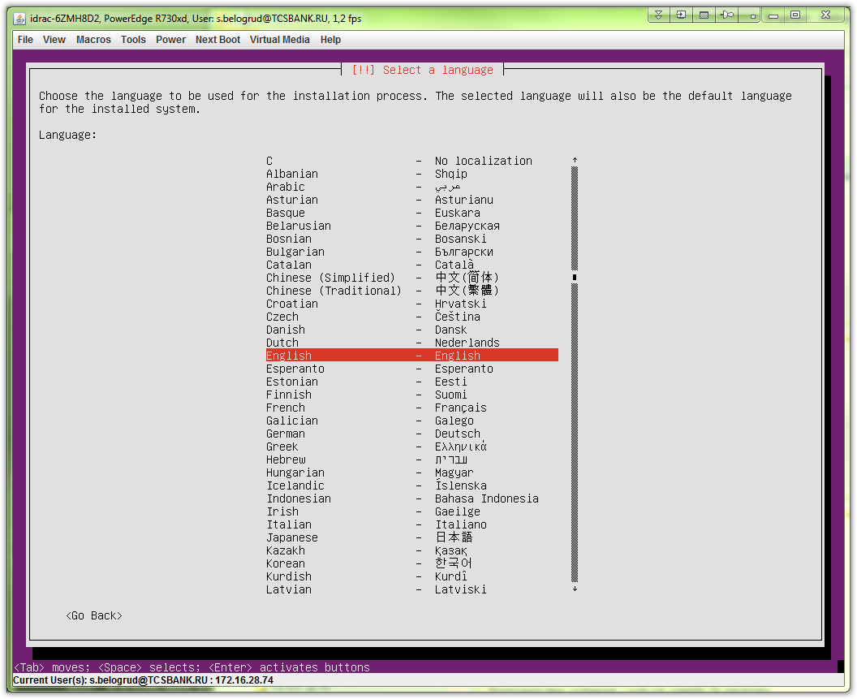
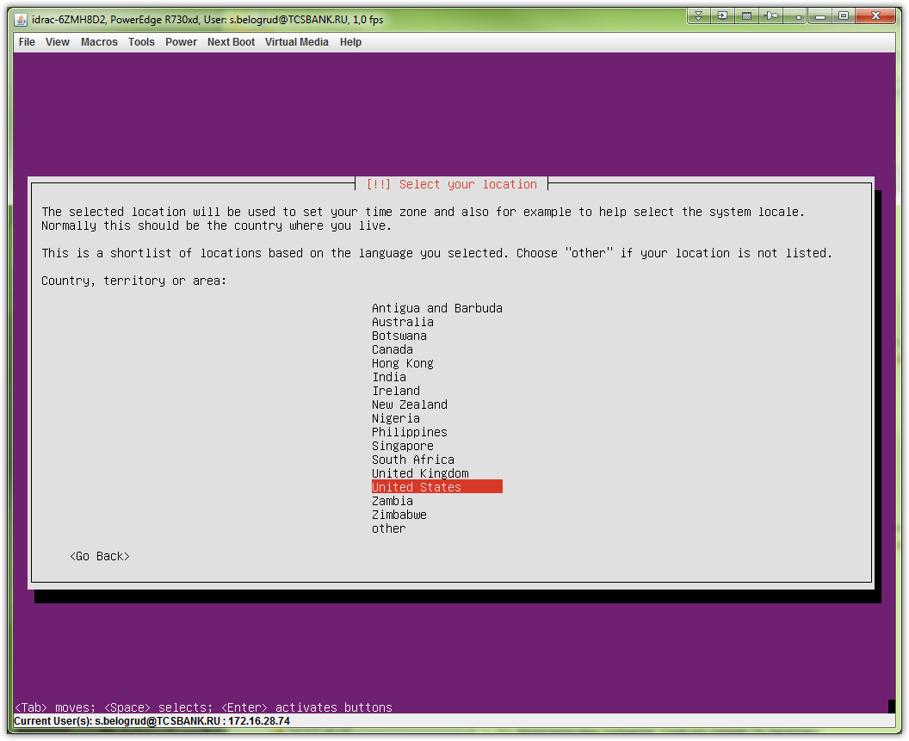

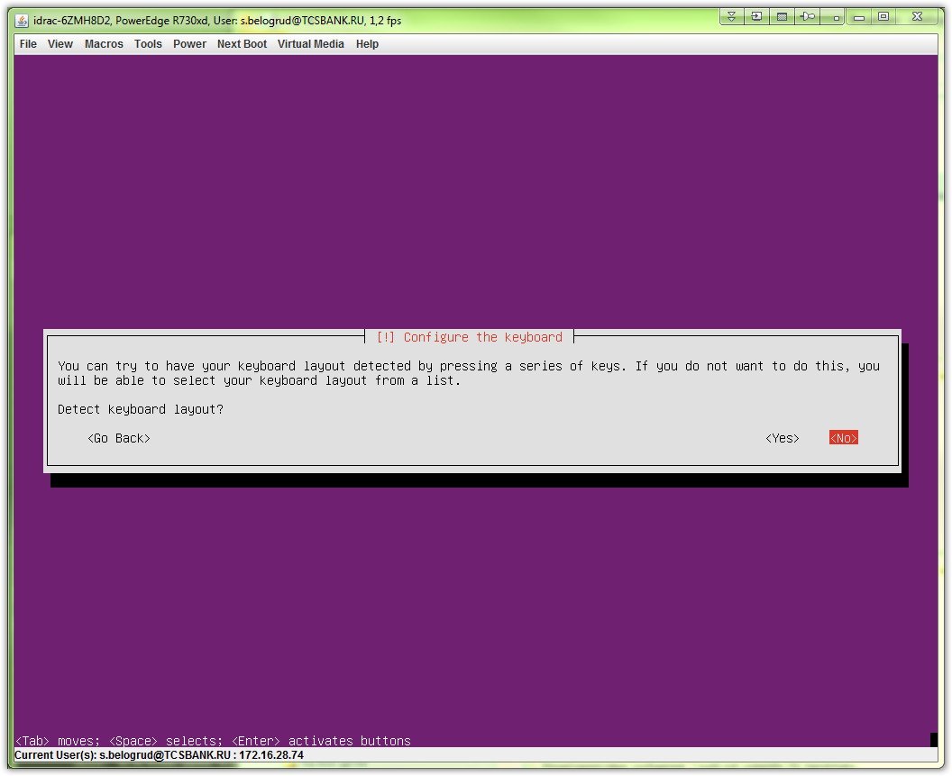

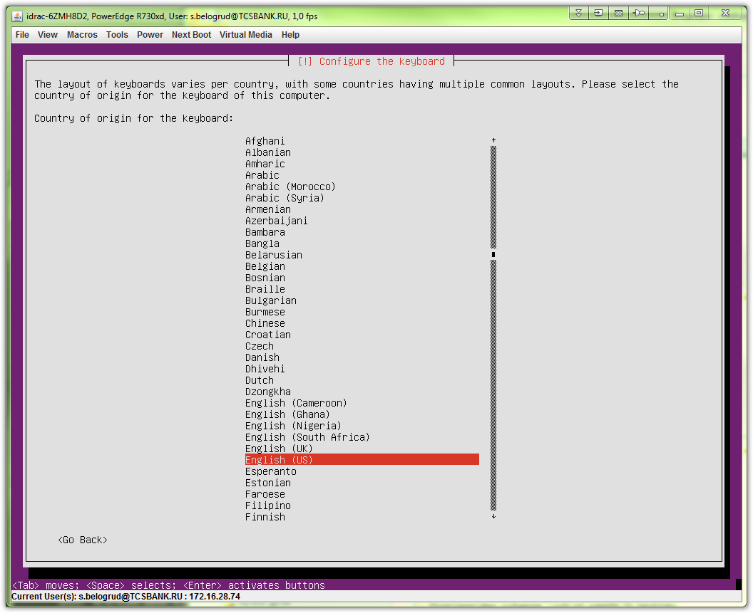
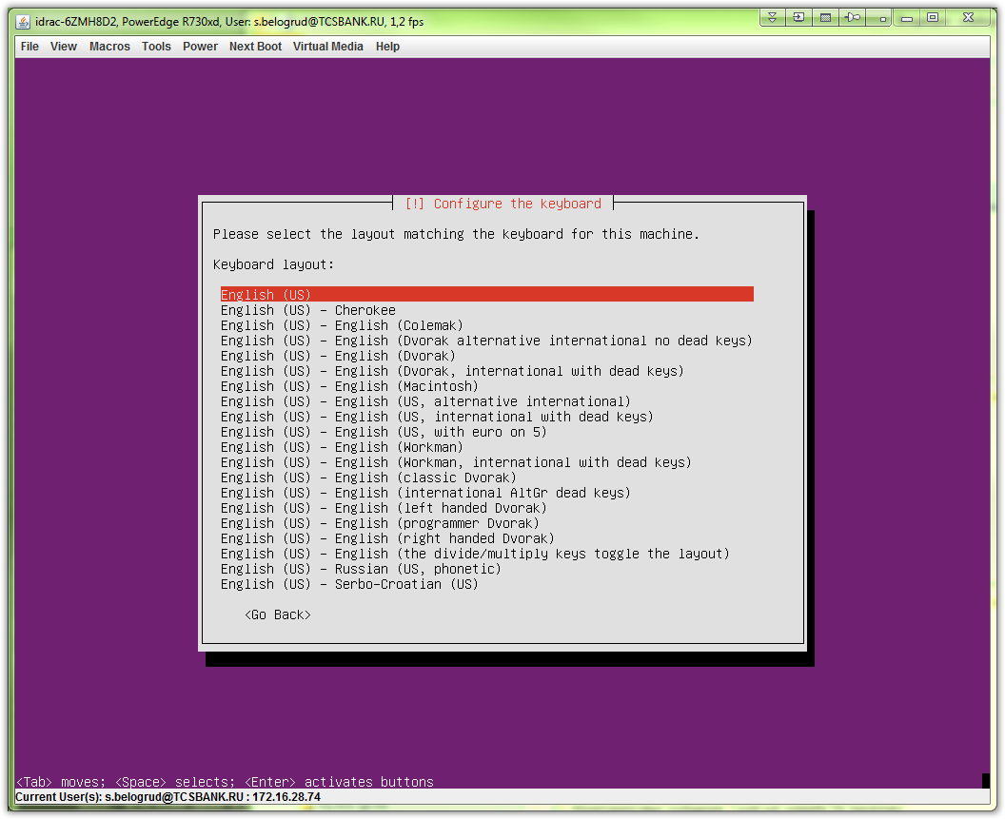

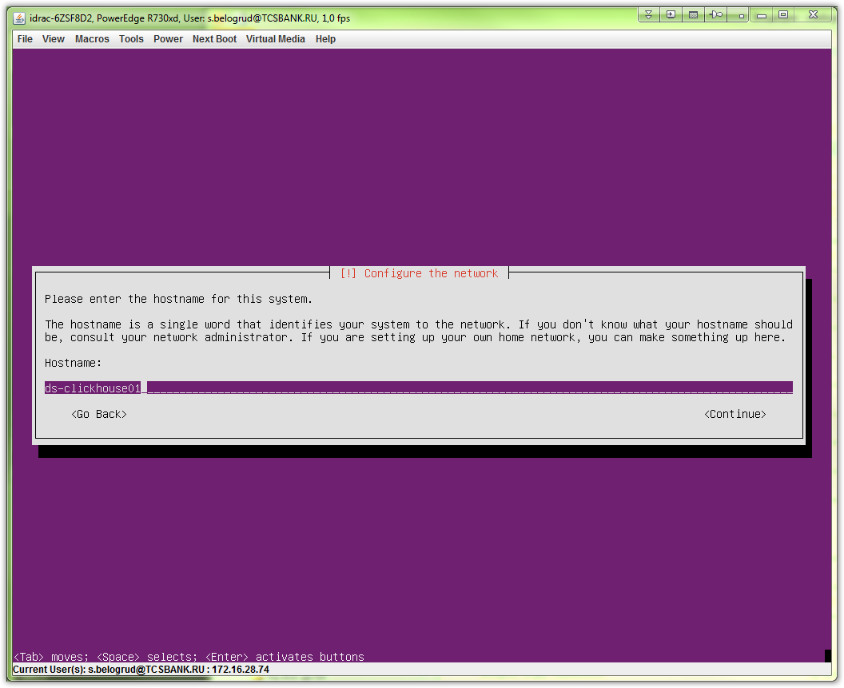

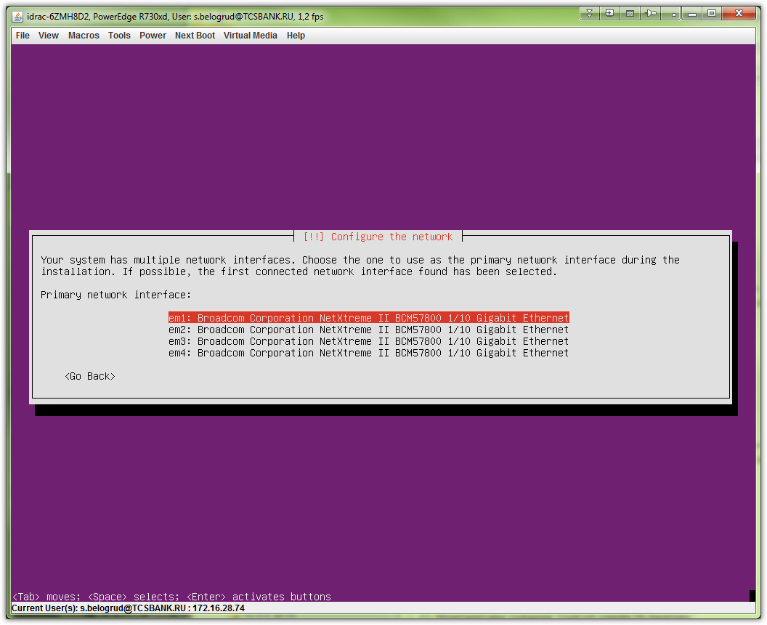

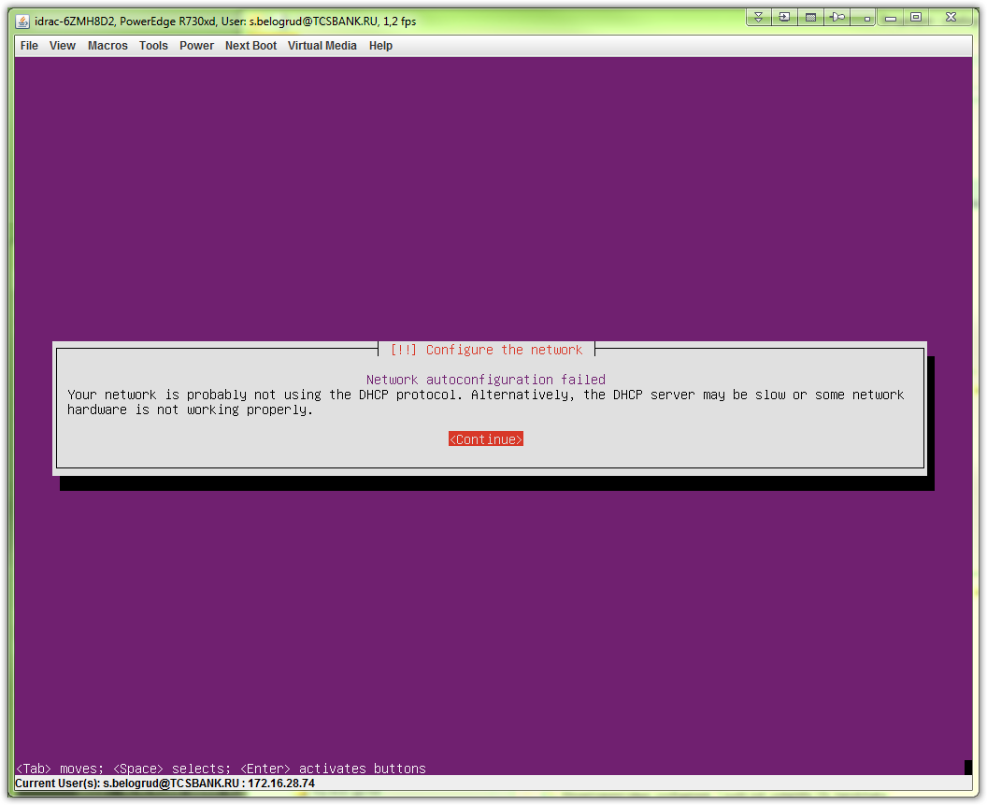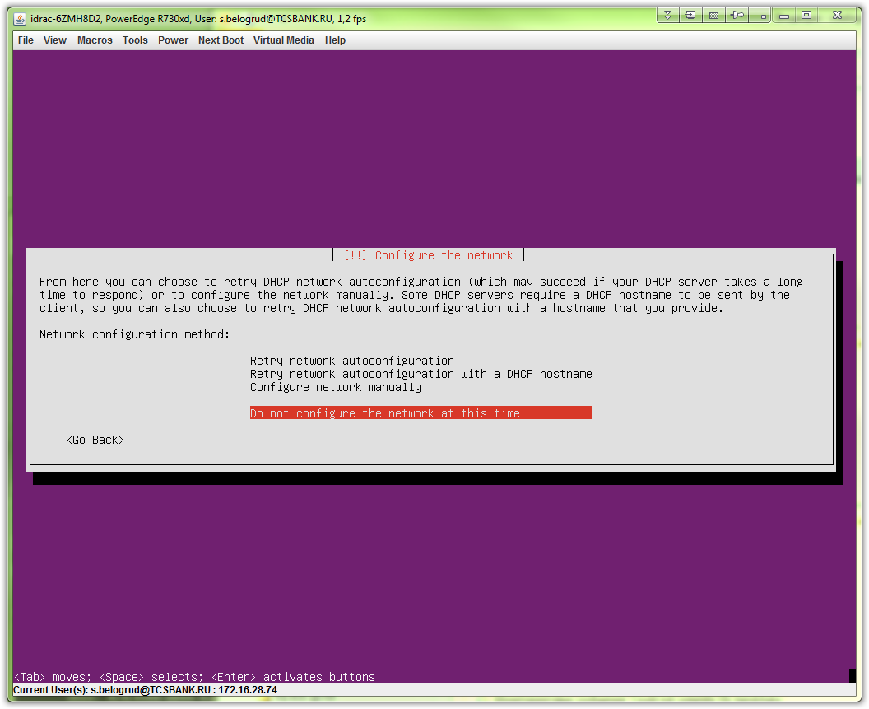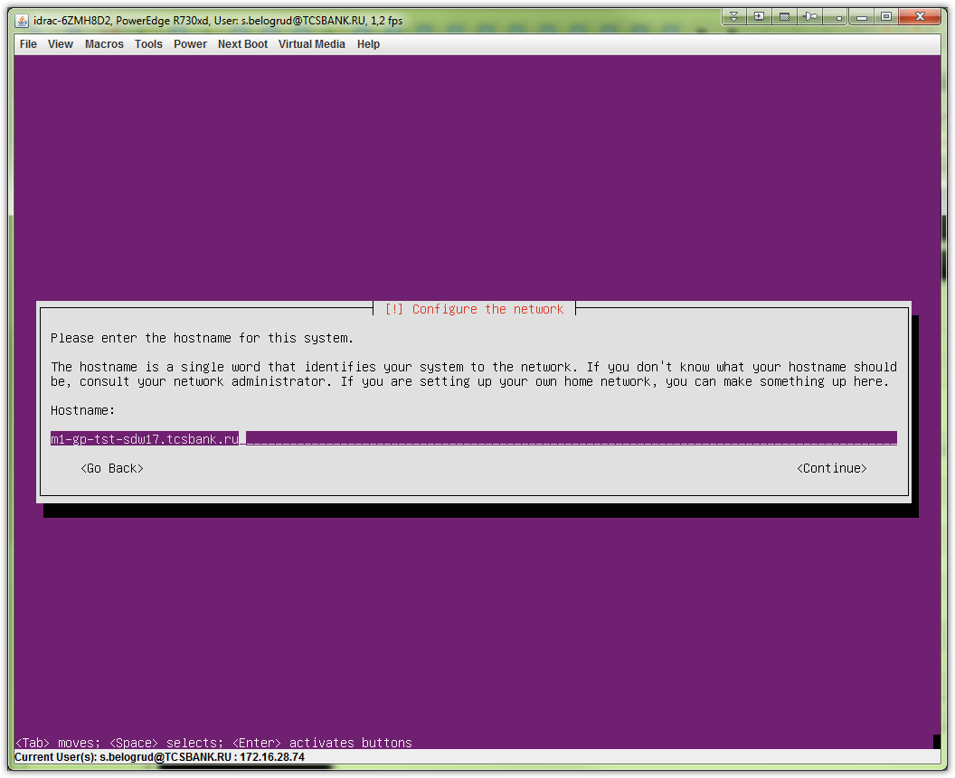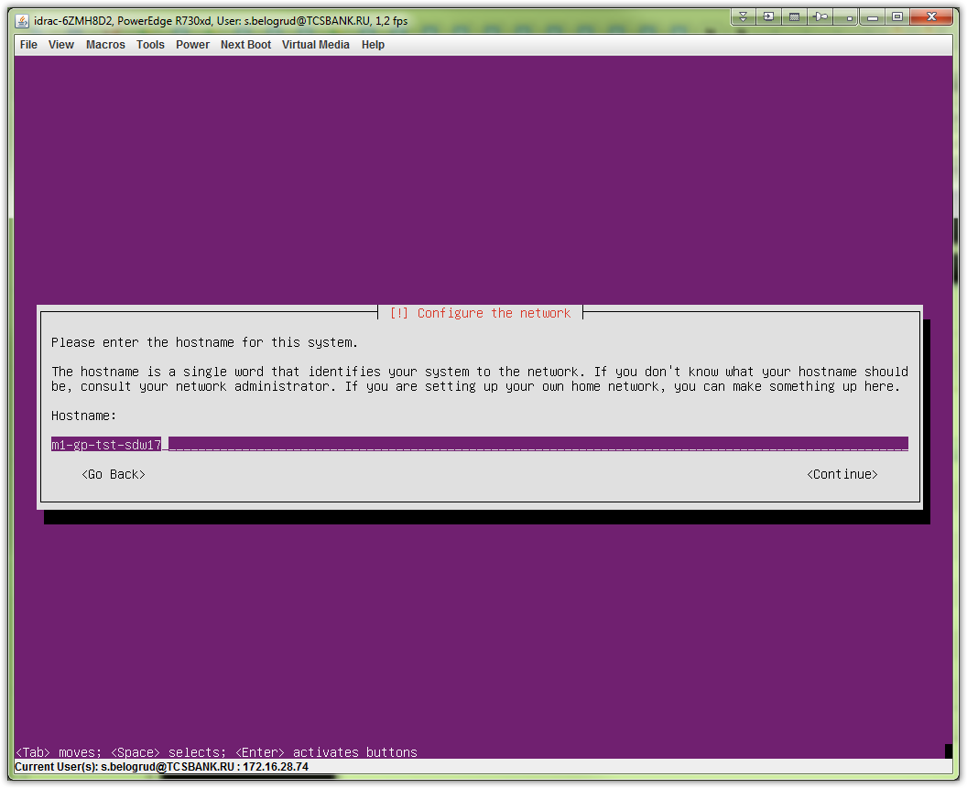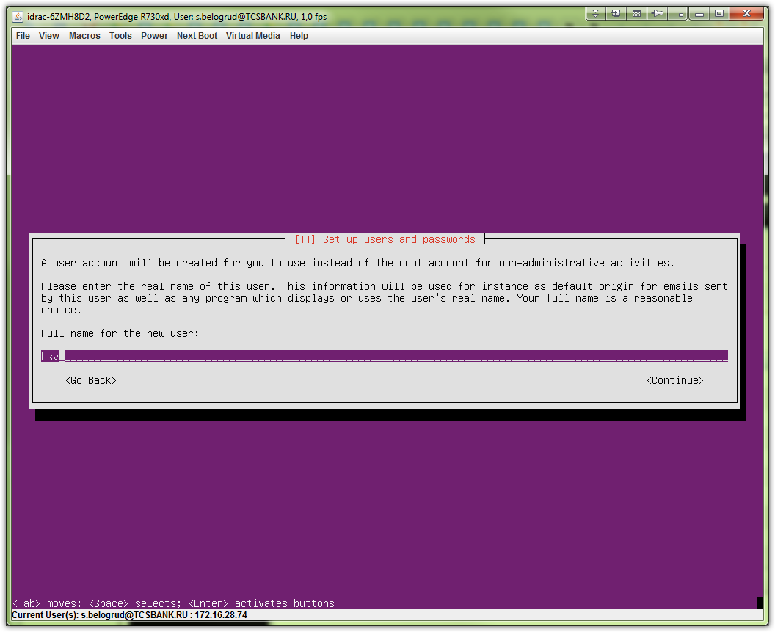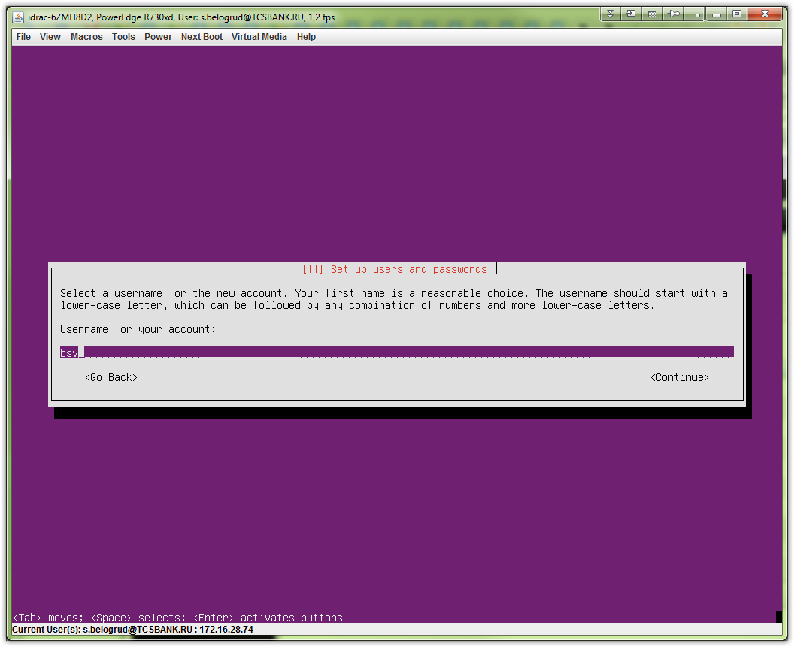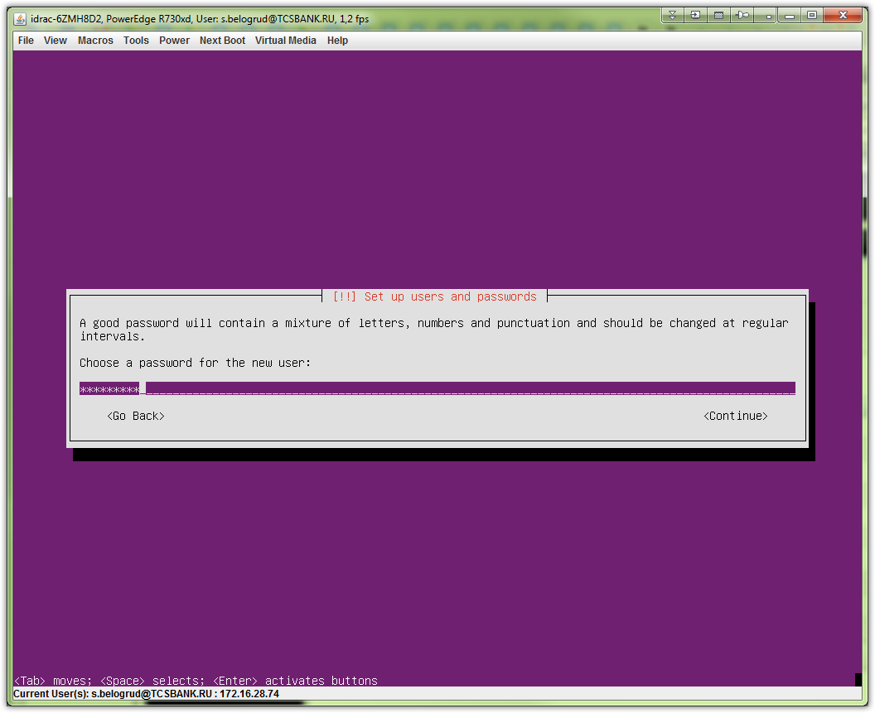

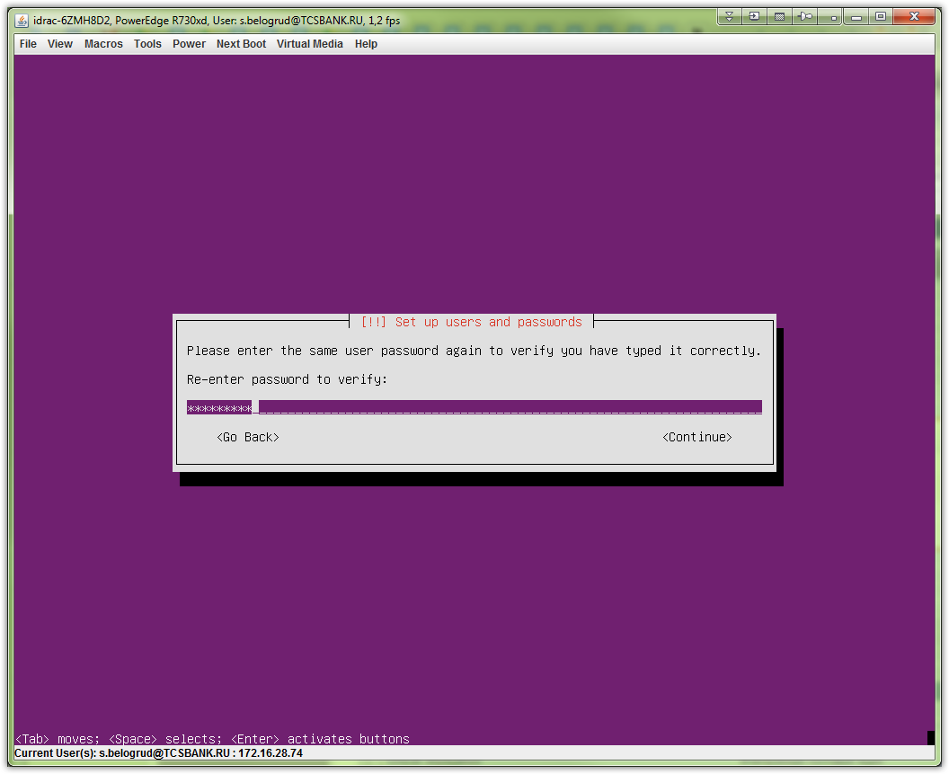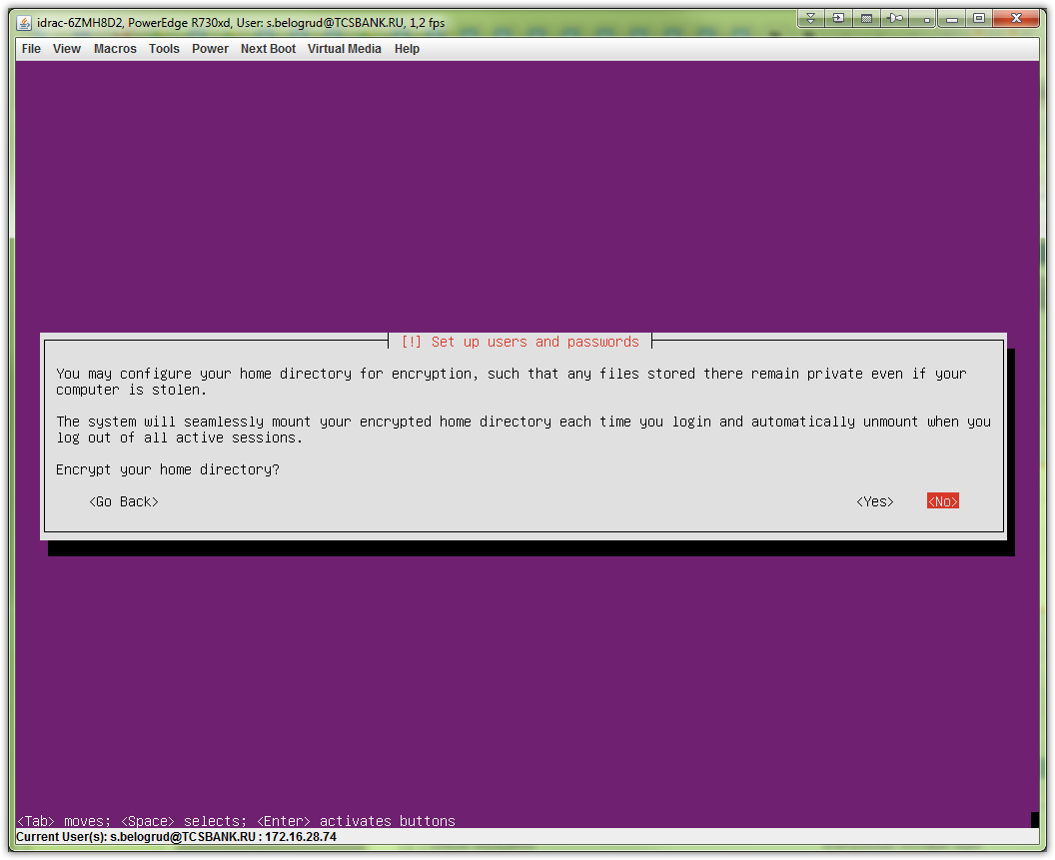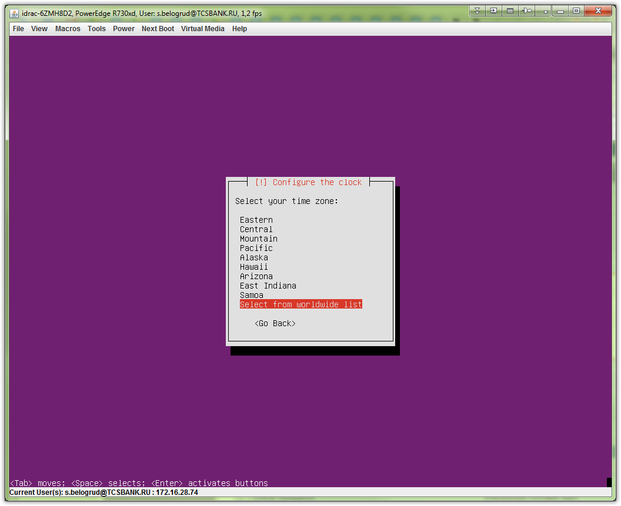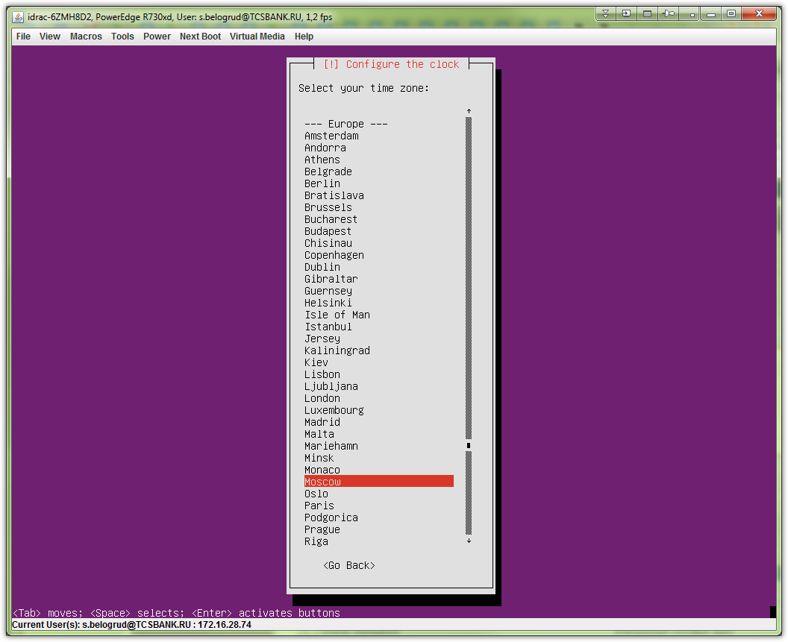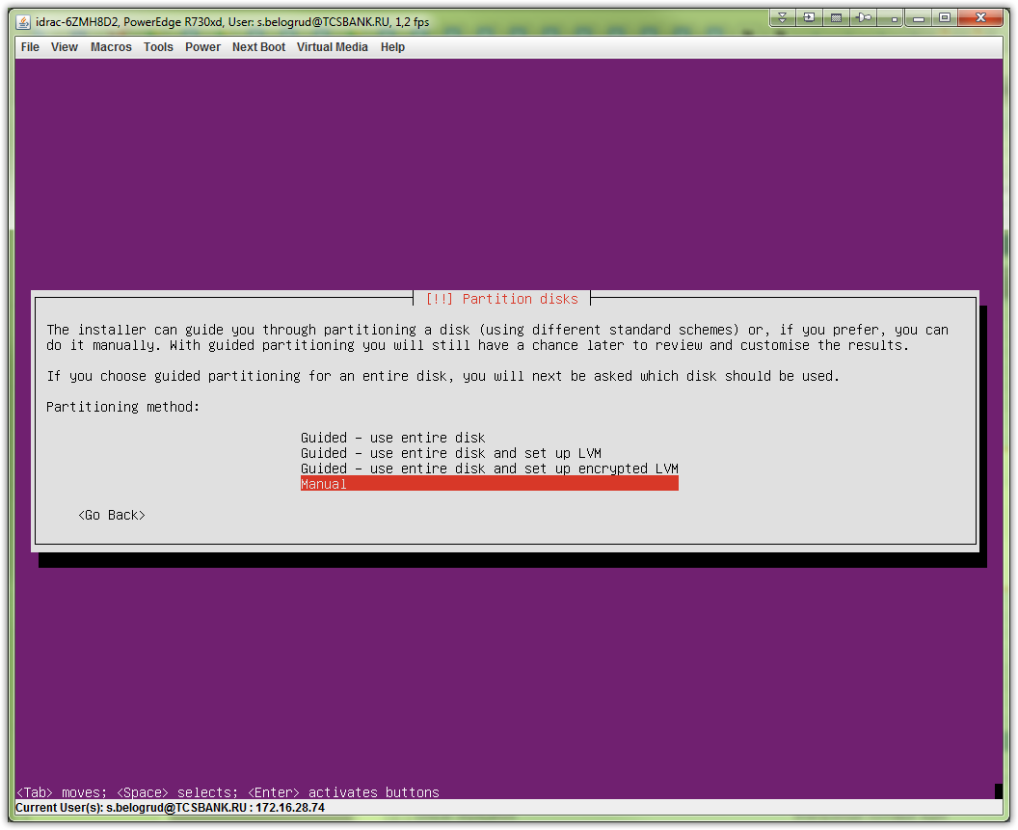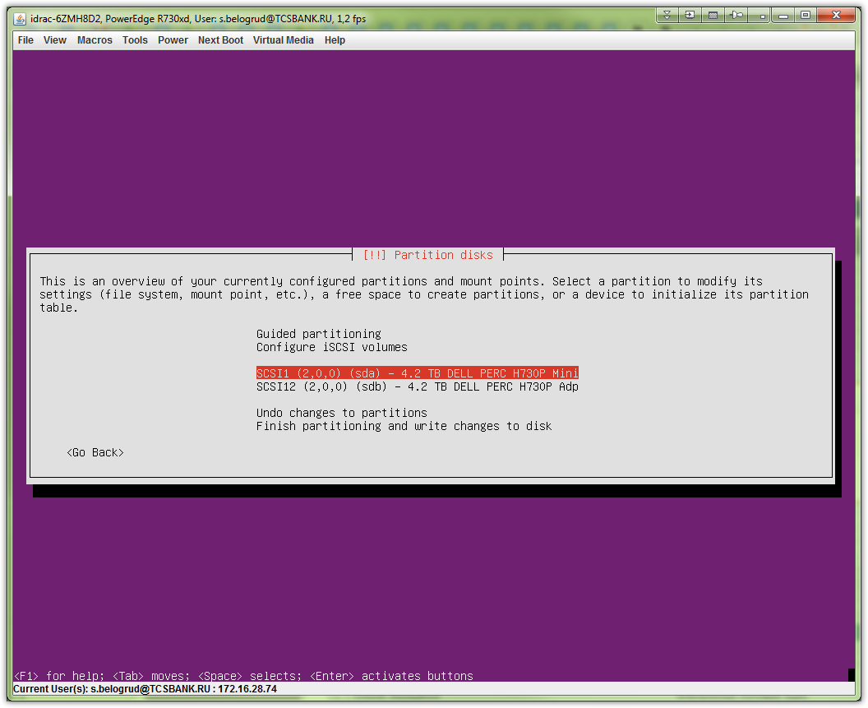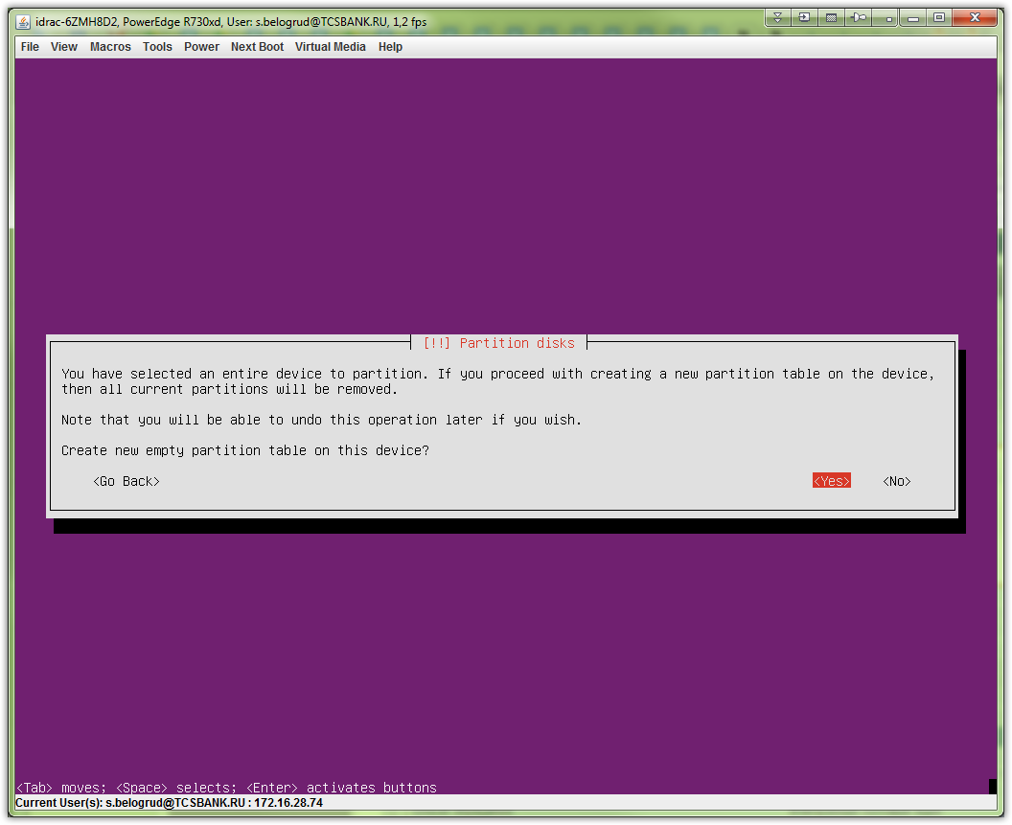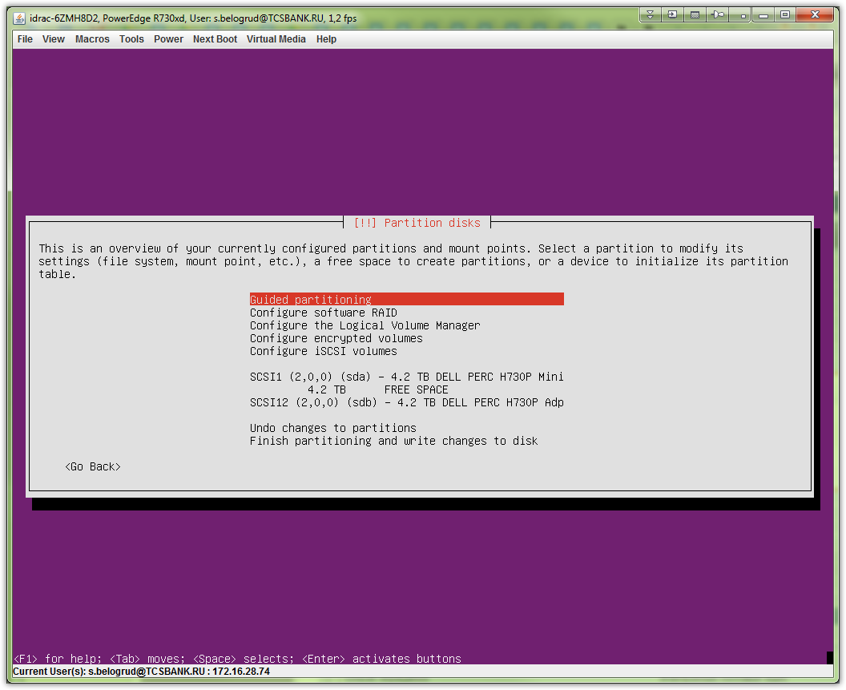

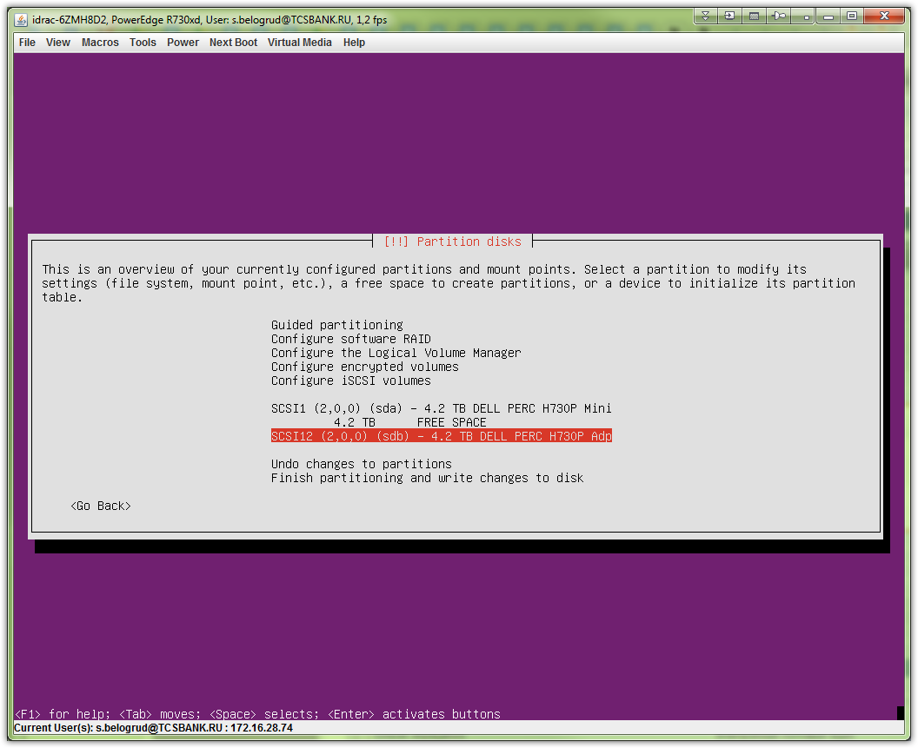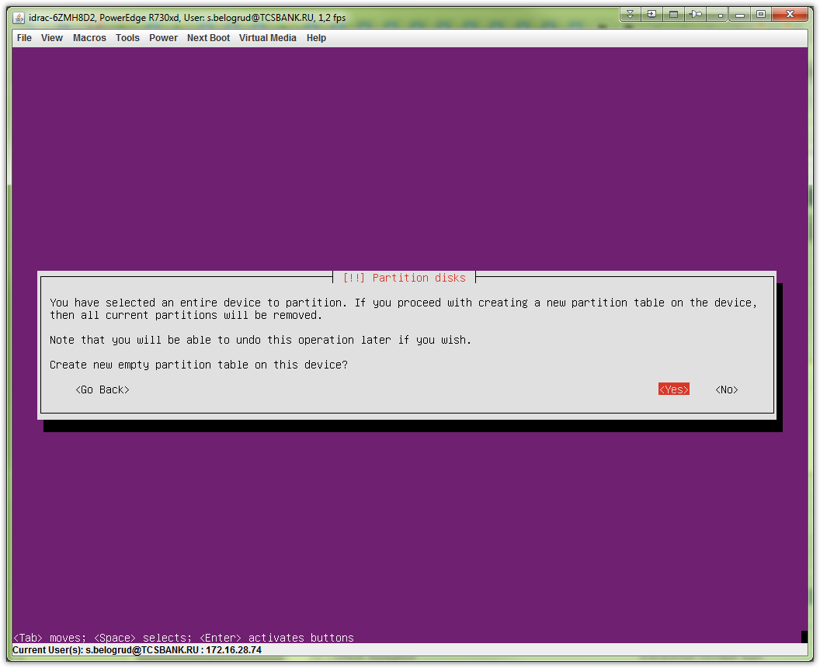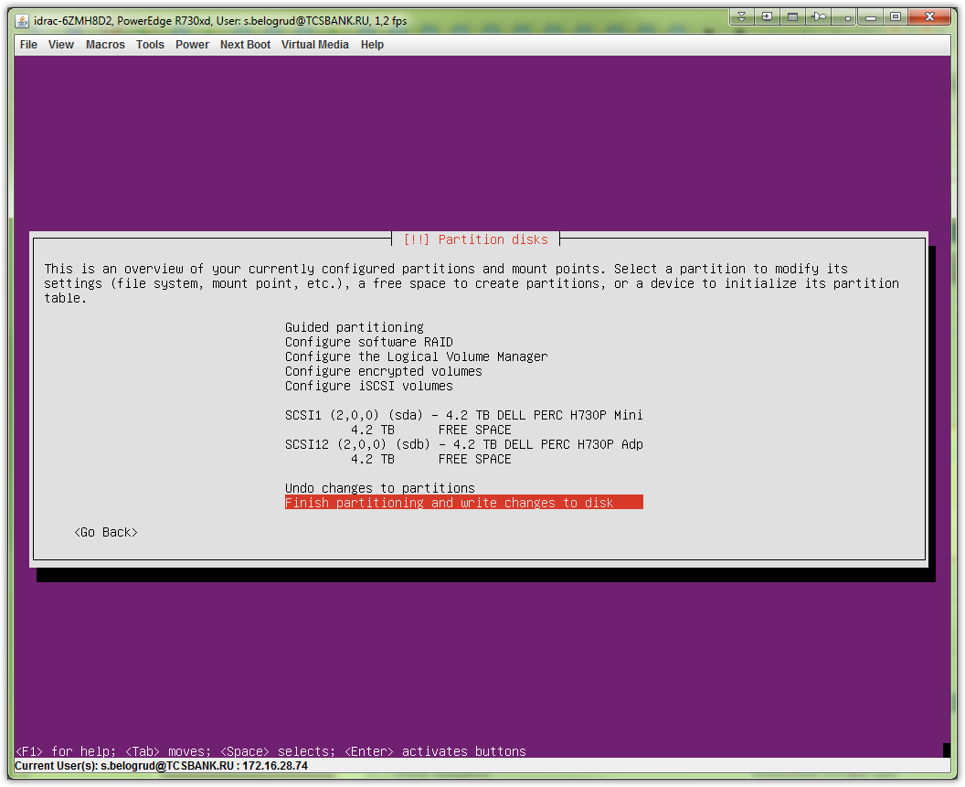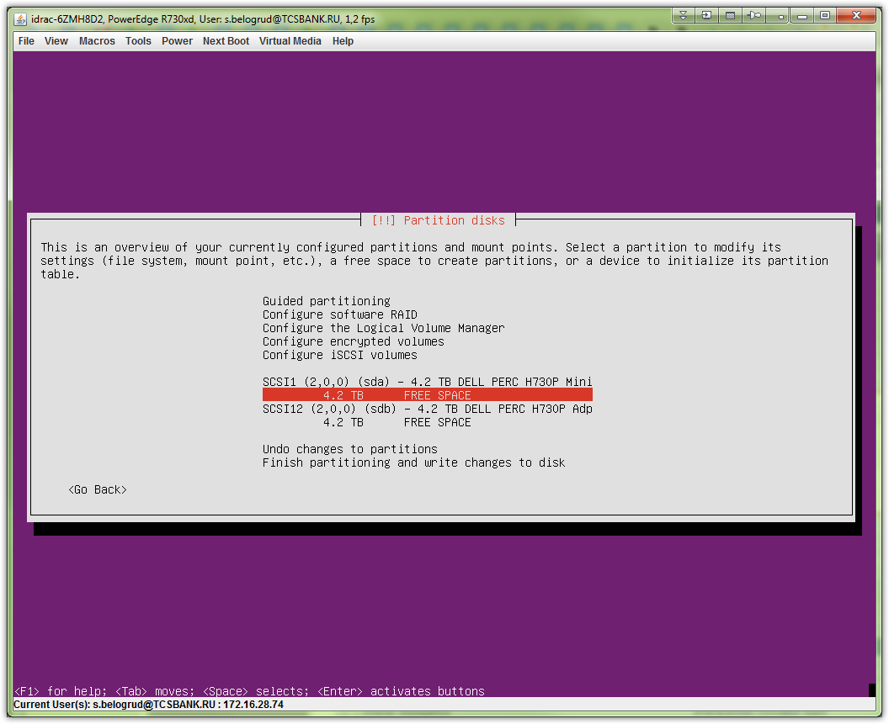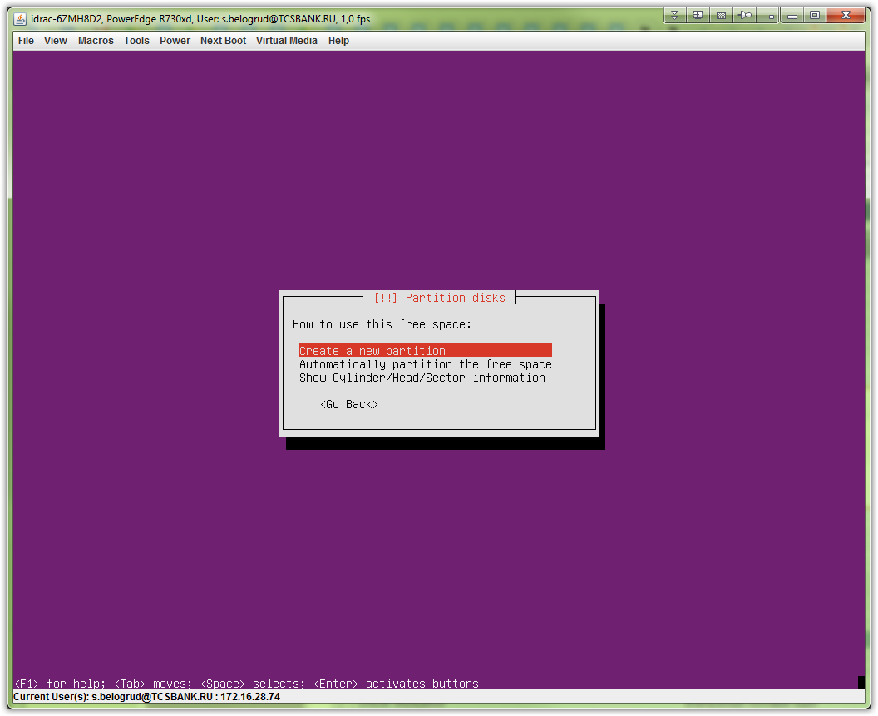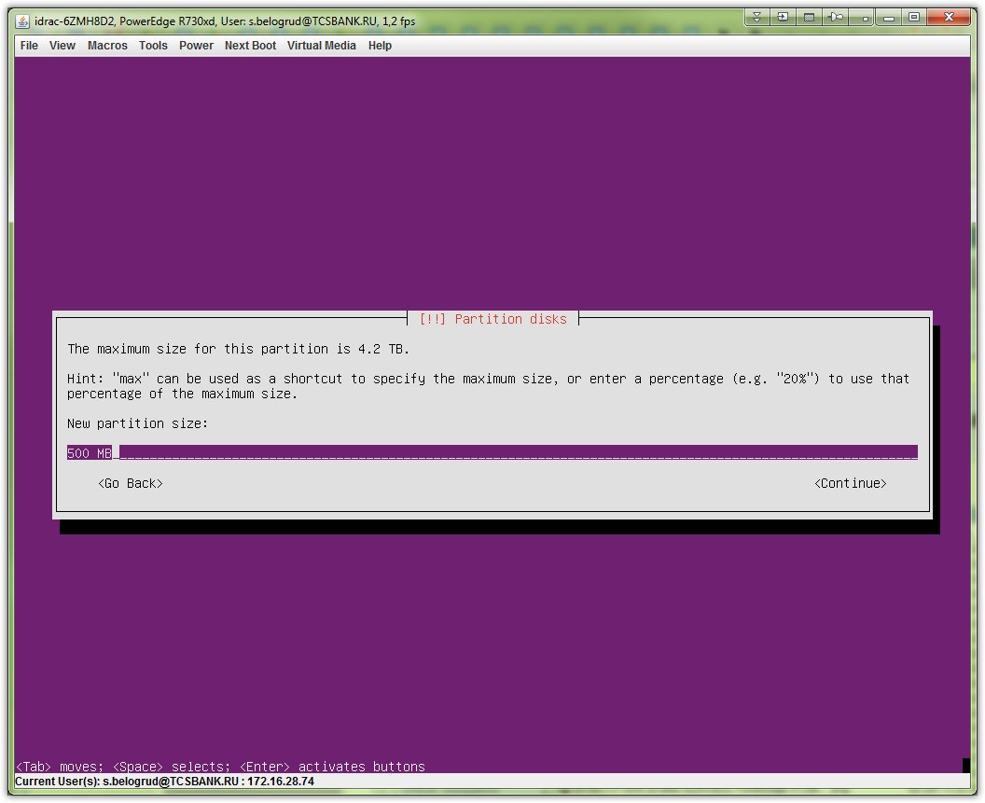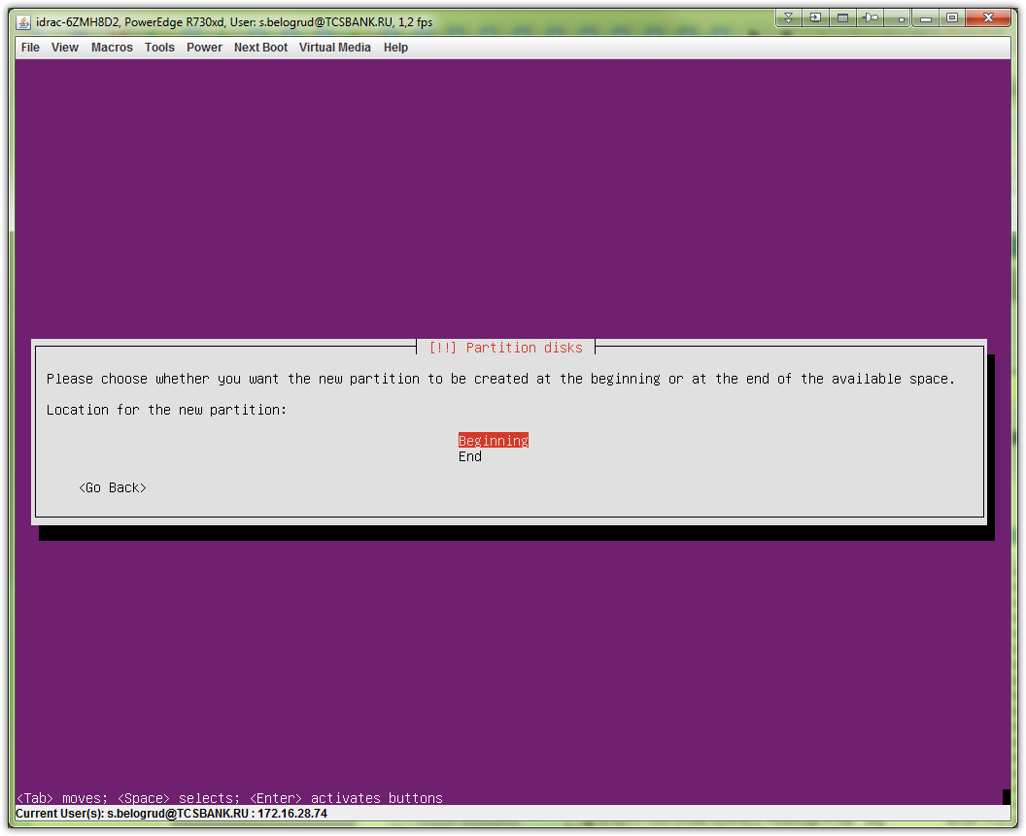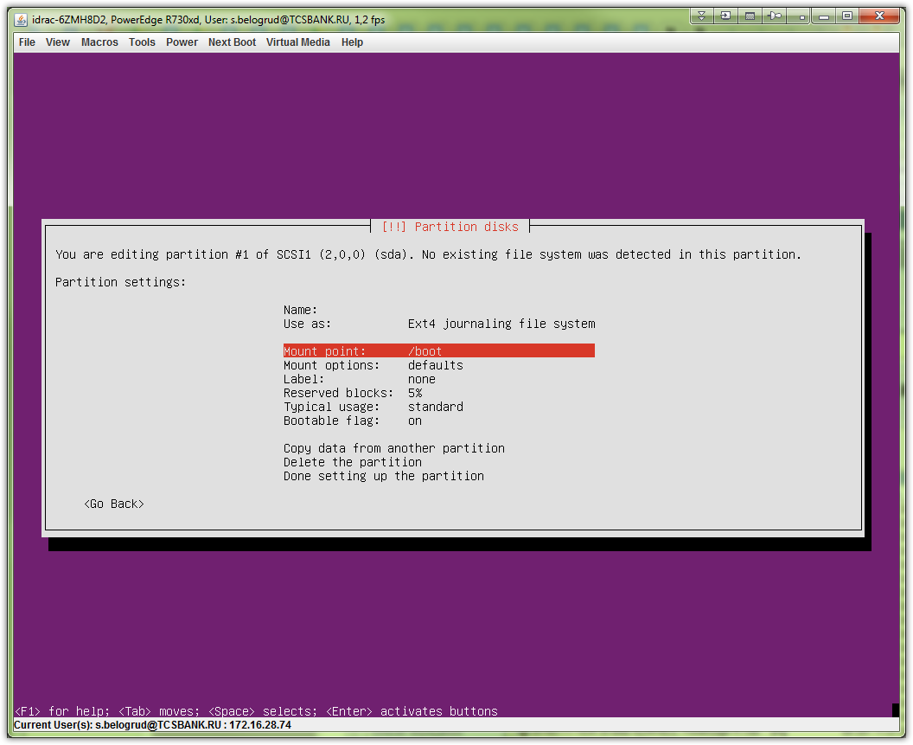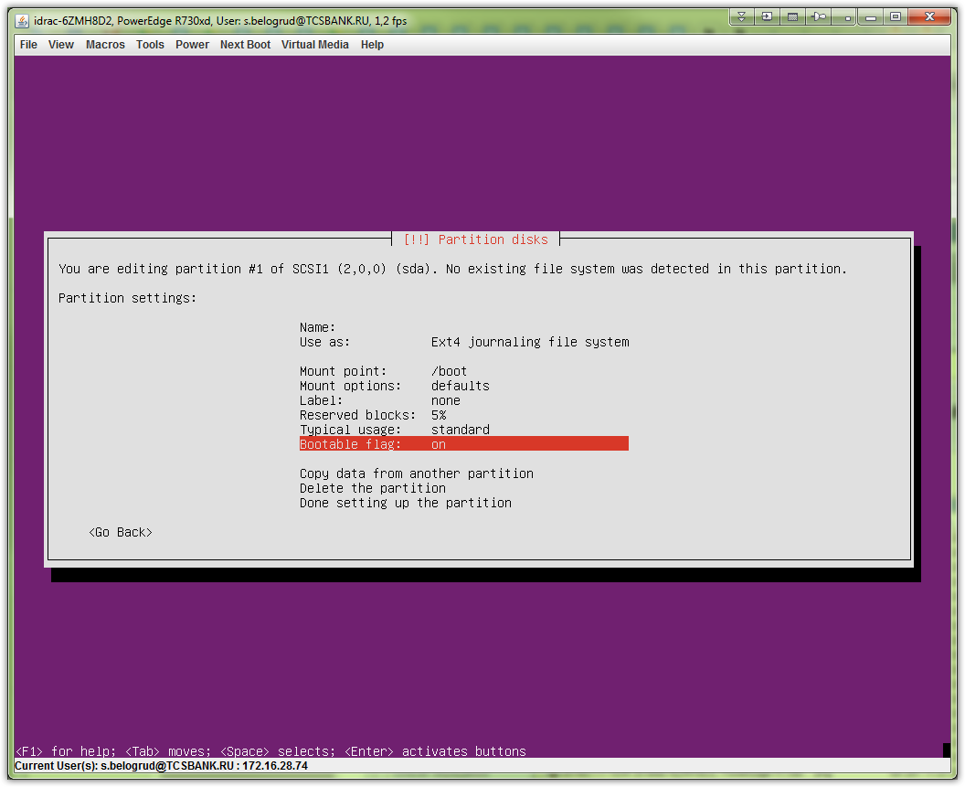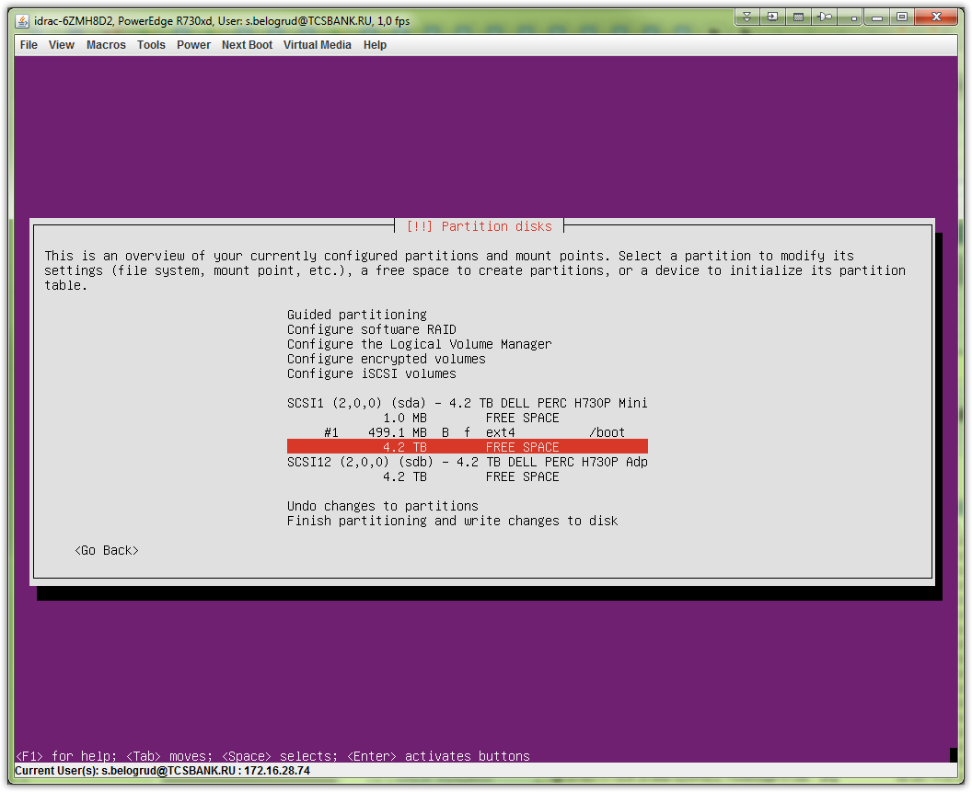

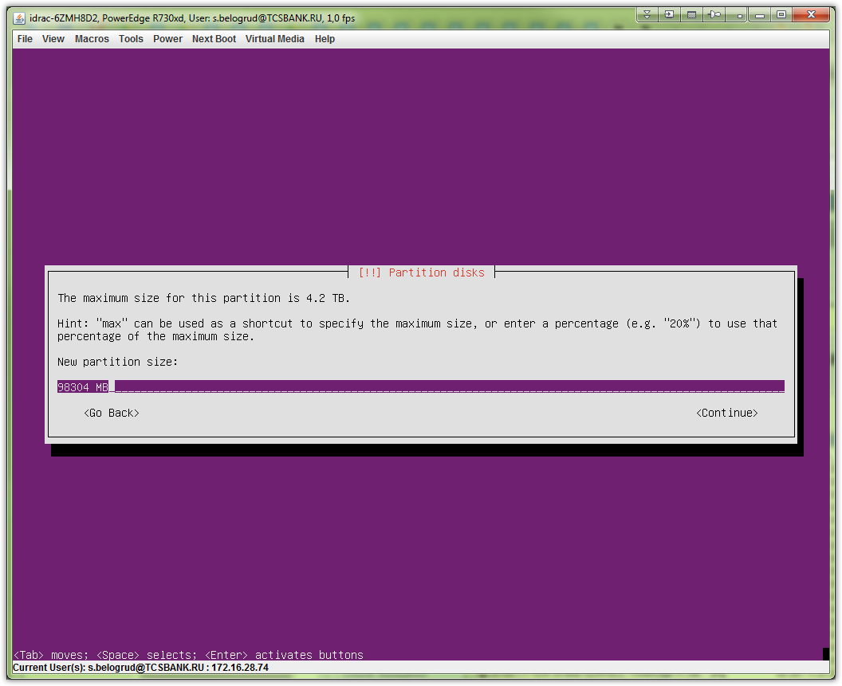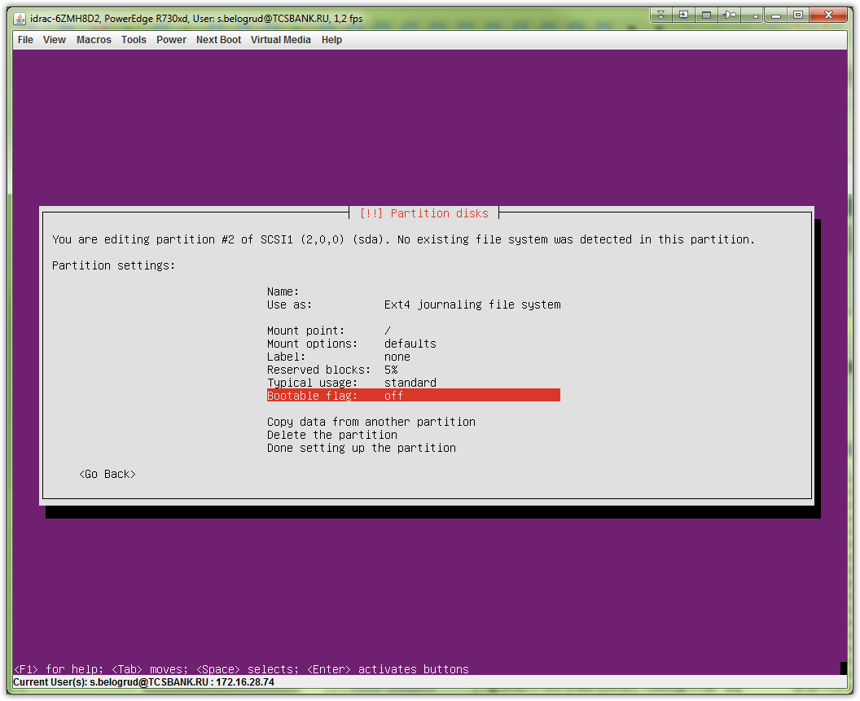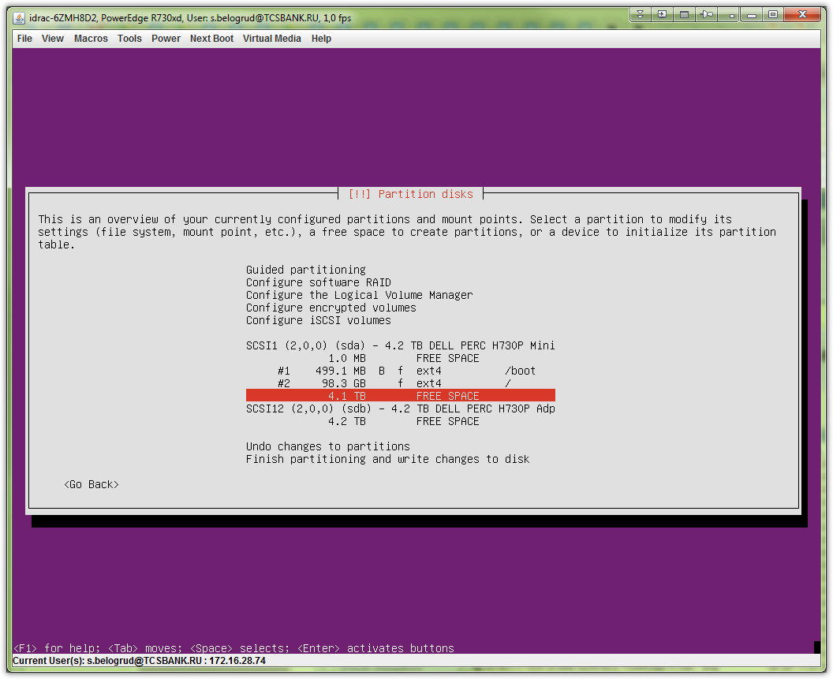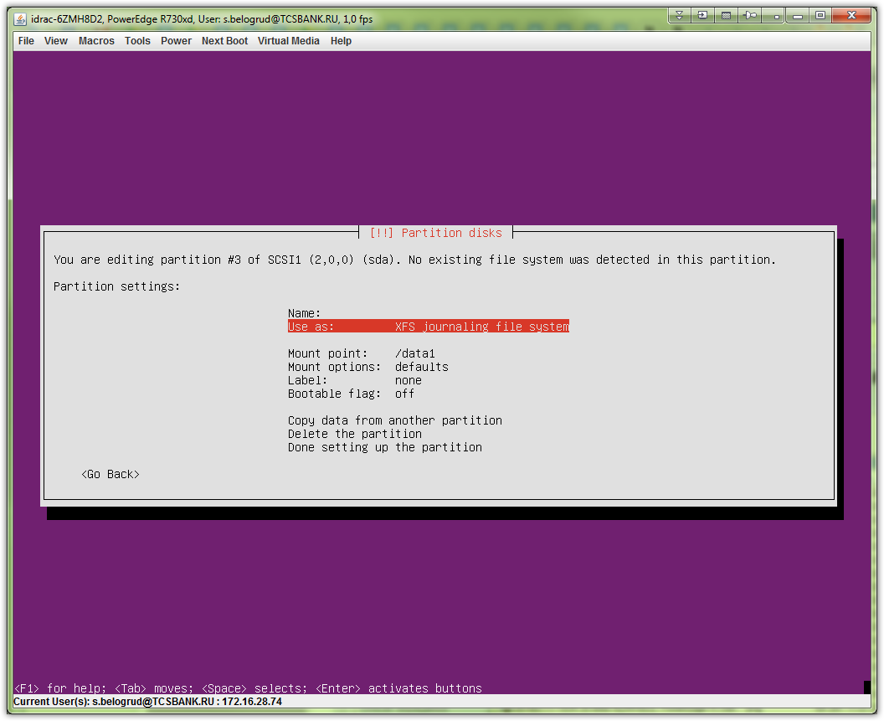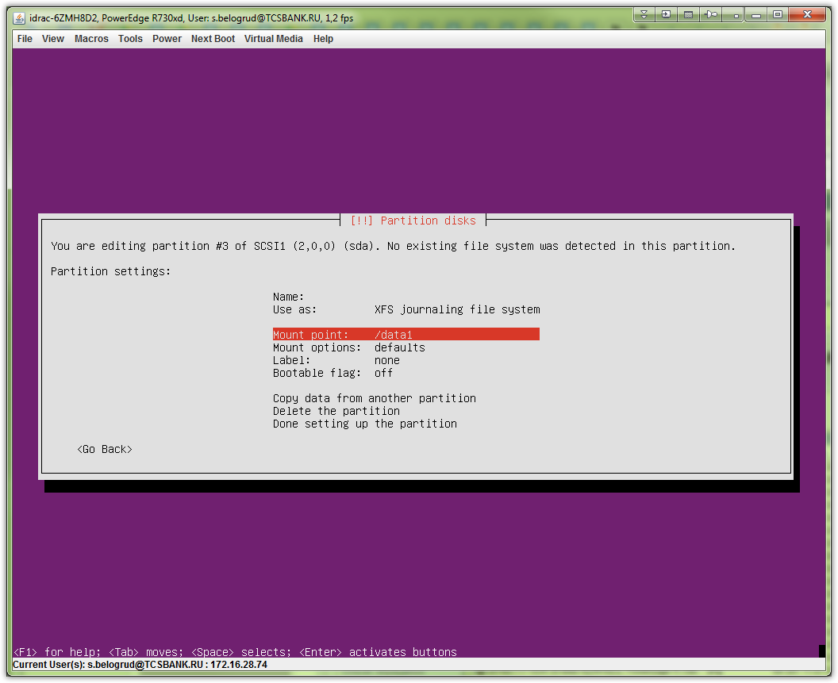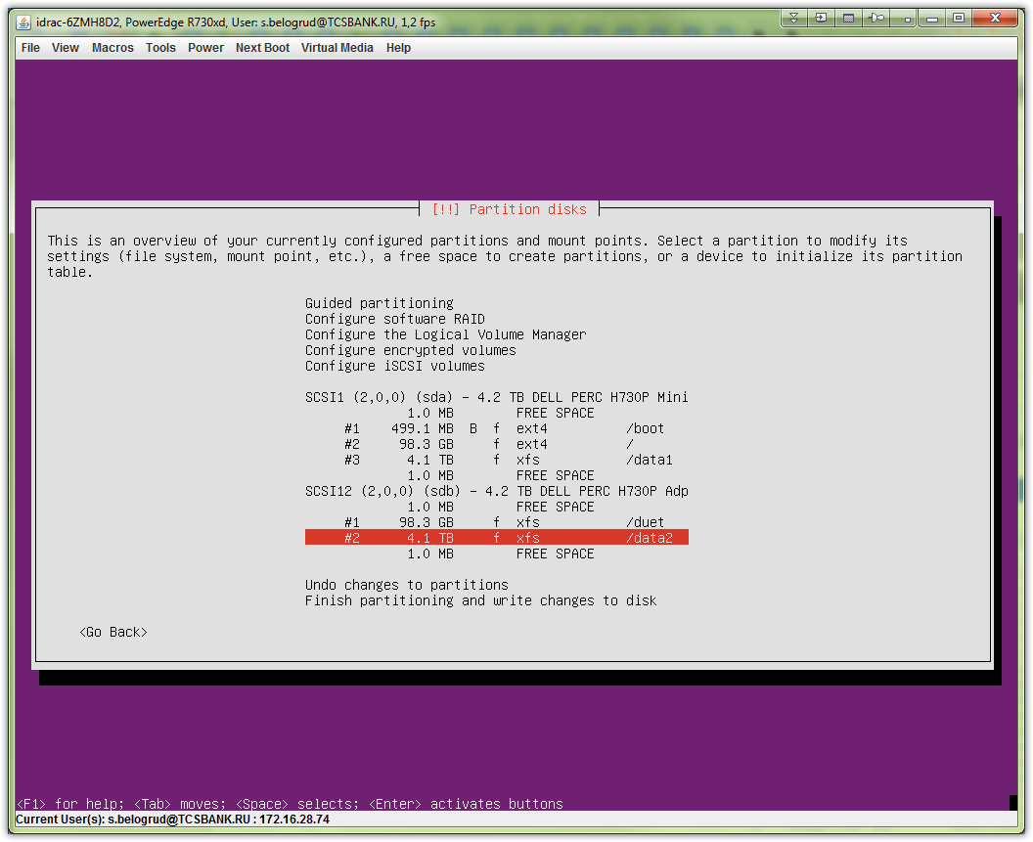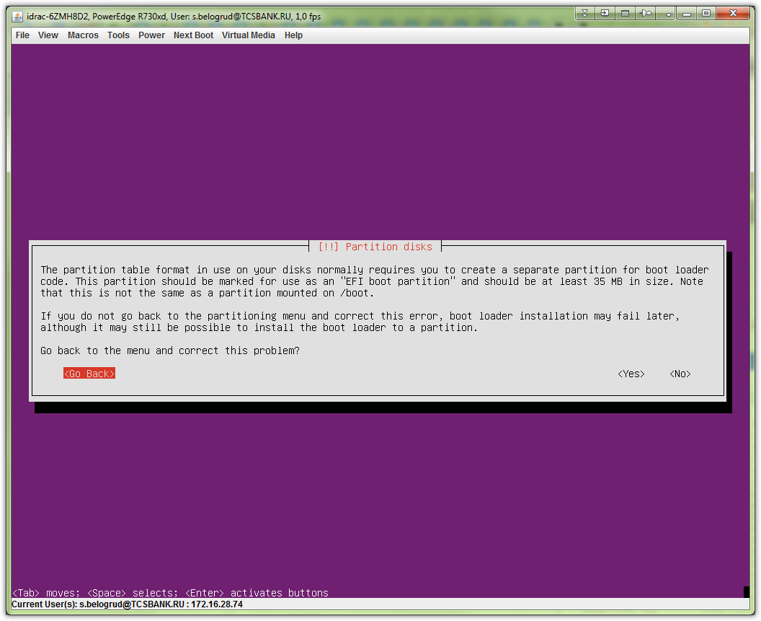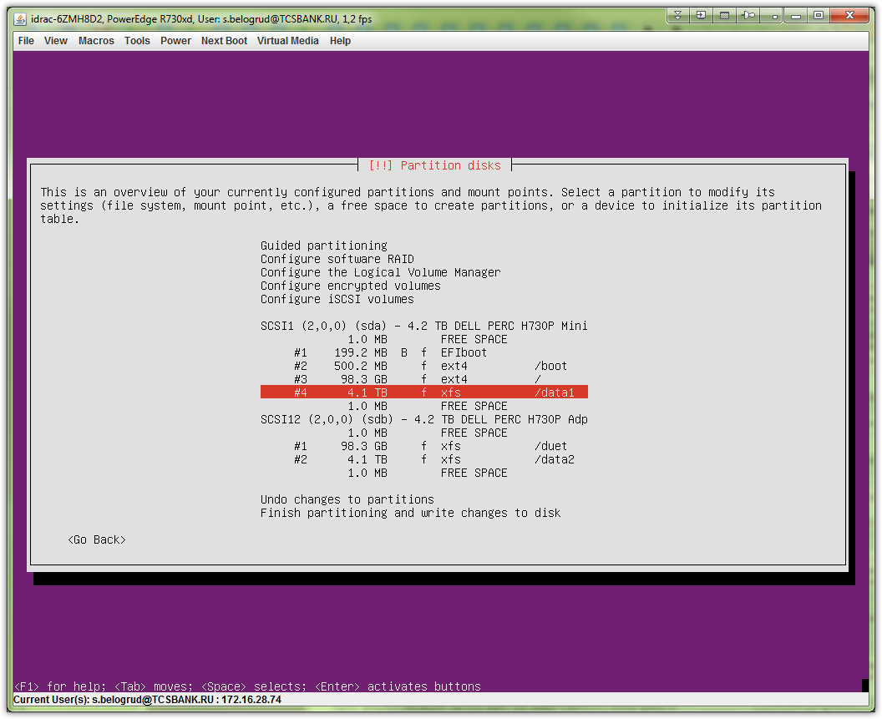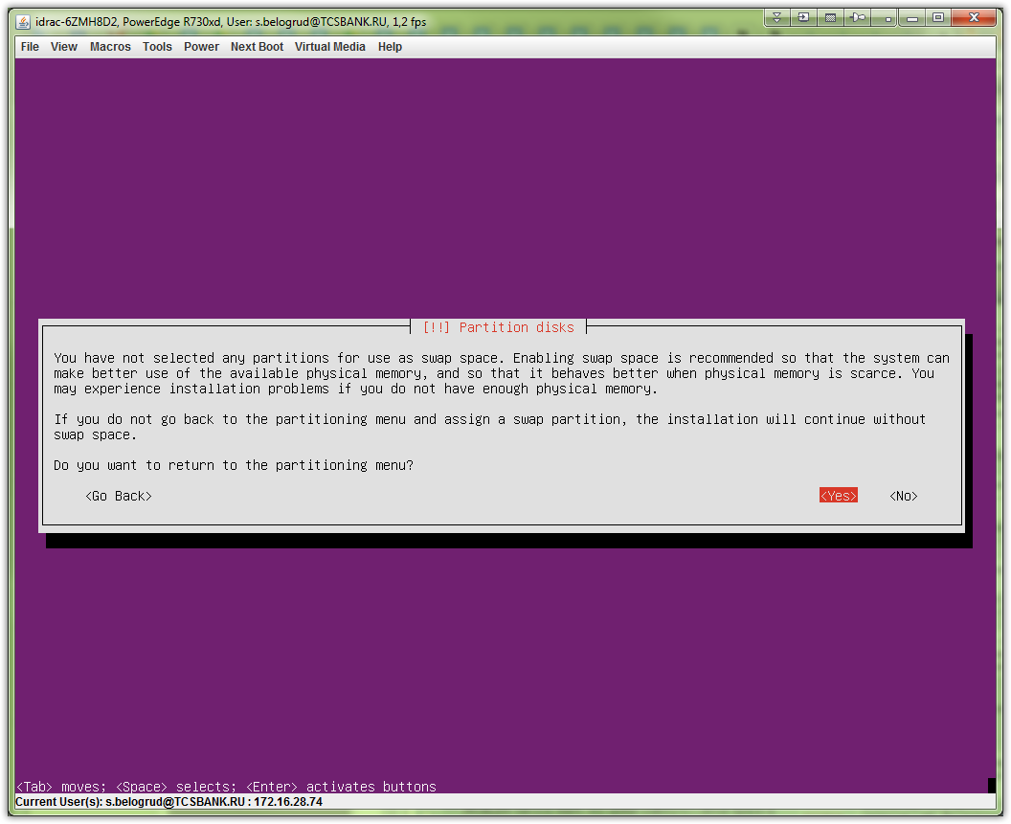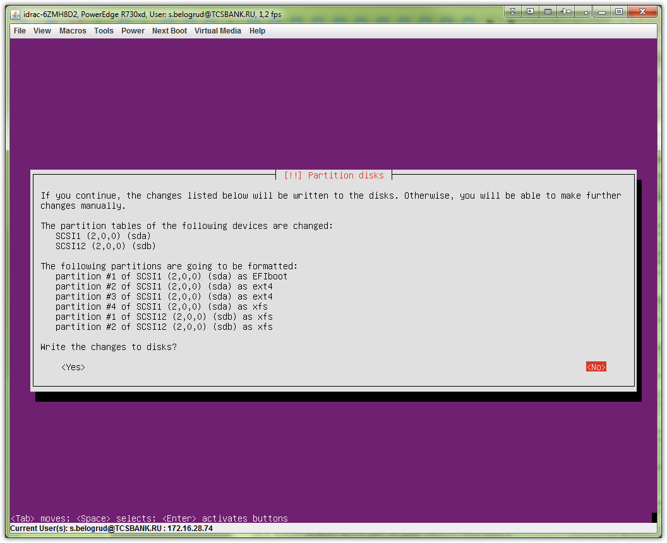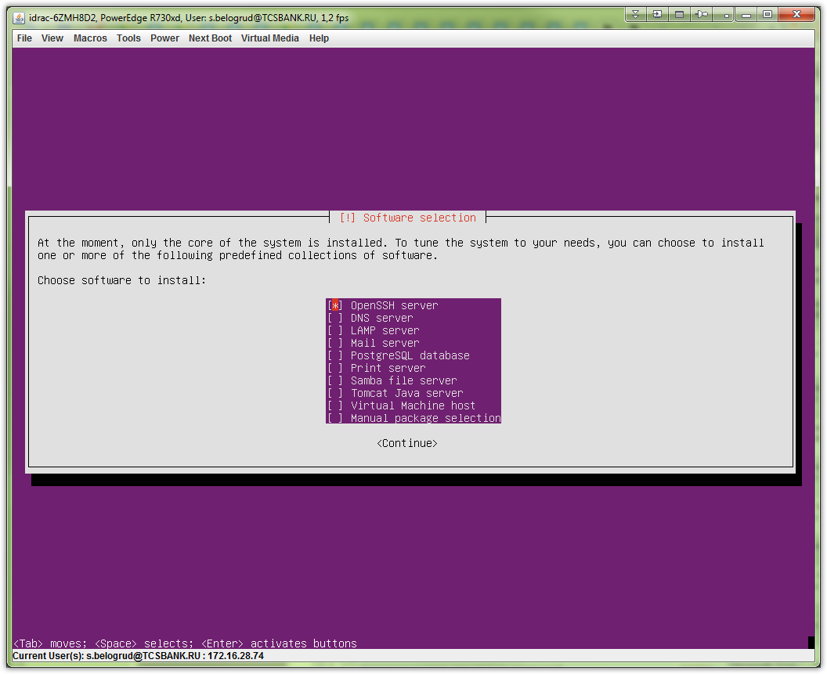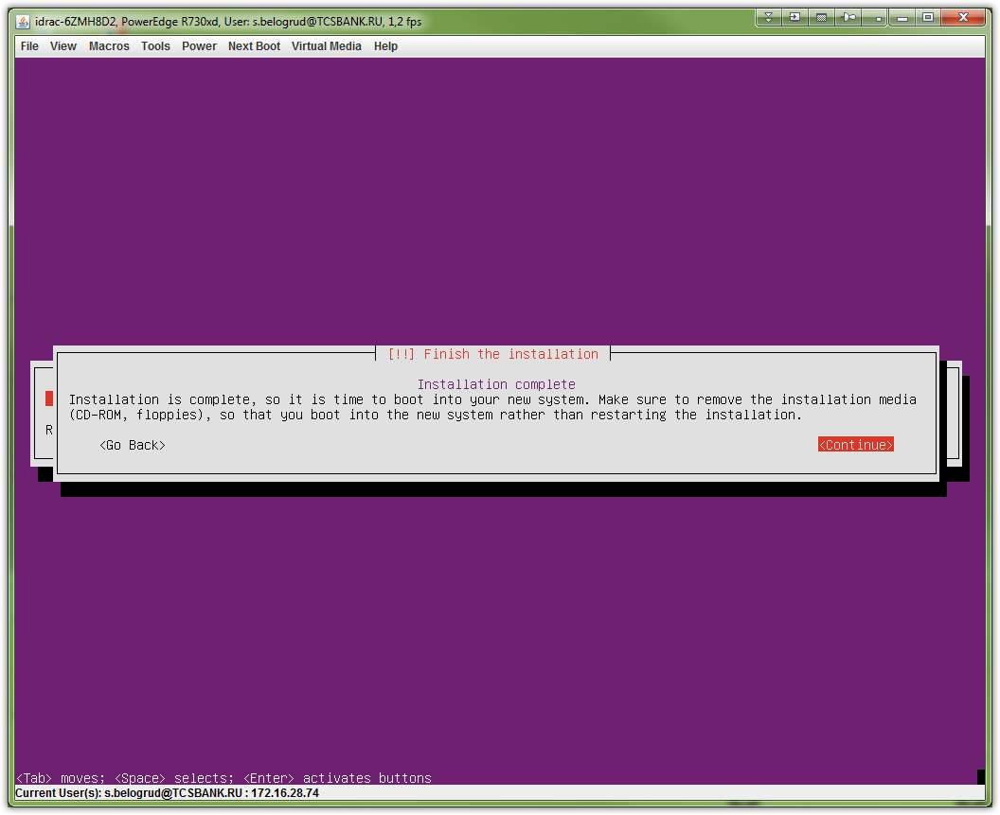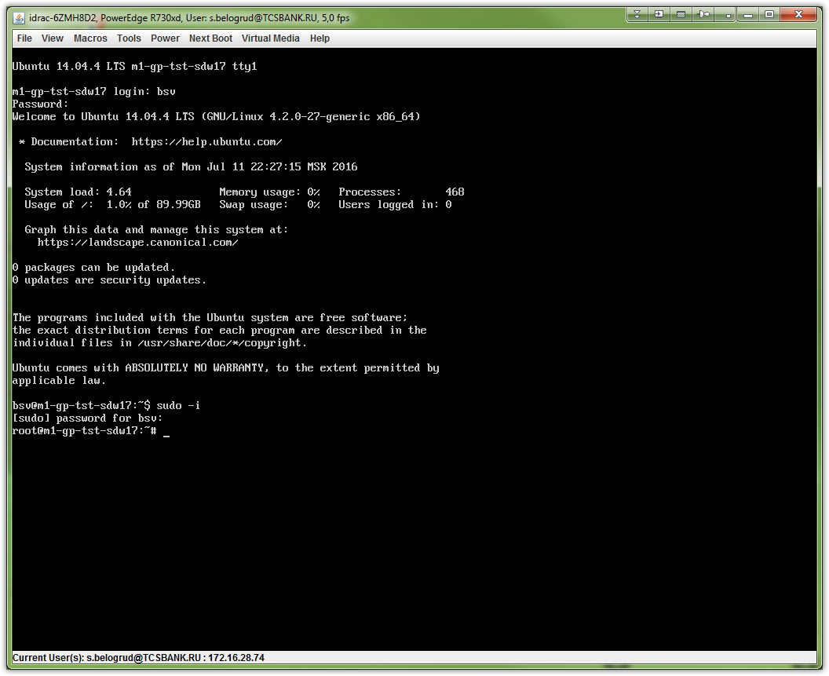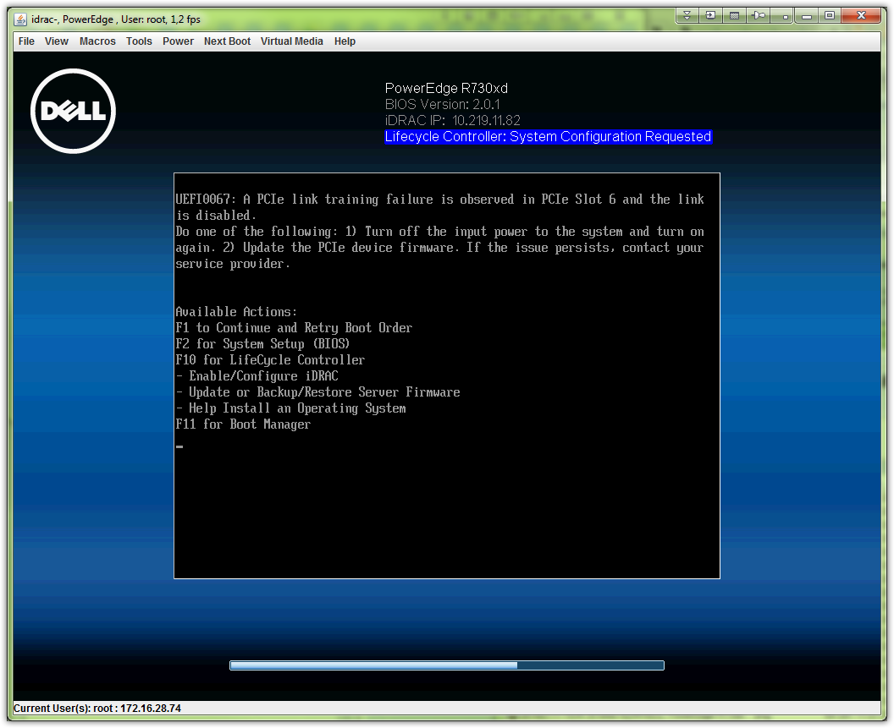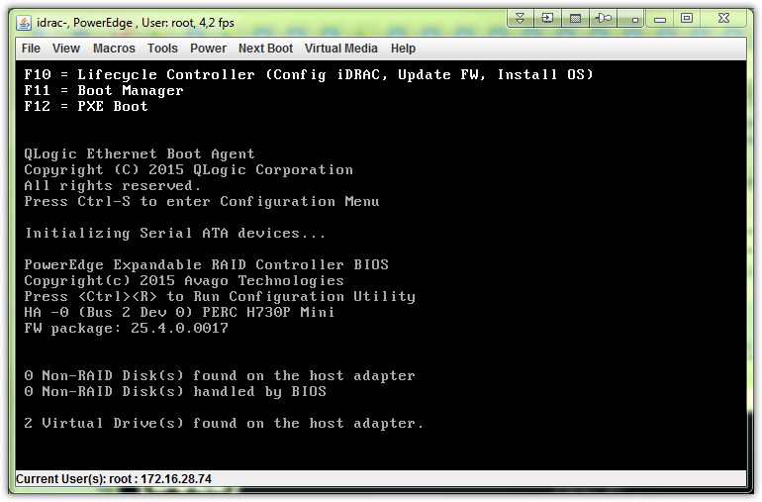

http://sysadm.mielnet.pl/install-dell-open-manage-software-on-linux-server/

